**St Catherine’s Convent**



**Mathematics Examination Paper II**

**Grade 12 September 2013**

Examiner: Miss L. Collie Time: 3 hours Moderator: Mrs A. Rossouw Marks: 150

**Learning Outcomes:**

**LO 3 – Trigonometry, Analytical Geometry, Transformation Geometry**

**LO 4 – Statistics**

**PLEASE READ THE FOLLOWING INSTRUCTIONS CAREFULLY**

1. This paper consists of 9 pages. 8 pages with 13 questions and page 9 is a diagram sheet for question 7. There is also a separate 2 - page formula sheet. Please check that your question paper is complete.

2. Read the questions carefully.

3. Answer all the questions.

4. Number your answers exactly as the questions are numbered.

5. You may use an approved non-programmable and non-graphical calculator, unless a specific question prohibits the use of a calculator.

6. Diagrams have not been drawn to scale.

7. Round off your answers to 1 decimal digit where necessary, unless otherwise instructed

8. All the necessary working must be clearly shown.

9. It is in your own interest to write legibly and to present your work neatly.

10. Tippex may not be used. Cross out errors.

**NAME**

|  |  |  |  |  |  |  |  |  |  |  |  |  |  |  |
| --- | --- | --- | --- | --- | --- | --- | --- | --- | --- | --- | --- | --- | --- | --- |
| **Question** | **1** | **2** | **3** | **4** | **5** | **6** | **7** | **8** | **9** | **10** | **11** | **12** | **13** | **total** |
| **Mark** | **12** | **7** | **10** | **12** | **13** | **6** | **10** | **12** | **14** | **20** | **8** | **15** | **11** | **150** |
|  |  |  |  |  |  |  |  |  |  |  |  |  |  |  |

# SECTION A

Please ensure that your calculator is in degree mode

**QUESTION 1 – 12 marks**

The given sketch represents $∆ABC$ with A (3; -8) and B (9; 10).

The altitude AD (*perpendicular height*) of the triangle cuts the median CM at Q (9; 4).

[*a median is a line from the vertex of a triangle to the midpoint of the opposite side*]

Determine the:

(a) gradient of the line AQ. (2)

(b) equation of the line BC. (3)

(c) coordinates of M, the midpoint of AB. (2)

(d) magnitude (*size*) of $B\hat{A}Q$ correct to 1 decimal place. (5)

__________________________________________________________________________________

**QUESTION 2 – 7 marks**

In the diagram there are three circles whose radii form a geometric series. The equation of the first circle is $x^{2}+y^{2}=144.$ The radius of the middle circle is half of the radius of the first circle. The diameters of the three circles are along the X-axis and the centre circle touches both of the other circles.



(a) Determine the radii of each of the circles (3)

(b) Determine the equation of the smallest circle (4)

__________________________________________________________________________________

**QUESTION 3 – 10 marks**

In the figure ST is a tangent to the circle with centre the Origin at P (3;4). Q lies on the circumference of this circle. The circle with centre R passes through O and Q.

(a) If Q is a rotation of P through 90˚ anti-clockwise around the origin O, determine the coordinates of Q (2)

(b) Determine the equation of the tangent ST at P (3)

(c) Write down the coordinates of R (2)

(d) Hence determine the equation of the circle with centre R (3)

_________________________________________________________________________________

**QUESTION 4 - 12 marks**

The diagram below shows the graphs of $f\left(x\right)=cosbx and g\left(x\right)=\sin\left(x-c\right)$ for the interval $-180°≤x≤180°.$ Use the graph to answer the following questions.



a) Determine the values of b and c. (2)

b) Write down the period of the graph of *f* (*x*). (1)

c) What is the maximum value of g(x)? (1)

d) For what value(s) of *x* will *f* (*x*).*g*(*x*) $<0$ if $-90°≤x≤90°.$ (4)

e) For what value(s) of *x* will *g*(*x*) increase as *x* increases. (2)

f) Find the equation of the graph of *g*(*x*) if it is reflected about the x-axis and then translated

30˚ to the right. (2)

_________________________________________________________________________________

**QUESTION 5 – 13 marks**

**K (-4 ; 2), M (6 ; 2), N (-2 ; -2) K’ (-6 ; 3) M’ (9; 3) and N’ (-3; -3). P (3; 2)**

(a) In the above figure, ΔKMN is enlarged by a certain factor to form $∆K^{'}M^{'}N^{'}.$

Determine the factor of enlargement (2)

(b) Write down the general rule for the transformation in (a) (2)

(c) Use your answer in (b) to determine the coordinates of $P'$ if the P(3; 2). (2)

(d) M is the reflection of K about the line with equation *x* = *a*. Determine the value of *a.* (2)

(e) $∆KMN$ is rotated 180˚ about the origin to form $∆K"M"N".$ Write down the coordinates

of $K".$ (2)

(f) $∆KMN$ is translated 3 units to the right and 1 unit up to obtain $∆K'''M'''N'''$.

Write down the ratio of $\frac{K^{'}K^{'''}}{K^{'}M^{'''}}$ after the translation. (3)

__________________________________________________________________________________

**QUESTION 6 – 6 marks**

The figure shows a pyramid ABCDwith base an isosceled triangle BCD in the horizontal plane and faces $∆ABC and ∆ABD$ in the vertical plane.

$$B\hat{C}D=B\hat{D}C=30°, BC=30 metres and A\hat{D}B=60°$$

$$V_{pyramid}=\frac{1}{3}×area of base×perpendicular height$$

Determine the volume of the pyramid without using a calculator (6)

__________________________________________________________________________________

**QUESTION 7 – 10 marks**

The ogive (cumulative frequency) below represents the finishing times of the 590 runners who completed the RAC Old Parks 10km race on 1 June 2008

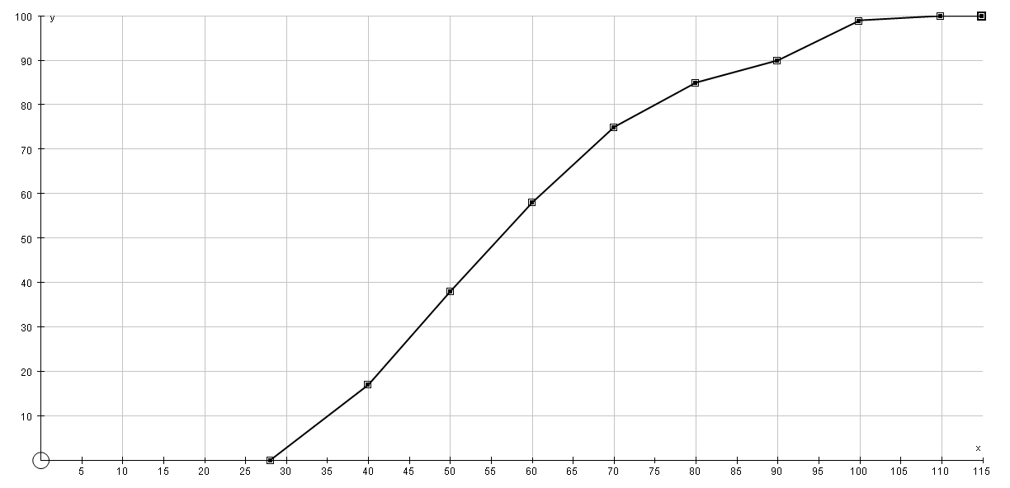

Percentage

Finishing time (min)

(a) Estimate in how many minutes a runner would have had to complete the race in order to be placed in the 20th percentile or better. (2)

(b) If a silver medal is awarded to all runners completing the race in under 40 minutes, assuming that the first ten runners are awarded gold medals, estimate the number of runners who would receive a silver medal. (3)

(c) Draw a box and whisker plot to summarize the data represented on the graph. (5)

The ogive has been reproduced on the diagram sheet.

__________________________________________________________________________________

**SECTION B**

**QUESTION 8 – 12 marks**

(a) The point B (4;3) is rotated about the origin through an anti-clockwise angle of 45˚.

 Determine the coordinates of $B^{'},$ without using a calculator, leave your answer in simplest surd form. (5)

(b) The point A (2;5) is rotated through an angle $α$ anti-clockwise about the origin and the image obtained is $A^{'}(-4,232; -3,330)$. Determine the size of α (7)

__________________________________________________________________________________

**QUESTION 9 – 14 marks**

Given that $σ=\sqrt{\frac{\sum{x^{2}}}{n}-{\overline{x}}^{ 2}}=\sqrt{\frac{\sum{{\left(x-\overline{x}\right)}^{2}}}{n}}$

The following table has some information about three data sets. Determine the missing information, round your answers correct to 3 decimal places in this question when necessary. (7x2)

|  |  |  |  |  |  |  |
| --- | --- | --- | --- | --- | --- | --- |
| Data set | n | $$\sum{x}$$ | $$\sum{x^{2}}$$ | $$\overline{x}$$ | $$σ$$ | $$\sum{{\left(x-\overline{x}\right)}^{2}}$$ |
| i | 63 | 7623 | 924 800 | (a) | (b) |  |
| ii | (c ) | 152,6 | (d) | 10,9 | 1,7 |  |
| iii | 52 | (e) | 57 300 | 33 | (f) | (g) |

_________________________________________________________________________________

**QUESTION 10 – 20 marks**

(a) If $cos35°=k,$ prove that $\sin^{2}70°=4k^{2}-4k^{4}.$ (5)

(b) Without using a calculator prove that $\frac{2cos^{2}40°-2sin^{2}40°}{8sin10°}=\frac{1}{4}$ (4)

(c) Prove the following identity:

$\cos\left(90°-a\right).cosb+cosa.\cos\left(90°-b\right)=sin⁡(a+b)$ (2)

(d) Find $θ∈[90°;360]$, without using a calculator if

$\cos\left(90°-θ\right).cos17°+cosθ.cos73°=\frac{\sqrt{3}}{2}$ (2)

(e) Solve for $θ$: $cos2θ+2sin2θ+2=0$ (7)

__________________________________________________________________________________

**QUESTION 11 – 8 marks**

Two circles $x^{2}+y^{2}-2x-2y=2 and x^{2}+y^{2}-8x-10y=k$, where k is a constant, are given. Determine the value(s) of k if the circles touch each other externally. (8)

__________________________________________________________________________________

**QUESTION 12 – 15 marks**

From point Y the angle of elevation to the top of the vertical tower RD is equal to α. $W\hat{R}Y=θ$.

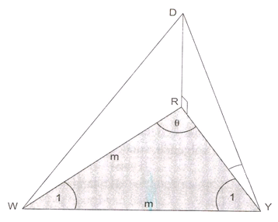The point W is in the same horizontal plane and equidistant from R and Y i.e. WR =WY = m units.

α

a) Express DR, the height of the tower, in terms of RY and α. (2)

b) Express the size of  in terms of θ. (2)

c) In $∆RWY,$, show that $RY=\frac{m.sin2θ}{sinθ}$. (3)

d) Prove that $RY=2m.cosθ$. (2)

e) Write the height of the tower, RD in terms of m, θ and α. (1)

f) If $θ=75°, α=30° and m=\sqrt{2} units$. Determine RD without using a calculator. (5)

__________________________________________________________________________________

**QUESTION 13 – 11 marks**

In the diagram below, ABC is a right-angled triangle. KC is the bisector of $A\hat{C}B$. AC = *r* units and $B\hat{C}K=x°$.

(a) Write down AB in terms of *x* and *r*. (2)

(b) Give the size of $A\hat{K}C$ in terms of *x*. (1)

(c) If it is given that $\frac{AK}{AB}=\frac{2}{3}$, calculate the value of *x*. (8)

**DIAGRAM SHEET NAME_____________________________________________________**



Finishing time in minutes

Percentage