

|  |  |
| --- | --- |
| **Advanced Programme Mathematics TRIALS**  **Paper 1 Algebra and Calculus** | |
| **FORM 5**  **12th September 2017** | |
| **TIME: 2 hours TOTAL: 200 marks** | |
| **Examiner: Mrs A Gunning** | **Moderated: Ms C Mundy** |
| **PLEASE READ THE FOLLOWING INSTRUCTIONS CAREFULLY BEFORE ANSWERING THE QUESTIONS.**   * This question paper consists of 8 pages, plus an Information Booklet. Please check that your question paper is complete. * Read and answer all questions carefully. * It is in your own interest to write legibly and to present your work neatly. * All necessary working which you have used in determining your answers **must** be clearly shown. * Approved non-programmable calculators may be used except where otherwise stated. Where necessary give answers correct to **1 decimal place** unless otherwise stated. * Ensure that your calculator is in **RADIAN** mode. * Diagrams have not necessarily been drawn to scale. | |

**Question 1**

Consider: $5^{n+1}+ 2^{n}$ is a multiple of 3, $n∈N$

Assuming that this statement is true for values of $n=1$ and $n=k$ where $∈N$,

prove it is true for the next natural number $n=k+1$. (8)

**[8]**

**Question 2**

Solve $f\left(x\right)=0$ where $x∈C$ if $x^{2}-10$ is a factor of

$f\left(x\right)= x^{4}+3x^{3}-20x^{2}-30x+100$ (8)

**[8]**

**Question 3**

Solve for $x$

1. $\frac{e^{x}}{e^{x}-1}$ $=10$ (5)
2. $\ln{{(e}^{3x-10})}=2x$ (4)
3. ${\left(\ln{x}\right)}^{2}= \ln{e^{3}+ \ln{x^{2}}}$ (11)

**[20]**

**Question 4**

If $\left(a+3i\right)\left(4-i\right)=11+bi$, find the values of $a$ and $b$ respectively. (7)

**[7]**

**Question 5**

Given $f\left(x\right)= x^{2}-3x$

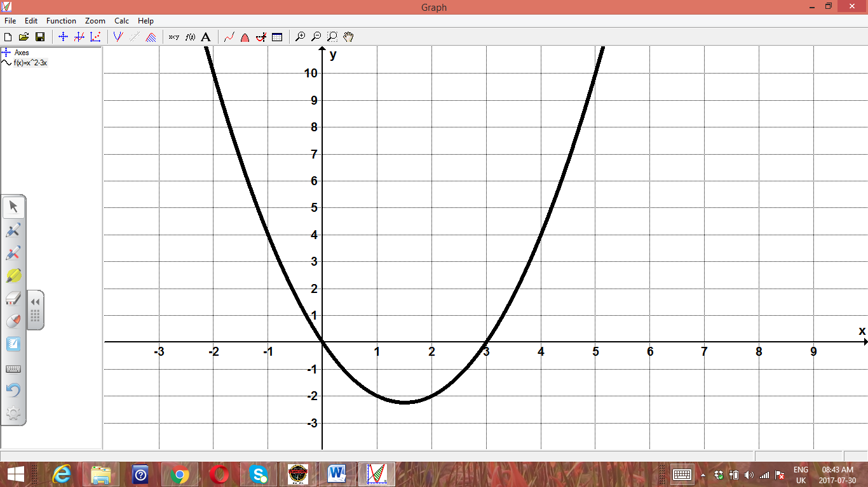

1. Calculate the area bounded by $f(x)$, the $x$ axis between the values $x=3$ and $x=4$ by using a Riemann Sum. (12)
2. On the relevant given set of axes, provided separately, sketch the following 2 graphs. Show clearly on both graphs, the coordinates of the turning points, salient points and endpoints. Intercepts on the X axis are NOT required.
   1. $g\left(x\right)= \left|x^{2}-3x\right|-1$ where $x∈[-2;5]$ (6)
   2. $h\left(x\right)= \left|x^{2}-3x-1 \right|$ where $x∈[-2;5]$ (4)

**[22]**

**Question 6**

Given $f\left(x\right)=$ $\frac{1}{(5-3x)}$

1. Write down the first, second and third derivatives of $f\left(x\right).$ (6)
2. Hence write down a general formula for the $n^{th}$ derivative of $f\left(x\right)$ where n is a natural number. (5)

**[11]**

**Question 7**

The following sketch shows the graph of $y=f'(x)$

The graph cuts the $x$ axis at $(-3;0)$ and $B(2;0)$ and has stationary points at $A(-1,33;18,52)$ and $B$.

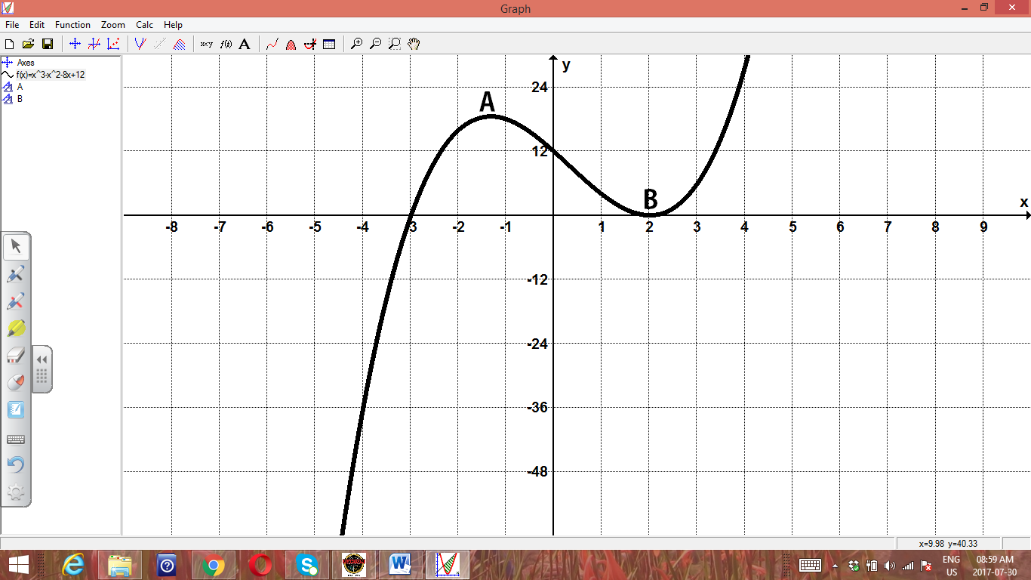

1. The graph of $f$ also has two stationary points. Write down the $x$ values of these points and state, with reasons, the nature of these points. (Remember, the given sketch represents $f'(x)$) (6)
2. Draw a rough graph of $f(x)$ on the given set of axes provided separately, if $f\left(x\right)$ passes through the origin. (6)

**[12]**

**Question 8**

Consider the sketch of $h\left(x\right)=$ $\frac{2x^{3}}{x^{2}-16}$

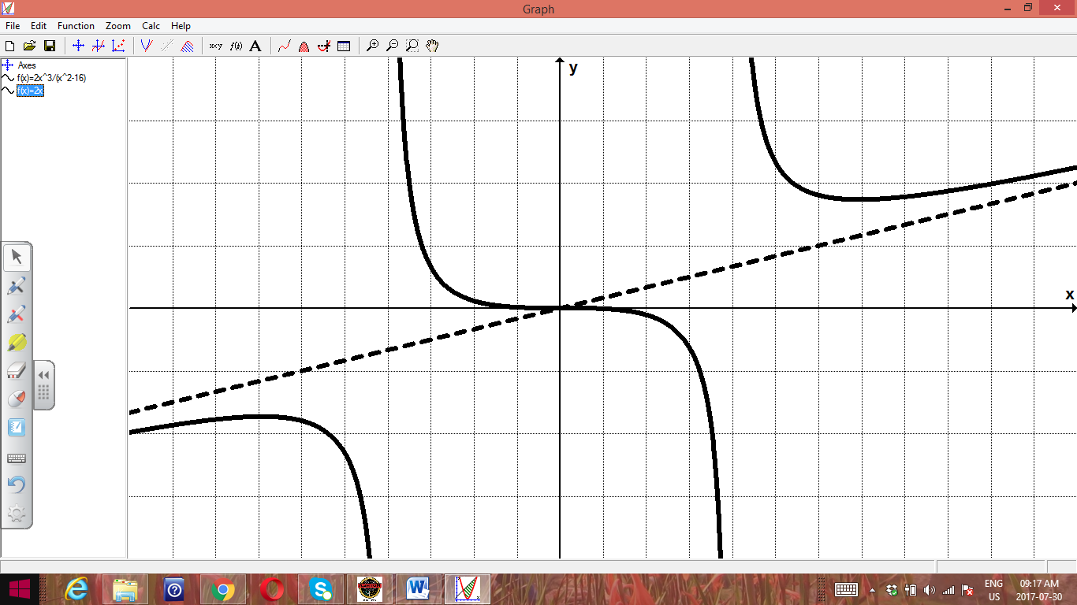

R

Q

P

From the sketch, and from the given function

1. Write down the domain of $h(x)$ (2)
2. What type of stationary point is
   1. Point P (1)
   2. Point Q (1)
   3. Point R (1)
3. Show all the relevant mathematical calculations in validating your answers in 7(b) and in deriving the coordinates of these three points. (12)
4. Determine the equations of all asymptotes. (Show relevant working detail.) (8)

**[25]**

**Question 9**

Below is the sketch of the graphs of $f\left(x\right)=x-20$ and $g\left(x\right)= {\left(\cos{x}-2\right)}^{3}$ for $x≥0$

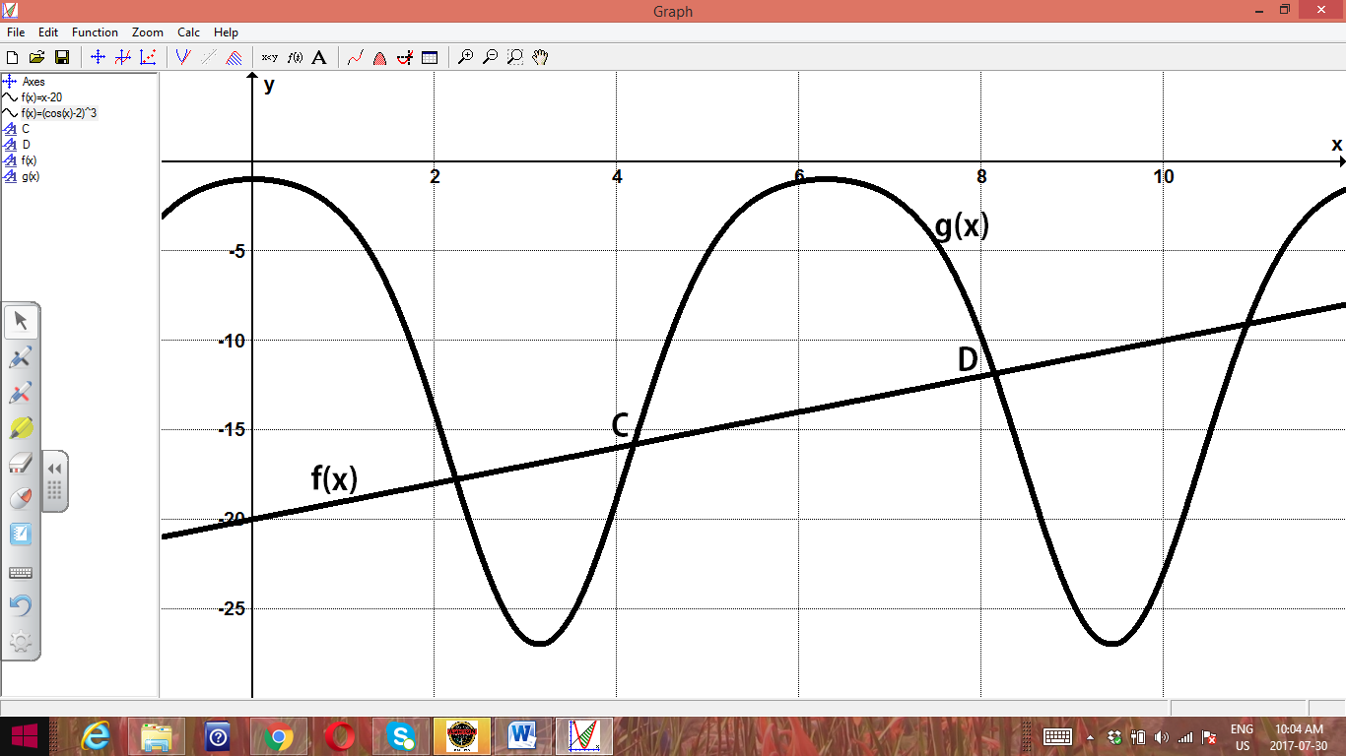

The points of intersection in the interval $x∈\left[4;9\right],$ namely C and D are indicated on the sketch.

Use the Newton-Raphson method to calculate the $x$ coordinate of the point D, correct to 4 decimal places. (12)

**[12]**

**Question 10**

Given the equation $x^{3}-xy^{2}+ y^{3}=7$

1. Show that the point $\left(2;1\right)$ lies on the curve. (2)
2. Determine an expression for $\frac{dy}{dx}$ (8)
3. Hence, determine the equation of the tangent to the curve at the point $(2;1)$. (5)

**[15]**

**Question 11**

Determine the following integrals, showing all calculations.

1. $\int{\left(3x^{2}-2\right)\sqrt{2x^{3}-4x+7} dx}$ (10)
2. $\int{x\cos{x dx}}$ (9)
3. $\int{2\sin{3x\cos{2x dx}} }$ (6)

**[25]**

**Question 12**

Draw a rough sketch of $y= x^{2}+5x-6$ and then calculate the following showing all relevant steps.

1.  $\left(x^{2}+5x-6\right)dx$ (8)
2. The area bounded by this curve and the $x$ axis for $x∈[-1;2]$. Clearly indicate the relevant area on your sketch. (6)

**[14]**

**Question 13**

Given $f\left(x\right)=x+4$ and $g\left(x\right)= x^{2}-2x$

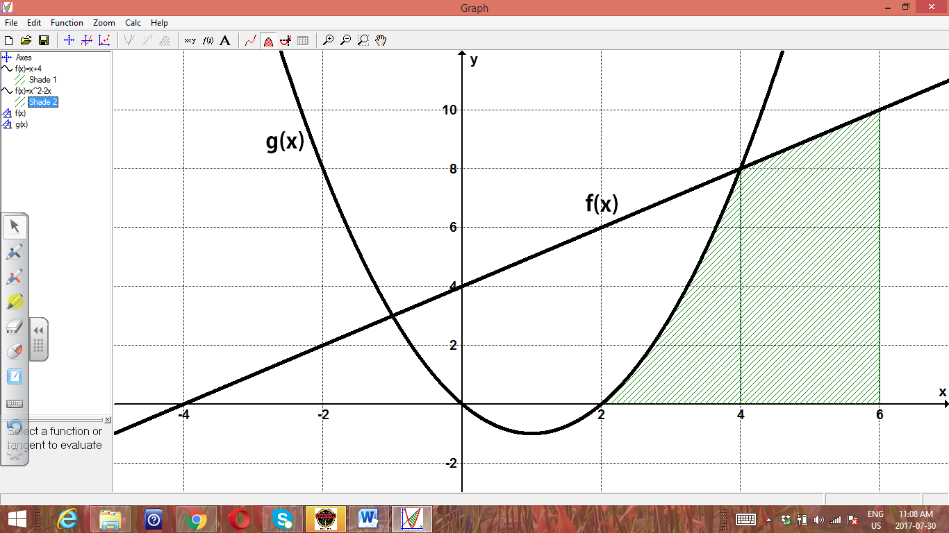

Determine the volume if the shaded region is rotated about the $x$ axis through $2π$ radians. (Show all relevant calculations. Hint: consider each graph separately.) (11)

**[11]**

**Question 14**

In the diagram PR is an arc of the circle with centre O, (ie RO=PO), radius $r$ cm and $P\hat{O}R= θ$ radians. (The diagram is not drawn to scale.)

The point Q lies on PO and RQ $⊥$ PO. (The answer for (b) to be given in simplest surd form.)

$$θ$$

**Q**

**r cm**

**O**

**R**

**P**

1. Show that the area of the shaded section PQR is given by

$A=$ $\frac{1}{2}$ $r^{2}(θ-\sin{θ\cos{θ) {cm}^{2}}}$ (6)

1. Hence determine the area of the striped section if $r=10 cm$ and $θ=$ $\frac{π}{3}$ radians (4)

**[10]**