

**GRADE 12 JUNE 2015**

**ADVANCED PROGRAMME MATHEMATICS**

**PAPER 1 ALGEBRA AND CALCULUS**

**2 HOURS 200 MARKS**

**INSTRUCTIONS:**

1. Answer all the questions.

2. This question paper consists of 11 questions and 4 information sheets.

3. Non-programmable and non-graphical calculators may be used.

4. All necessary calculations must be clearly shown and writing must be legible.

5. Where applicable calculations should be done using radians and

answers should be given in radians.

6. All answers should be given to 2 decimal places.

7. Pace yourself. Aim to answer 50 marks in 30 minutes.

**QUESTION 1**

1.1 Given $f\left(x\right)=\left|2x+1\right|$

(a) Solve for $x$ if $\left|2x+1\right|=3$ (4)

(b) Hence, solve for $x$ if ${\left(2x+1\right)}^{2}-$ $\left|2x+1\right|-6=0$ (6)

1.2 Solve for $x$, $x∈R$, in $\frac{8}{x+6}≤2$ (8)

1.3 Resolve the expression $\frac{x+4}{x^{3}-x^{2}}$ into its partial fractions. (10)

**[28]**

**QUESTION 2**

Prove by mathematical induction that $9^{n}-8n-1$ is divisible by $8$

for all natural values of $n,$ with $n>1.$**[14]**

**QUESTION 3**

3.1 Solve for $x:$

(a) $e^{2-x}=4$ (leave answer in terms of a natural log) (4)

(b) ${\left(\ln{x}\right)}^{2}=\ln\left(\frac{e^{2}}{x}\right)$ (leave answer in terms of $e$) (8)

3.2 Newton’s law of cooling for a liquid, in this case a cup of soup, is

given by the equation:

$T=T_{s}+\left(T_{0}-T_{s}\right)e^{-kt}$

where: $t$ is time in minutes

$k$ is a constant for the specific fluid

$T$ is the temperature in $℃$ at any given time $t$

$T_{0}$ is the initial temperature in $℃$ which is the

value of $T$ at $t=0$

$T_{s}$ is the surrounding temperature in $℃$

(a) Determine the temperature of the soup after 15 minutes

(from the beginning). Give the answer correct to the

nearest whole number. (3)

(b) Give the equation of the asymptote of the graph of $T.$ (2)

(c) Explain the meaning of this asymptote in real life terms. (2)

(d) A cup of soup cooled from $90℃$ to $60℃$ in $10$ minutes in

a room where the surrounding temperature was $20℃$.

Prove, by showing all working, that $k=-\frac{1}{10}\ln\left(\frac{4}{7}\right)$ (8)

**[27]**

**QUESTION 4**

4.1 Given $p\left(x\right)=2x^{3}+ax^{2}+bx-15$ with a zero at $x=2-i$.

Determine the values of $a$ and $b.$ (10)

4.2 For how many values of $n$ is $i^{3n+2}$ a real number if

$0≤n≤155$? Show all your working. (4)

4.3 The graph of the fourth-degree function $f\left(x\right)$ has been

sketched below. One of the roots is $2i$. Find a possible

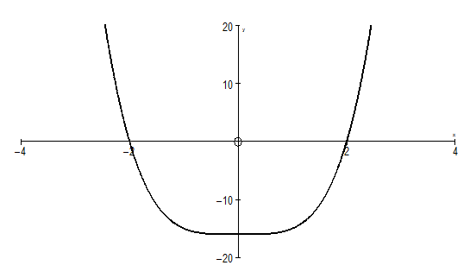equation for $f\left(x\right)$. (6)

**[20]**

**QUESTION 5**

A coin is designed by starting with an equilateral $∆ABC$ of side $2cm.$

With centre $A$, an arc of a circle is drawn joining $B$ and $C$. Similar arcs

with centres $B$ and $C$ join $C$ to $A$ and $A$ to $B$ respectively.

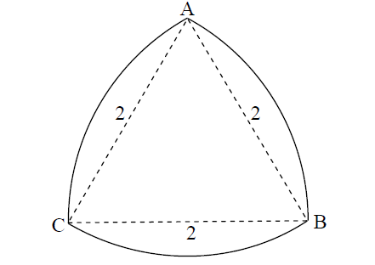

5.1 Find the perimeter of the coin. (4)

5.2 Find the area of the face of the coin. (8)

**[12]**

**QUESTION 6**

The graph of the function $g\left(x\right)=\left|x\right|ln\left(1-x\right), x<a,$ is shown below.

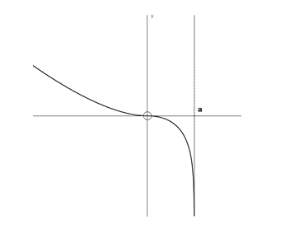

6.1 Write down the value of $a.$ (2)

6.2 Sketch the following graphs. You do not need to work out any

values – simply show how the shape changes.

(a) $y=\left|g\left(x\right)\right|$ (4)

(b) $y=g\left(\left|x\right|\right)$ (4)

**[10]**

**QUESTION 7**

7.1 $g\left(x\right)=\left\{\begin{matrix}\frac{\left(x-3\right)\left(x+1\right)}{x-3} & if & x<-1 \\ x^{2}+1 & if & x≥-1\end{matrix}\right.$

Determine, with algebraic motivation, whether $g$ is continuous at

the following points. State the type of discontinuity if applicable:

(a) $x=-1$ (6)

(b) $x=3$ (4)

7.2 Given $f\left(x\right)=\sqrt{x}$ and $g\left(x\right)=1-x^{2}$

Determine $fog$ together with its domain. (6)

**[16]**

**QUESTION 8**

The following sketch shows the graph of $y=f'\left(x\right)$. This graph cuts the

$x$-axis at $\left(3;0\right)$ and $B\left(0;0\right)$, and has stationary points at $B$ and $C\left(1;-4\right)$.

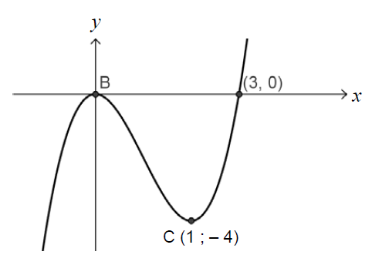

The graph of $f$ has two stationary points. Give the $x$ values of these points **and** state, with motivation, the nature of these points.

(Remember that the sketch represents $f'\left(x\right)$. ) **[6]**

**QUESTION 9**

9.1 If $f\left(x\right)=\frac{1}{1-2x}$, determine $f'\left(x\right)$ from first principles. (10)

9.2 Given $f\left(x\right)=x\sqrt{2x+3}$, determine $f'\left(x\right)$ (6)

9.3 Determine $D_{x}\left[\tan^{3}x\right]$ (3)

9.4 Determine $\frac{dy}{dx}$ if $y=\sin{y.\sin{x.}}$ (8)

**[27]**

**QUESTION 10**

Below is a sketch of the graphs of $f\left(x\right)=2\sqrt{x}\sin{x}$ and $g\left(x\right)=x$.

The graphs intersect in three places on the domain $x∈\left[0;3\right]$.

P is the point of intersection of $f$ and $g$ indicated on the graph.

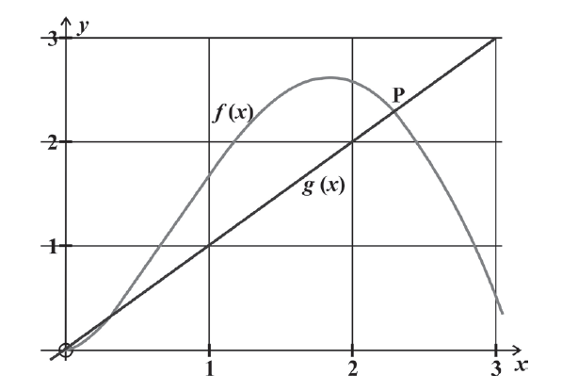

10.1 Find $f'\left(x\right)$. (6)

10.2 State the iterative formula you would use to solve $f\left(x\right)=g\left(x\right)$

using the Newton-Rhapson Method. (4)

10.3 Determine the $x$- coordinate of P, correct to **4** decimal places. (4)

**[14]**

**QUESTION 11**

Given that $h\left(x\right)=\frac{2x^{3}}{x^{2}-4}$

11.1 Determine the co-ordinates of all stationary points. (12)

11.2 Determine the equations of all asymptotes. (6)

11.3 Draw a neat sketch of $h\left(x\right)$, showing all asymptotes and

stationary points as well as the co-ordinates of the intercepts

with the axes. (8)

**[26]**

|  |
| --- |
| **TOTAL = 200 MARKS** |