

**GRADE 12 JUNE 2015**

**ADVANCED PROGRAMME MATHEMATICS**

**PAPER 2 MATRICES AND GRAPH THEORY**

**1 HOUR 100 MARKS**

**INSTRUCTIONS:**

1. Answer all the questions.

2. This question paper consists of 6 questions and 4 information

sheets.

3. Non-programmable and non-graphical calculators may be used.

4. All necessary calculations must be clearly shown and writing must be legible.

5. All answers should be given to 2 decimal places.

6. Pace yourself. Aim to answer 50 marks in 30 minutes.

**QUESTION 1**

Consider the matrices $L\left(\begin{matrix}4 & 4 \\ -6 & 2 \\ 12 & -2\end{matrix}\right)$, $M\left(\begin{matrix}0 & -6 \\ 8 & k\end{matrix}\right)$, $N\left(\begin{matrix}-12 & 6 \\ k & -2\end{matrix}\right)$

1.1 Explain why $L$ has no inverse. (2)

1.2 Calculate the value of $k$ so that $N$ has no inverse. (2)

1.3 Calculate the value of $k$ so that $M-2N=\frac{1}{2}\left(\begin{matrix}48 & -36 \\ 6 & 13\end{matrix}\right)$ (4)

1.4 Determine (if possible) the matrix product $LM$ where $k=4.$

If it is not possible, explain in words why this is so. (4)

1.5 $N$ (where $k=-3)$ is to be transformed by a shear of factor 1,

parallel to the $y$-axis, followed by a stretch of factor $-2$, also

parallel to the $y$-axis. Calculate the new co-ordinates of the

transformed matrix $N$. (8)

**[20]**

**QUESTION 2**

PENTA is a regular pentagon, formed by rotating point P(26,4 ; 19,1) about the origin.

The coordinates of two other vertices are also given: A(26,4 ; –19,1) and N(–32,6 ; 0).

*P(26,4 ; 19,1)*

*A(26,4 ; –19,1)*

*N(–32,6 ; 0)*

*E*

*T*

*O*

2.1 Explain why PÔE = 72o. (2)

2.2 Use a matrix equation to calculate the coordinates of E, correct

to the nearest integer. (6)

2.3 PENTA is already the image of another regular pentagon, after

an enlargement through the origin by a factor of 3. If PENTA

has an area of *k* square units, give the area of the original

figure in terms of *k*. (2)

2.4 Line segment PA is to be reflected about a line with equation

*y = mx*. The images of these respective points are then

$P'\left(31;-10\right)$ and $A'\left(19,2;26,3\right)$. Find the angle of inclination

of the line of reflection, correct to the nearest degree. (14)

**[24]**

**QUESTION 3**

Cramer’s Rule is often used to calculate the solutions to simultaneous equations.

Consider the simultaneous equations *ax + by + cz = p*

*dx + ey + fz = q*

*gx + hy + iz = r*

To solve for the variable *x*, set up the following fraction: $x=\frac{det\left(\begin{matrix}p & b & c \\ q & e & f \\ r & h & i\end{matrix}\right)}{det\left(\begin{matrix}a & b & c \\ d & e & f \\ g & h & i\end{matrix}\right)}$

Notice that the denominator of the fraction is the determinant of the matrix created from the coefficients of the three simultaneous equations.

Also notice that the numerator of the fraction is the same as the denominator, except that the *x*-column has been replaced by the answers to each of the three equations.

Similarly, to solve for the variable *y*, set up the fraction: $y=\frac{det\left(\begin{matrix}a & p & c \\ d & q & f \\ g & r & i\end{matrix}\right)}{det\left(\begin{matrix}a & b & c \\ d & e & f \\ g & h & i\end{matrix}\right)}$

Now answer the following questions with regards to the set of

simultaneous equations: *x + y – 2z = 0*

*x + y + 4z = –3*

*2x – y = –1*

3.1 Set up a fraction in the matrix form (as shown above) that will

give the solution for the variable *z* in this specific set of

equations. (Do NOT simplify or solve for *z*). (4)

3.2 Give the value of the denominator of the fraction, that is, the

value of the determinant of the matrix used to solve this set of simultaneous solutions. (2)

3.3 Now give the value of the numerator of the fraction used to

solve for z. (2)

3.4 Give the (simplified) answer for the variable *z*. (2)

**[10]**

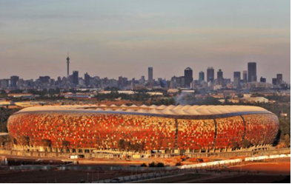**QUESTION 4**

The given adjacency

matrix represents

the distance in metres

between each of the

six security cameras

at Soccer City.

|  |  |  |  |  |  |  |
| --- | --- | --- | --- | --- | --- | --- |
|  | A | B | C | D | E | F |
| A |  | 60 | 100 | 110 | 80 | 70 |
| B | 60 |  | 70 | 80 | 90 | 85 |
| C | 100 | 70 |  | 50 | 65 | 105 |
| D | 110 | 80 | 50 |  | 60 | 40 |
| E | 80 | 90 | 65 | 60 |  | 40 |
| F | 70 | 85 | 105 | 40 | 40 |  |

4.1 A security guard needs to inspect each of the six cameras

within his shift. Using Kruskal’s Algorithm find a lower bound for

his route, initially leaving out vertex A. Clearly state the order in

which you choose edges. Also state the length of this lower

bound. (8)

4.2 The Hamiltonian Circuit A-B-C-D-E-F-A yields a route of 350

metres. By inspection determine a shorter route for the guard

to inspect each camera, starting and ending at camera A. (6)

**[14]**

**QUESTION 5**

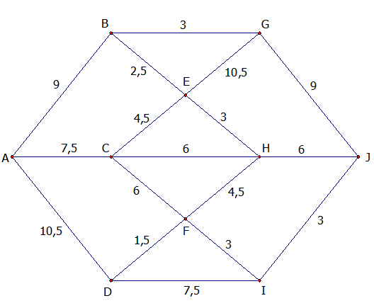The network below shows some paths on an estate. The weight of

each edge represents the time taken, in minutes, to walk along a path.



5.1 Use Dijkstra’s algorithm to find the minimum walking time

from A to J. You must show evidence that you have used

Dijkstra’s algorithm. (12)

5.2 Write down the corresponding route. (2)

5.3 A new subway is constructed, directly connecting C to G.

The time taken to walk along this subway is $x$ minutes. The

minimum time taken to walk from A to G is now reduced, but

the minimum time taken to walk from A to J is slightly longer**.**

Find the range of possible values for $x$. (8)

**[22]**

**QUESTION 6**

OCTAVE is an octahedron, with its corresponding graph drawn alongside it.

A

E

O

T

C

V

O

V

T

E

A

C

6.1 Does OCTAVE represent a regular graph? Give a reason for

your answer. (2)

6.2 Is it possible to construct an Eulerian Circuit in OCTAVE? Give

a reason for your answer. (2)

6.3 A graph is said to be “planar” if it can be drawn in a two

dimensional plane without any edge crossing any other edge. Redraw the graph of OCTAVE to demonstrate that it is indeed

planar. (6)

**[10]**

|  |
| --- |
| TOTAL MARKS = 100 |