

**GRADE 12 SEPTEMBER 2015**

**ADVANCED PROGRAMME MATHEMATICS**

**PAPER 1 ALGEBRA AND CALCULUS**

**2 HOURS 200 MARKS**

**INSTRUCTIONS:**

1. Answer all the questions.

2. This question paper consists of 12 questions and 4 information sheets and a diagram sheet for question 4.2 and 12.

3. Non-programmable and non-graphical calculators may be used.

4. All necessary calculations must be clearly shown and writing must be legible.

5. All answers should be given to 2 decimal places.

6. Pace yourself. Aim to answer 50 marks in 30 minutes.

**QUESTION 1**

Given the formula 

1.1 Determine the value of the first three terms of the series. (3)

1.2 Using Mathematical Induction, prove the formula true for all

natural values of *n*. (13)

**[16]**

**QUESTION 2**

2.1 Solve for $x ,$ where $\frac{3}{x-3}≥\frac{2}{x+2}$ (8)

2.2 Solve the equation $5×4^{x-1}=\frac{1}{3^{2x}}$, giving your answers in the

form $x=\frac{\ln{p}}{\ln{q}}$, where $p$ and $q$ are rational numbers. (6)

2.3 Solve for $x$: $2^{\left|\frac{2}{\log_{5}{x}}\right|}=16$ (8)

2.4 Decompose $\frac{x-10}{2x^{2}+5x-3}$ into its partial fractions. (6)

**[28]**

**QUESTION 3**

3.1 The polynomial $x^{3}+mx^{2}+nx-8$ is divisible by $\left(x+1+i\right).$

Find the value of $m$ and $n.$ (8)

3.2 Find the values of the two real numbers $x$ and $y$ such

that ${\left(x+iy\right)}^{2}=-8+6i$. (10)

**[18]**

**QUESTION 4**

4.1 The function of $f$ is represented by the graph below:

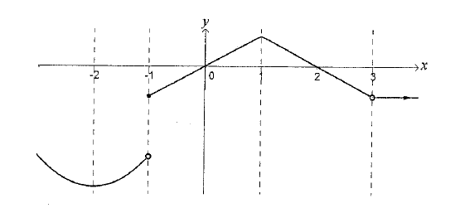

Give all the values of $x$ for which:

(a) the limit exists, but the function is not defined. (2)

(b) the left and right hand limits both exist, but they are

unequal. (2)

(c) $f$ is continuous but not differentiable. (2)

(d) $f^{'}\left(x\right)=0.$ (3)

(e) $f^{''}\left(x\right)>0.$ State reason. (3)

4.2 The diagram shows the graph of the function

$f\left(x\right)=\left\{\begin{matrix}px^{n}+q & if x<4; & n∈N \\ -x+4 & if x≥4 & \end{matrix}\right.$

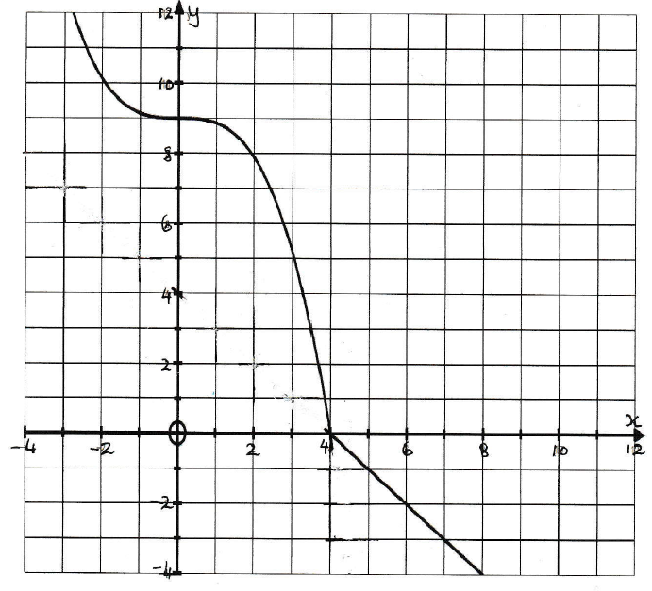

**Answer this question on the diagram sheet.**

Using the diagram and without solving for $p$ and $q,$ draw separate sketches on the set of axes provided, clearly showing all intercepts

with the axes, and asymptotes where applicable.

(a) $y=\left|f\left(x\right)\right|$ (3)

(b) The inverse function, $y=f^{-1}\left(x\right).$ (5)

**[20]**

**QUESTION 5**

5.1 Find the derivative of $\frac{\sin{2x}}{{\left(2-x\right)}^{3}}$. (Do not Simplify your answer.) (6)

5.2 Find the gradient of the tangent to the curve defined by the equation $xy+3x^{2}-x^{2}y^{2}=12$ at the point $\left(2;-1\right)$. (16)

5.3 If $y=\tan{x,}$

(a) determine $y''$ (4)

(b) prove that $y^{''}-2y=2y^{3}$ (5)

**[31]**

**QUESTION 6**

The diagram shows $∆ABC$ in which $AB=5cm, AC=BC=3cm.$

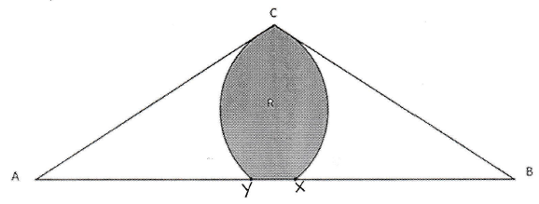The circle, centre $A,$ radius 3 $cm,$ cuts $AB$ at $X$; the circle, centre $B,$ radius 3 $cm$, cuts $AB$ at $Y.$

6.1 Determine the size of angle CAB, giving your answer in radians

to four decimal places. (4)

6.2 The region $R,$ shaded in the diagram, is bounded by the arcs

$CX, CY$ and the straight line $XY$. Calculate:

(a) the perimeter of the region $R$ (4)

(b) the area of sector $ACX$ (2)

(c) the area of the region $R$ (6)

**[16]**

**QUESTION 7**

It is required to solve : $\tan{x=1-x^{2}}$ using Newton’s method.

If $x_{1}=0,7$ is a reasonable first approximation, solve for the nearest

solution, correct to 5 decimal places. Show proof of iteration. **[8]**

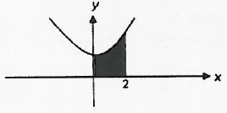

**QUESTION 8**

Use Riemann Sums to determine the

shaded area bounded by the curve

$y=2x^{2}+1$, the axes and the line $x=2.$

**[10]**

**QUESTION 9**

Determine the following integrals:

9.1 $\int{\left(\frac{1}{x^{2}}+x+1\right) dx}$ (4)

9.2 $\int{\cos{2θsin5θ dθ}}$ (6)

9.3 $\int{\sin^{2}x.cosx dx}$ (4)

9.4 $\int{\frac{5x}{\sqrt{2-x}} dx}$ (10)

**[24]**

**QUESTION 10**

Given the function $f\left(x\right)=\frac{2x^{2}-2x+5}{x+1}$

10.1 Determine the equation of the oblique asymptote of the

graph of $f.$ (6)

10.2 Does the oblique asymptote intersect the graph? Motivate

your answer. (3)

**[9]**

**QUESTION 11**

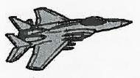The fuel tank on the wing of a jet is formed by

rotating the region bounded by

$y=\frac{1}{8}x^{2}\sqrt{2-x}$ about the $x$ axis between

$x=0$ and $x=2,$ where units are measured in

metres.

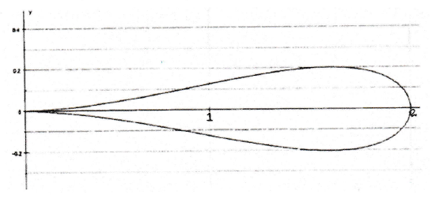

11.1 Write down the definite integral to calculate the volume of the

fuel tank. (4)

11.2 Show by calculation that the volume is $\frac{π}{30}$ cubic metres. (6)

**[10]**

**QUESTION 12**

There is a small amount of water currently in a W-shaped container

below . The container is a prism with W-cross section throughout.

A tap is turned on so that the water flows at a constant rate into the

left side of the container.

**Sketch a graph on the diagram sheet** of the height of the water, $h$,

as recorded on the metre –stick shown in the left side of the

container as a function of time, $t$. Clearly label your graph all the

salient points and added explanations where necessary.

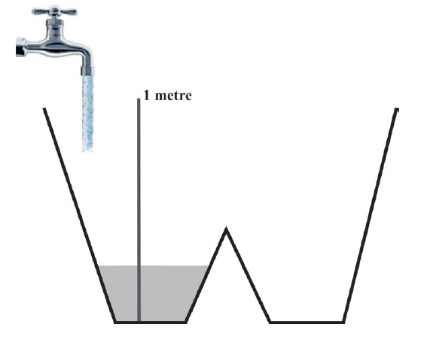

**[10]**

|  |
| --- |
| TOTAL MARKS = 200 |

**GRADE 12 APM P1 DIAGRAM SHEET NAME……………………..**

4.2 (a)



4.2 (b)

**GRADE 12 APM P1 DIAGRAM SHEET NAME……………………..**

12.

