

**GRADE 12 September 2015**

**ADVANCED PROGRAMME MATHEMATICS**

**PAPER 2 MATRICES AND GRAPH THEORY**

**1 HOUR 100 MARKS**

**INSTRUCTIONS:**

1. Answer all the questions.

2. This question paper consists of 7 questions and 4 information

sheets.

3. Non-programmable and non-graphical calculators may be used.

4. All necessary calculations must be clearly shown and writing must be legible.

5. All answers should be given to 2 decimal places.

6. Pace yourself. Aim to answer 50 marks in 30 minutes.

**QUESTION 1**

Consider the matrices $P=\left(\begin{matrix}4 & -1 & 0 \\ 2 & 2 & 1 \\ 6 & 2 & 3\end{matrix}\right)$ and $Q=\left(\begin{matrix}4 & 0 & a \\ -3 & b & 14 \\ -1 & 4 & c\end{matrix}\right)$

1.1 Write down the determinant of $P.$ (2)

1.2 Write down the transpose of $P.$ (2)

1.3 Calculate the values of $a, b$ and $c,$ if it is given that $Q$ is $P's$

matrix of minors. (6)

**[10]**

**QUESTION 2**

The trapezium T has vertices with co-ordinates $\left(1;1\right); \left(1;3\right); \left(4;3\right)$ and

$\left(3;1\right).$ Shapes A, B, C,D and E are images of T under different

transformations. These transformations are illustrated in the diagram below.

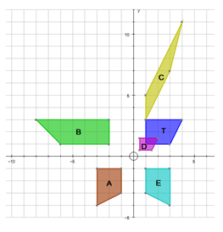

2.1 Describe in detail the following transformations in words:

(a) T $→$ E (3)

(b) T $→$ B (3)

2.2 Quote a single matrix that would effect the following

transformations:

(a) T $→$ D (2)

(b) T $→$ A (2)

(c) T $→$ C (4)

(d) D $→$ C (4)

**[18]**

**QUESTION 3**

The transformation matrix $T\left(\begin{matrix}1,8 & -2,4 \\ 2,4 & 1,8\end{matrix}\right)$ is given:

3.1 The co-ordinates of the endpoints of a line segment are $K\left(3;0\right)$

and $L\left(-2;5\right)$. Determine the co-ordinates of the endpoints if

the line segment is transformed by $T.$ State the matrix equation

used to find the answer, and leave your answer in matrix form. (6)

3.2 Determine $T^{-1}$, the inverse of $T.$ Give your answer in the form

$k\left(\begin{matrix}a & b \\ c & d\end{matrix}\right)$. (4)

3.3 The point $P'\left(15;-30\right)$ is the image of point $P$ after it has been

transformed by $T.$ Determine the co-ordinates of $P$ before it was

transformed by $T.$ State the matrix equation used to find the

answer, and leave your answer in point form. (4)

**[14]**

**QUESTION 4**

A fruit company makes three fruit juice blends daily. The company

daily purchases 800 units of apple juice , 650 units of orange juice

and 350 units of kiwi juice.

AppleOrange blends 2 units of apple juice with 2 units orange juice

per litre;

AppleKiwi blends 3 units of apple juice with 1 unit kiwi juice per litre;

OrangeKiwi blends 3 units orange juice with 1 unit kiwi juice per litre.

4.1 Set up a system of equations that models this situation. (6)

4.2 Use either Gaussian Reduction or a matrix equation to

determine how many litres of each blend the company should produce if it wishes to use up all supplies daily. (8)

**[14]**

**QUESTION 5**

A travel agent wants to promote eco-tourism in the Ellisras rural

community. The accompanying graph represents routes between

various game farms in the area, where the weight of the edges are

distances measured in kilometres.

The agent wants to scout out the area and so needs to drive along

all the roads, starting and ending at Ellisras. Due to the cost of petrol,

she wants to minimize the route she must travel.

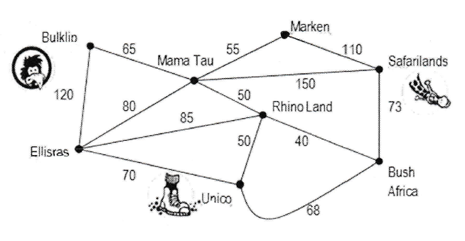

5.1 Which roads should she choose to drive twice in order to

minimize the whole route? (4)

5.2 State a possible Eulerian circuit for her to travel. Clearly state

the circuit, as well as the length of the entire route she travels. (8)

5.3 On a particular trip, she started running out of time and so

decided to leave out the road between Mama Tau and

Safarilands. If she still drove an Eulerian circuit for the

remainder of the trip, calculate the difference in distance she

travelled compared to Q 5.2 above. (4)

**[16]**

**QUESTION 6**

The matrix below gives the distance (in metres) between each of the

six security cameras in one of the 2010 World Cup stadiums.

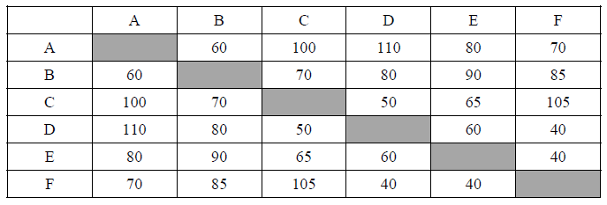

6.1 A minimum spanning tree of cabling needs to be laid between the

cameras. Starting at D, use Prim’s algorithm to construct a

minimum spanning tree. (8)

6.2 The surveillance team needs to check each of the cameras on a

hourly basis. Find an upper bound for the shortest route they can

if the security office is at A. (8)

**[16]**

**QUESTION 7**

In a **complete** graph every vertex is directly connected to every other

vertex. A complete graph is notated by $K_{n}$, where $n$ is the number of

vertices in the graph.

Some examples of complete graphs are given below:

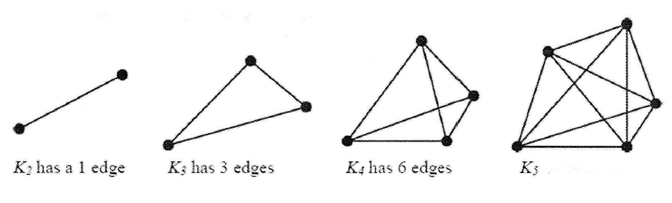

7.1 (a) Write down the total number of edges in the graph $K_{5}.$ (2)

(b) State the number of edges in a minimum spanning tree

for the graph $K_{5}$. (2)

(c) State the number of edges in a Hamiltonian circuit for the

graph $K_{5}$. (2)

7.2 A simple connected graph G has six vertices and nine edges,

and G is an Eulerian circuit. Draw a sketch to show a possible

graph of G. (6)

**[12]**

|  |
| --- |
| TOTAL = 44 MARKS GRAPH THEORY |