

**Matric**

**JuNE 2015**

**ADVANCED PROGRAMME MATHEMATICS**

**Time: 3 Hours Marks: 280**

**Reading Time: 10 Min Examiner: R Bourquin**

**Moderator: D Taylor**

___________________________________________________________________________

**PLEASE READ THESE INSTRUCTIONS CAREFULLY:**

1.The Habits of Mind that you should be making use of in this examination are:

Thinking flexibly, Applying past knowledge to new situations, Striving for Accuracy

and Precision and Managing Impulsivity.



2. This question paper consists of $9$ pages and an answer booklet of $5$ pages and an Information Sheet.

3. When sketching graphs intercepts, asymptotes, salient points, stationary points   
and points of inflection must be labelled.

4. ***Question 7 and Question 11(e) must be completed in your Answer Booklet.***

5.All the necessary working details must be clearly shown. Answers only will not   
necessarily be given full marks.

6. Approved non-programmable and non-graphical calculators may be used except where otherwise stated

7**.** Give answers correct to TWO decimal digits, where necessary.

9. Diagrams are not drawn to scale.

**10. Make sure that your calculator is in Radian Mode.**

**CALCULUS AND ALGEBRA**

**QUESTION 1**

(a) Given: $i^{2}=-1$ and $p=5-i$ and $q=4+i$

Determine $Im\left(\frac{p}{q^{*}}\right)$ (5)

(b) Given: $i^{2}=-1$

(1) Determine a cubic equation with roots $1+i$ and $3.$ (6)

(2) Hence give one example of a $4^{th}$ degree equation  
 with roots $1+i$ and $3$. (3)

**[14]**

**QUESTION 2**

Determine the following limits if they exist:

(a)  (4)

(b)  (4)

(c)  (4)

(d)  g (6)

**[18]**

**QUESTION 3**

(a) Given $f\left(x\right)=\sqrt{2x-1}$

Determine $f'(x)$ from first principles. (8)

(b) Find the derivative $\frac{dy}{dx}$ for $y=\sqrt{x+\sqrt{x}}$

Write your answer with positive exponents and in surd form. (8)

(c) Determine the equation of the tangent to the curve $xy^{2}+3x^{2}=xy+12$ at   
the point $(-2; 1)$. (11)

(d) Prove that $D_{x}(\sin{x. cos⁡(a-x))= cos⁡(a-2x)}$ (8)

**[35]**

**QUESTION 4**

Given: 

(a) Write $f(x)$ as a split function without the absolute value notation. (5)

(b) Hence, or otherwise, determine $f^{'}\left(x\right).$

State your solution as a split function. (3)

(c) Determine the value (if it exists) of $f'(4)$ and $f^{'}\left(0\right).$ (4)

(d) By using the limit definition discuss the continuity of $f$ at $x=1$. (6)

(e) Determine if $f$ is differentiable at $x=3.$ Justify your answer fully. (6)

**[24]**

**QUESTION 5**

Solve for $x∈R$, to 2 decimal digits:

(a) $-2\ln\left(x-4\right)=6$ (4)

(b) $2e^{-2x}-1=0$ (4)

(c) $\ln\left(x-5\right)+\ln\left(x+1\right)=ln⁡(x+9)$ (6)

(d) $\frac{e^{x}+1}{e^{x}-1}$ $=e^{x}$ (8)

**[22]**

**QUESTION 6**

Newton’s law of cooling for a liquid, in this case a cup of soup, is given by the equation:

$T=T_{S}+(T_{0}-T_{S})e^{-kt}$

where

$t$ is the time in minutes

$k$ is the constant for the specific fluid

$T$ is the temperature in $°C$ at any given time $t$

$T_{0}$ is the initial temperature in $°C$ (the value of $T$ at $t=0)$

$T_{s}$ is the surrounding temperature in $°C$

(a) A cup of soup was cooled from $90°C$ to $60°C$ in $10$ minutes in a room  
 where the temperature was $20°C.$

Show by solving for $k$ and showing all working,  
that $k=-$ $\frac{1}{10}$ $ln$ $\left(\frac{4}{7}\right)$ (8)

(b) Determine the temperature after $15$ minutes.  
 Give the answer correct to the nearest integer. (3)

(c) Give the equation of the asymptote of the graph of $T.$ (2)

(d) Explain the meaning of this asymptote in real life terms. (2)

**[15]**

**QUESTION 7**

**ANSWER THIS ENTIRE QUESTION IN YOUR ANSWER BOOKLET.**

(a) Sketch $f\left(x\right)=-\left|-e^{x}+4\right|$ on the axes provided. (5)

(b) $h\left(x\right)=\left|x-2\right|-6$

1. Determine the co-ordinates of the intercepts of $h.$ (4)
2. Determine the equation of each straight line branch of $h.$ (4)
3. Sketch $h\left(x\right)=\left|x-2\right|-6$ on the axes provided. (5)
4. Sketch $g\left(x\right)=-x-2$ on the axes provided. (2)

(5) Determine algebraically the co-ordinates of the point(s) of intersection   
 of $h$ and $g.$ (5)

(6) State the value(s) of $x$ for which $g\left(x\right)≥h\left(x\right).$ (2)

(c) (1) $f\left(x\right)=e^{x}$

State the equation of $f^{-1}(x)$. (2)

(2) $f^{-1}$ is then translated $2$ units to the left and $1$ unit down to form $p\left(x\right).$

State the equation of $p(x)$. (2)

(3) Sketch $p(x)$ on the axes provided. Give intercept(s) to 2 decimal digits if necessary. (4)

**[35]**

**QUESTION 8**

Prove, by the method of mathematical induction, that for all natural numbers $n,$



**[10]**

**QUESTION 9**

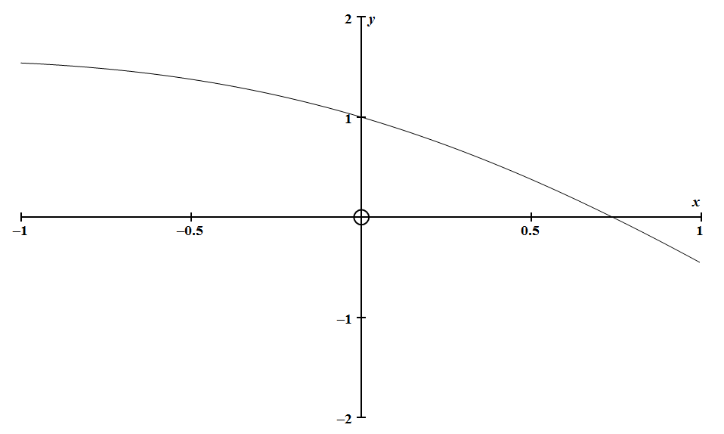

The function $f\left(x\right)=cosx-x$ for $x∈[-1;1]$ is drawn above

Use Newton’s method to determine the $x-$ intercept of $f$ for $x∈[-1;1]$.

Solve to $6$ decimal digits.

**[10]**

**QUESTION 10**

Given: $g\left(x\right)=$ $\frac{1}{2x^{2}}$

Determine the formula for $g^{n}(x)$. **[9]**

**QUESTION 11**

Given: $f\left(x\right)=$ $\frac{3x+3}{3x-x^{2}}$

(a) Determine the equation(s) of the asymptotes(s) of $f.$

Show all your working. (7)

(b) Determine the co-ordinates of the intercept(s) of $f$ if they exist. (2)

(c) Determine the co-ordinates of the stationary point(s) of $f$ if they exist. (11)

(d) Determine whether the gradient of $f$ is positive or negative for the   
 following intervals of $x:$  
  
 [NB: The gradient does not change within the given intervals.]



$x∈(-∞; -3)$

$x∈(-3; 0)$

$x∈(0; 1)$

$x∈(1; 3)$

$x∈(3; ∞)$

(7)

(e) **ANSWER QUESTION 11(e) IN YOUR ANSWER BOOKLET**

Sketch a fully labelled diagram of $f$ on the axes provided in   
your **Answer Booklet.** (8)

**[35]**

**QUESTION 12**

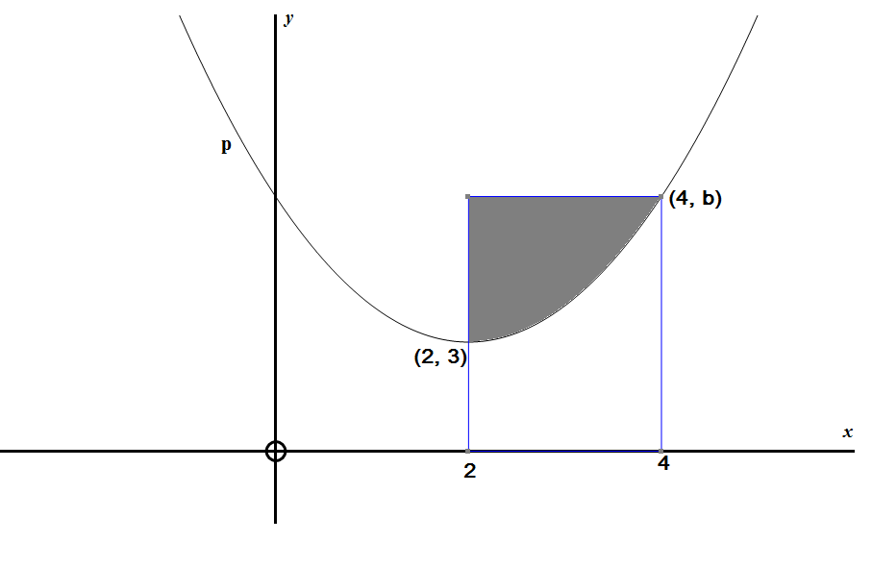(a)

er

The function $p\left(x\right)=x^{2}-4x+7$ is drawn above. This diagram is not to scale.

$(4;b)$ and $(2; 3)$ are points on $p.$

1. Determine the value of $b.$ (1)
2. Calculate the area of the shaded region above. (7)

(b) Determine the following integrals:

(1) $\int{\left(\frac{-5}{\sqrt{-4x+3}}\right)}$ $dx$ (5)

(2) $\int{2sin4xcos5x dx}$ (6)

(3) $\int{sec^{4}}x.sinx dx$ (7)

**[26]**

**QUESTION 13**

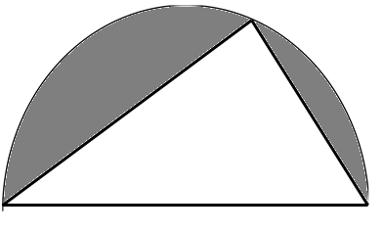

C

B

D

O

$$θ$$

$$90°$$

In the diagram above:

* $DCB$ is a semicircle, centre O
* $r$ is the radius of the semicircle.
* $r$ is a fixed constant
$D\hat{B}C=θ$

* $θ$ is not fixed. i.e $θ$ is a variable.
* $D\hat{C}B=90°$ (Angles in a semi-circle)

(a) Show that the area of the shaded region is given by $A=r^{2}\left(\frac{π}{2}-sin2θ\right)$. (9)

(b) Determine the value of $θ$ which will minimize the area of the shaded region. (6)

(c) Determine the minimum area of the shaded region in terms of $r.$ (3)

(d) Use the second derivative test to show that the value of $θ$ you determined in (b)  
 does in fact minimize the area of the shaded region. (5)

(e) Determine the value of $θ$ which maximizes the shaded area.  
 Hence determine the maximum area of the shaded region. (4)

**[27]**

**Total: 280 Marks**