

**ADVANCED PROGRAMME MATHEMATICS**

**PAPER 1**

**CALCULUS AND ALGEBRA**

**PRELIMINARY EXAMINATION**

**SEPTEMBER 2015**

Time: 2 HOURS 30 MINUTES Marks: 230

Reading Time: 10 MINUTES

Examiner: R Bourquin

Moderator: D Taylor

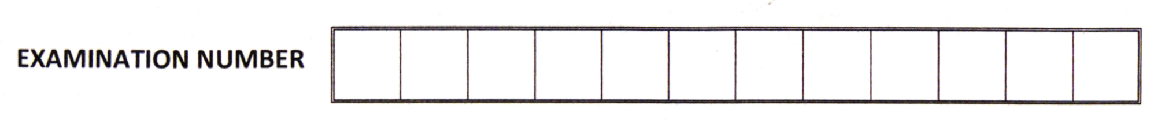

**READ THE FOLLOWING INSTRUCTIONS CAREFULLY**

1.The Habits of Mind that you should be making use of in this examination are:

Thinking flexibly, Applying past knowledge to new situations, Striving for Accuracy

and Precision and Managing Impulsivity.

2. This question paper consists of $7$ pages, an Answer Sheet and an Information Sheet.

3. When sketching graphs, all intercepts, asymptotes, salient points, stationary points   
and points of inflection must be labeled.

4. ***Question 2.4 and Question 6.4 must be completed on your Answer Sheet.***

5.All the necessary working details must be clearly shown. Answers only will not   
necessarily be given full marks.

6. Approved non-programmable and non-graphical calculators may be used except where otherwise stated.

7**.** Give answers correct to TWO decimal digits, where necessary.

8. Diagrams are not drawn to scale.

**9. Make sure that your calculator is in Radian Mode.**

**MODULE 1 CALCULUS AND ALGEBRA**

**QUESTION 1**

The following result is on your data sheet:  .

Prove using Mathematical Induction that the statement is true for all natural numbers $n$.

**[12]**

**QUESTION 2**

2.1 Given: $\ln{a}=3$

Express $\ln{x^{3}}+6\log_{a}{x}$ as a single logarithm. (5)

2.2 Given $2e^{x}-1=e^{-x}$, solve for $x$ (5)

2.3 The radioactive mass, $M$ grams in a lump of material is given by $M=25e^{-0,0012t}$  
 where $t$ is the time in ***seconds*** since the first observation.

1. Determine the initial size of the mass. (1)
2. Determine the mass after $1$ **hour.** (3)
3. The half-life of a radioactive substance is the time it takes to decay to  
    to half of its mass.  
    Determine the half-life of this material. (4)
4. Determine the equation of the horizontal asymptote of this function. (2)

2.4 Draw the graph of $y=\ln\left(x+1\right)-2$ on your Answer Sheet.

Clearly label all intercepts with the axes as well as all asymptote(s). (5)

**[25]**

**QUESTION 3**

3.1 Solve for $x$ if: $3\left|x\right|+{2x}^{2}-2=0$ (7)

3.2 Given that: $2-$ $\frac{\left|x+1\right|}{2}$ $≥0$ and $\frac{2x+1}{x-1}$ $≥1$

Determine the values of $x$ for which both of the above inequalities are satisfied. (13)

**[20]**

**QUESTION 4**

4.1 Given: $i^{2}=-1$

Two roots of the quartic equation (degree 4) are $x=5-2i$ and $x=2+\sqrt{3}$.  
Determine the equation if it is further given that the equation has a constant   
term of $58.$ (10)

4.2 Given: $i^{2}=-1$

Express $\frac{3+2i}{5-i}$ $+ i^{13}$ as a complex number in standard form ( $a+bi)$. Show all working. (9)

**[19]**

**QUESTION 5**

Given: 

5.1 Discuss the continuity of *f* at *x* = 0. Justify your answer fully. (8)

5.2 Discuss the differentiability of *f*  at *x* = 0. Justify your answer fully. (8)

**[16]**

**QUESTION 6**

Given: $f\left(x\right)=$ $\frac{x^{2}-1}{x-3}$

6.1 Determine the equation of each asymptote of function $f$. (6)

6.2 Determine the coordinates of any turning points of the function $f$ (correct to  
 2 decimal places) and by means of calculation determine whether they are local   
 maxima or local minima. (12)

6.3 Determine the $x$ and $y-$ intercepts of the function $f.$ (4)

6.4 Sketch a fully labelled diagram of the graph of $f(x)$ on the axes provided   
on the Answer Sheet. (8)

**[30]**

**QUESTION 7**

Determine, showing all working, the following limits if they exist:

7.1  (5)

7.2  (5)

**[10]**

**QUESTION 8**

The graph below shows the continuous function $f\left(x\right)=1-x+cos^{2}x$ for $x∈\left[0;4\right]$

$A$ is the $x-$ intercept of $f.$

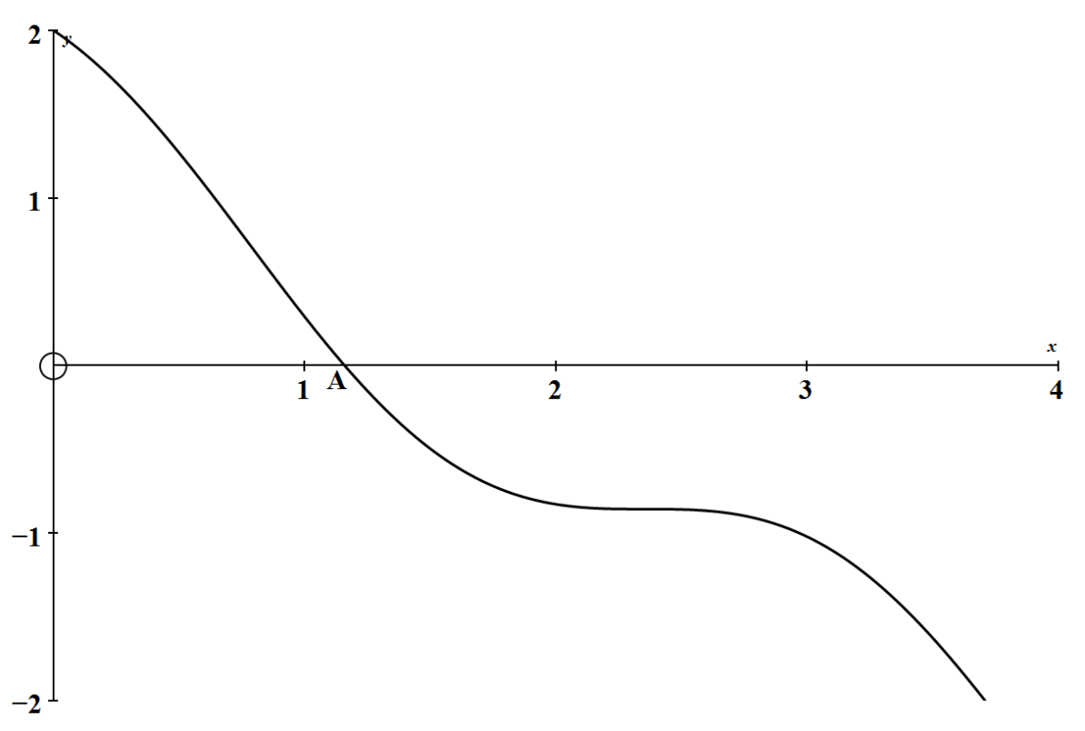

8.1 Show algebraically that  has an $x-$ intercept between $x=1$ and $x=2$ (4)

8.2 Using Newton’s method determine the $x$ value of A correct to four   
 decimal digits. (8)

**[12]**

**QUESTION 9**

The equation of a curve is $x^{3}+y^{3}=9xy$

9.1 Show that $\frac{dy}{dx}$ = $\frac{3y-x^{2}}{y^{2}-3x}$ (10)

9.2 Find the equation of the tangent to the curve at the point $(2;4)$ giving  
 your answer in the form $ax+by=c$ (6)

**[16]**

**QUESTION 10**

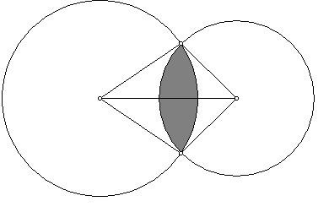

A

B

C

D

4

5

Refer to the figure above:

Circles centre C (with radius 4 cm) and D ( with radius 5 cm) intersect at

A and B. **CD = 7 cm.**

e

(1) Show that (in radians)  and 

(correct to two decimal digits). (10)

(2) Find the area of the shaded region. (8)

**[18]**

**QUESTION 11**

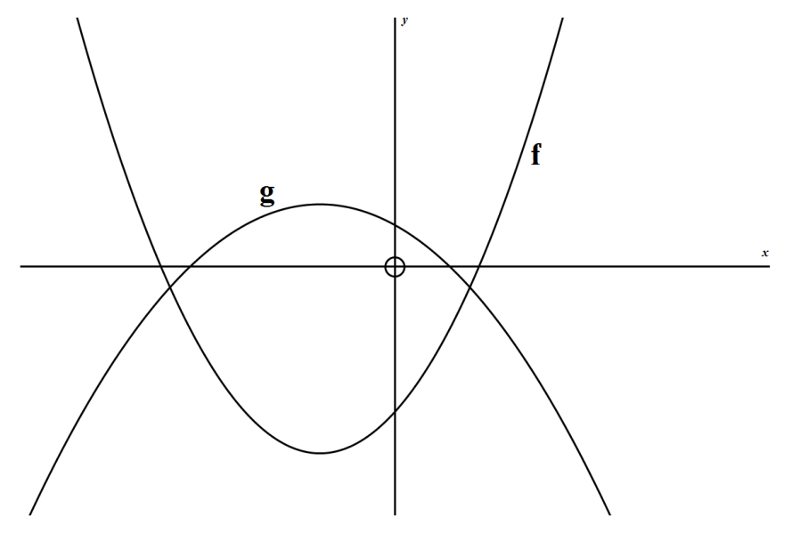

11.1 The curves of $f\left(x\right)=2x^{2}+4x-7$ and $g\left(x\right)=-x^{2}-2x+2$

are sketched above.

Determine the area bounded between $f$ and $g$. (8)

11.2 Determine the volume generated when the area between the $x-$ axis, the lines $x=2$ 
 and $x=4$ and the function $y=x^{2}+x$ is rotated about the $x-$ axis. (5)

**[13]**

**QUESTION 12**

Determine the following integrals leaving your answers with positive exponents:

|  |  |  |
| --- | --- | --- |
| 12.1 | $$\int{\frac{1}{(3x-2)^{2}}} dx$$ | (5) |
| 12.2 | $$\int{\sqrt{x}.\sqrt{1+x^{\frac{3}{2}} }} dx$$ | (6) |
| 12.3 | $$\int{\left(2x+1\right)\sin{3x} dx}$$ | (8) |

12.4  (7)  **[26]**



**QUESTION 13**

In the adjacent diagram:

Particle P moves in a circular trajectory,   
anti-clockwise, with a radius of 2 units.  
Particle P started moving at A.

13.1 Give the distance travelled by the particle when it reaches P in terms of $θ$. (2)

13.2 The speed of the particle as a function of the angle $θ$ can be   
 obtained by $v\left(θ\right)=\frac{θ}{θ^{2}+1}$

1. Calculate the value of $θ$ for which the speed will be a maximum. (9)
2. Calculate how far the particle has travelled when it reaches its  
    maximum speed. (2)

**[13]**

**Total for Module 1: 230 Marks**