

|  |  |
| --- | --- |
| **Advanced Programme Mathematics TRIALS**  **Paper 1 Algebra and Calculus** | |
| **FORM 5**  **7th September 2018** | |
| **TIME: 2 hours TOTAL: 200 marks** | |
| **Examiner: Mrs A Gunning** | **Moderated: Ms M Eastes** |
| **PLEASE READ THE FOLLOWING INSTRUCTIONS CAREFULLY BEFORE ANSWERING THE QUESTIONS.**   * This question paper consists of 8 pages. Please check that your question paper is complete. Please make sure you have also been given an Information Booklet. * Read and answer all questions carefully. * It is in your own interest to write legibly and to present your work neatly. * All necessary working which you have used in determining your answers **must** be clearly shown. * Approved non-programmable calculators may be used except where otherwise stated. Where necessary give answers correct to **1 decimal place** unless stated otherwise. * Ensure that your calculator is in **RADIAN** mode. * Diagrams have not necessarily been drawn to scale. | |

**QUESTION 1**

* 1. Given:  and 

1. If  (referred to as the complex conjugate of *x*), express  in the form . (5)
2. Determine the value of *k* for which  is purely non-real. (2)
3. You are given $f\left(x\right)= x^{4} -2x^{3} -4x^{2}+6x+3$ and that $1+\sqrt{2}$ is a zero of $f(x)$.
   1. Use this information to write  as the product of 2 quadratic factors. (5)
   2. Hence determine the root(s) of $f(x)$ given that $x ϵ C$. (3)
4. Decompose $\frac{5x-4}{(x+1)(x-2)^{2}}$ into partial fractions. (6)

**[21]**

**QUESTION 2**

In using the induction method to prove the correctness of a statement, you assume the statement is true for $n=k$.

Assuming $2^{k}+2^{k+1}+ 2^{k+2}$ is divisible by 7, prove that it will be true for the next natural number $n=k+1$. (5)

**[5]**

**QUESTION 3**

* 1. Solve for *x* rounded off to two decimal places where appropriate. Show all relevant working details.
  2.  (6)
  3. $2e^{x}-1= e^{-x}$ (5)
  4. $f\left(x\right)= e^{2x}-9$ and $g\left(x\right)=\ln\left(x-1\right) for x>1$

Solve for if (8)

* 1. Consider the curve defined by $y=\ln\left(x+2\right)-1$

1. Determine the coordinates of the intercepts with the axes rounded off to one decimal place where necessary. (4)
2. Write down the equation of any asymptotes. (1)
3. Hence sketch the graph $y=\ln\left(x+2\right)-1$ on the given set of axes on the inside front cover of your answer book. (3)

**[27]**

**QUESTION 4**

* 1. Draw separate quick sketch graphs of each of the following five functions.

1. a function *f* such that *f* is continuous but not differentiable at .
2. a function *g* such that  exists, but *g* is not continuous at .
3. a function *h* such that  does not exist.
4. a function *k* such that .
5. a function *p* such that . (10)
   1. Consider the function
$$f\left(x\right)= \left\{\begin{aligned}x^{2}+2, x≤2 \\ ax-4, x>2\end{aligned}\right.$$

6. Determine the value of $a$ if the function is continuous at $x=2$. (3)
7. Using your value of $a$ from $(i)$ determine whether or not the function is differentiable at $x=2$. (4)
   1. Evaluate the following without using a calculator:
8.  (4)
9.  (6)

**[27]**

**QUESTION 5**

1. The functions $f$ is defined for  as follows:

$f\left(x\right)$ $=\frac{2}{3x-2}$; determine:

1. $f^{'}(x)$ (1)
2. $f^{''}(x)$ (1)
3. $f^{'''}(x)$ (1)
4. a formula for $f^{n}(x)$, the $n^{th}$ derivative of $f(x)$. (5)
   1. Determine the gradient of the function  at any point by using first principles. (7)
5. Determine the equation of the tangent to the curve $xy^{3}+3x^{2}=xy+12$ at the

point  (9)

**[24]**

**QUESTION 6**

* 1. Consider $xsin x= -1$

1. Show that $xsin x= -1$ has a zero (x intercept) in the interval $x∈\left[-4; -3\right]$ (2)
2. Using the Newton Raphson method, calculate this solution, correct to 5 decimal places. (5)
   1. Given $f\left(x\right)=\cos{x\sin{2x}}$ for the interval $x∈[0 ;2π]$
3. Show that $f^{'}\left(x\right)=2\cos{x\left(1-3\sin^{2}x\right)}.$ (6)
4. Find the $x$ coordinates of the stationary points of the curve in the interval $x∈\left[0 ;2π\right].$ (3)

**[16]**

**QUESTION 7**

* 1. Determine the following integrals, showing all relevant working.

1.  (8)
2. $\int{\cos{5x\cos{8x dx}}}$ (5)
3.  (6)
   1. A curve is such that $\frac{dy}{dx}= \frac{4}{\sqrt{6-2x}}$ and $P(1;8)$ is a point on the curve. Find the equation of the curve. (6)
   2. 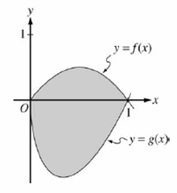Let *f* and *g* be the functions given by and  for . The graphs of these functions are shown in the figure below.

Find the area of the shaded region enclosed by the graphs of *f* and *g*. (8)

* 1. Determine, without using a calculator, the volume of the solid generated if part of the curve of  between  is rotated around the *x*-axis. (6)

**[39]**

**QUESTION 8**

The sketch given below represents 



A

B

*x*

*y*

* 1. Calculate the coordinates of A and B, the local maximum and minimum of *h*(*x*). (7)
  2. Determine the equation of the three asymptotes. (5)
  3. From the graph, find the value(s) of *x* if

 is real. (3)

* 1. Sketch , on the diagram printed on the inside back cover of the answer booklet. Show clearly the asymptotes. (5)

**[20]**

**QUESTION 9**

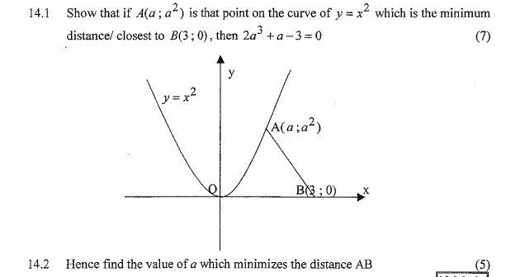

1. Show that, if $A(a; a^{2})$ is a point on the curve of $y= x^{2}$ such that it is the closest point on the curve to $B(3;0)$, ie the distance AB is a minimum,

then $2a^{3}+a-3=0$. (8)

1. Hence find the value of $a$ which minimises the distance $AB.$ (2)

**[10]**

**QUESTION 10**

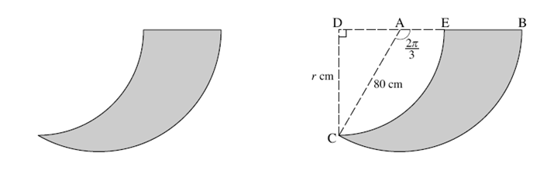

The diagrams above show the cross-section of a rudder of a boat, which is used in steering the boat.

CE is an arc of the circle with **centre D** and BC is an arc of the circle with **centre A**.

 and AC = 80 cm ; DC = r cm.

1. Calculate the area of sector ABC (leaving your answer **in terms of π**). (2)
2. Show that r =  (3)
3. Find the area of the cross-section (the grey area) of the rudder to **1 dp**. (6)

**[11]**