

|  |  |
| --- | --- |
| **Advanced Programme Mathematics TRIALS**  **Paper 2 Finance and Modelling** | |
| **FORM 5**  **August/September 2018** | |
| **TIME: 1 hour TOTAL: 100 marks** | |
| **Examiner: Mrs A Gunning** | **Moderated: Ms M Eastes** |
| **PLEASE READ THE FOLLOWING INSTRUCTIONS CAREFULLY BEFORE ANSWERING THE QUESTIONS.**   * This question paper consists of 6 pages, plus an Information Booklet. Please check that your question paper is complete. * Read and answer all questions carefully. * It is in your own interest to write legibly and to present your work neatly. * All necessary working which you have used in determining your answers **must** be clearly shown. * Approved non-programmable calculators may be used except where otherwise stated. * Where necessary give answers correct to **1 decimal place** unless otherwise stated. * Diagrams have not necessarily been drawn to scale. | |

**QUESTION 1**

The sequence 8 ; 6 ; *b* ; – 66 ; –142 is generated by the formula



Determine the possible values of *a* and *b.* (7)

**QUESTION 2**



Sam takes out a loan, P, with the intention of paying it back with monthly instalments over a period of 25 years. The continuous curve PQRS represents Sam’s Outstanding Balance over the 25 year period. The ideal curve of Outstanding Balance is given as the dotted line PS.

With reference to the time periods labelled A, B, C and D, interpret the shape of the curve and suggest possible reasons why Sam’s curve of Outstanding Balance did not follow the recommended path. (8)

**OR**

John opens a savings account and deposits R5 000 into the account immediately. Five months later he invests a further Rx into the account. The interest rate for the first four months is 18% per annum compounded monthly, 21% per annum compounded monthly for the next two months and 24% p.a. compounded monthly thereafter. The investment has a future value of R100 000 at the end of the 8 month. Calculate the value of $x$ [9]

**QUESTION 3**

How many years (to the nearest completed year) will it take to save $R 1,5$ million at $R 14 000$ monthly if the interest rate stays constant at $8,5 \%$ per annum compounded quarterly? The payments are made at the end of each month and with the first payment being made immediately. (8)

**QUESTION 4**

Kevin secures a 20-year home loan of R 1 250 000. The interest rate quoted by the bank is15% per annum to be compounded monthly.

1. Calculate his initial monthly payment. (5)
2. Calculate the balance outstanding after his 12th payment. (5)
3. How much interest was paid to the bank at this stage? (4)
4. He finds himself in financial difficulty and misses the 13th, 14th and   
   15th payments. The bank agrees to change his monthly payments from   
   the 16th month to accommodate these missed payments. They also reduced the interest rate from the beginning of the second year by 1%. It remains fixed for the remainder of the loan period. What will his revised monthly premium be from the 16th payment onwards? (5)

**QUESTION 5**

The following facts are known about servals in a game reserve:

* They have 2 litters per year.
* The average litter size is 3 kittens.
* The survival rate of serval kittens is 70%.
* 55 % of the serval population is female.
* The life expectancy of a serval is 7 years.

1. Calculate the annual growth rate of the serval population correct to 4 decimal digits. (5)
2. Express the growth rate of the serval population as a recursive formula, using an annual growth rate of serval per annum of 2,17%. (2)
3. Calculate, to the nearest integer, the serval population in 7 years’ time if there are currently 15 serval living in the reserve. (2)

OR

A farmer decides to use Cane Toads to control the population of insects, such as the Grey-Backed beetle, which is threatening his sugar cane production. He plans to start with a group of 20 toads. Cane Toads have an intrinsic growth rate of 80% per week.

1. Set up an equation using a Malthusian model and then calculate the population size of these Cane Toads at the end of each week for the first 8 weeks of growth. (5)
2. Express the growth of this toad population as an explicit formula.  
    Hence determine the size of the toad population after 22 weeks. (3)
3. Do you think the Malthusian model of growth you generated would realistically describe the growth of this toad population. Justify your answer. (2)
4. Suppose that the farmer decides that he should maintain a population of about 1000 of these toads by removing a certain number of toads each week. Determine how many toads he should remove per week. (3)

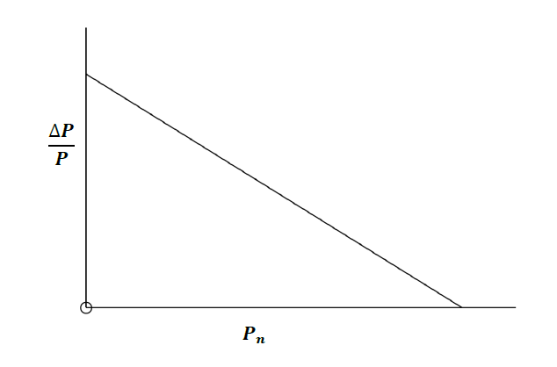

In a logistic model of population growth, a graph of the growth rate of a population ($\frac{∆P}{P}$) is plotted against population (𝑃𝑛). This graph is illustrated above. It is not drawn to scale.

The equation of the straight line above is $y=-0,0002x+0,0213$

Determine:

1. The intrinsic growth rate of the population. (1)
2. The carrying capacity. (2)
3. The growth rate of the population when the population is 32. (2)
4. 𝑃8 given 𝑃0=21 (4)

The population of an ant colony is modelled by using the Logistic model given below:

$$P_{n+1}=P_{n}+r×P_{n}\left(1-\frac{P_{n}}{2 500}\right)$$

Where $n$ is in days and $P_{0}=250$ and $P_{1}=375$.

1. What is the limit of the number of ants in the colony? (2)
2. Determine the value of $r$ correct to 2 decimal places. (3)

[5]

Predator – Prey Population Model Formula:

$R_{n+1}=R_{n}+aR_{n}\left(1-\frac{R_{n}}{K}\right)-b.R_{n}.F_{n}$

$F_{n+1}=F_{n}+f.b.R_{n}.F_{n}-c.F_{n}$

(a) Refer to the formulae above:

1. What does $K$ represent? (1)
2. What does $b$ represent? (1)
3. What does $f$ represent? (1)
4. What does $c.F_{n}$ represent in the predator equation? (1)
5. State a formula for the **growth rate** of the prey population in the absence of predators. (2)

The formulae governing the number of rabbits and foxes in a Predator-Prey model is given as:

$$R_{n+1}=R_{n}+a×R_{n}\left(1-\frac{R_{n}}{K}\right)-b×R_{n}×F_{n}$$

$$F_{n+1}=F_{n}+f×b×R_{n}×F_{n}-c×F_{n}$$

Calculate the equilibrium point for the above model given the following parameters: $a=0,64 b=0,008 c=0,048 K=400 f=0,12$ 
 (10)

The following information is given about a certain Predator – Prey population dynamic over a large number of population cycles:

* + Initially changes in both populations are dramatic. The changes in   
    population sizes then decrease towards equilibrium.
  + The initial population of the prey is 40 individuals.
  + The initial population of the predator is 5 individuals.
* The prey population reaches a minimum of 30 individuals.
  + The predator population reaches a minimum of 3 individuals.
  + The prey population reaches a maximum of 100 individuals.
  + The predator population reaches a maximum of 13 individuals.
  + The prey population reaches equilibrium at 55 individuals.
  + The predator population reaches equilibrium at 8 individuals.

**On the axis provided on your Answer Sheet** sketch a spiral phase plotting   
diagram that could represent the above Predator- Prey Relationship. (6)

Consider a population of 25 tundra wolves, , and 1 500 caribou, 𝐶𝑛, living in an area in northern Canada.

Their annual interaction has been modelled by the equations:

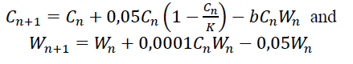

1. If the 1 500 caribou in the area represent 88,24% of the carrying capacity for the area, determine, to the nearest whole number, the carrying capacity for the area.

(2)

1. Determine the average lifespan of a wolf, in years. (2)
2. A female caribou gives birth to 2 calves every year. The percentage of females is 45%. Calculate, to 1 decimal place, the percentage of calves that survive. (3)
3. The population of the 2 species tends to an equilibrium or stable state. If the equilibrium population for the wolves is 35, calculate the rate at which encounters between the 2 species result in the death of the caribou. [Give the answer as a percentage correct to 1 decimal place] (3)
4. Calculate the equilibrium population of the caribou. (3)

The graph shows how the number of wolves and caribou change from one cycle to the next. A copy of the graph appears on the answer sheet.

Use the graph to answer the questions that follow.

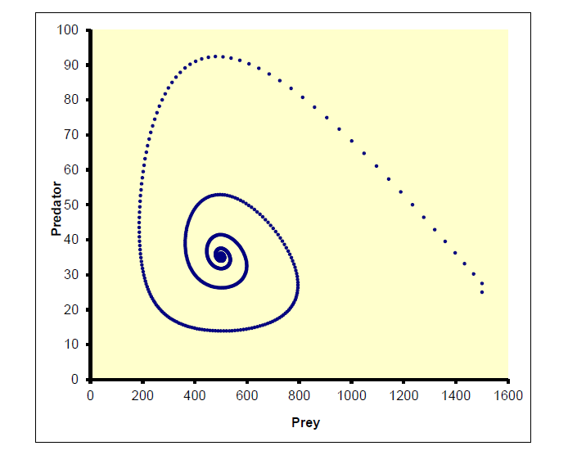

1. Indicate on the graph on the answer sheet where the maximum number of wolves and minimum number of caribou can be read off from the graph. [Use the letters A and B to indicate the answers] (2)
2. On the graph, indicate where the equilibrium number of caribou can be read off. [Use the letter C on the graph] (1)
3. Indicate, using the letter D on the graph on the answer sheet, when the wolf population first started to decrease. (1)

