

**ADVANCED PROGRAMME MATHEMATICS**

**TRIALS EXAMINATION 2019**

**ALGEBRA AND CALCULUS**

**TIME: 2 HOUR 200 MARKS**

**EXAMINER: Mrs T Thorne**

**MODERATOR: Mrs D Bolton**

**Name: _____________________________________**

**PLEASE READ THE FOLLOWING INSTRUCTIONS CAREFULLY.**

* This question paper consists of 8 pages.
* Read the questions carefully.
* **ALL** questions must be answered in the answer book provided.
* Number your answers exactly as the questions are numbered.
* Diagrams are **NOT** necessarily drawn to scale.
* All answers must be given correct to **two decimal places** where necessary,

unless stated otherwise.

* Approved calculators may be used, unless stated otherwise.
* All the necessary working details must be clearly shown.
* Make sure your calculator is in **RADIANS.**

**QUESTION 1**

* 1. Given:  and 

1. If  (referred to as the complex conjugate of $x$) and $k∈R$, express  in the form . (5)
2. Determine the value of *k* for which  is purely Real. (2)
3. Solve for $x$ if: $3\left|x\right|+{2x}^{2}-2=0$ (7)
4. Decompose $\frac{5x-4}{(x+1)(x-2)^{2}}$ into partial fractions. (8)

**[22]**

**QUESTION 2**

In using the induction method to prove the accuracy of a statement, you assume the statement is true for $n=k$.

Assuming $2^{k}+2^{k+1}+ 2^{k+2}$ is divisible by 7, prove that it will be true for the next natural number $n=k+1$. (5)

**[5]**

**QUESTION 3**

* 1. Solve for $x$ rounded off to two decimal places where appropriate. Show all relevant working details.
  2.  (7)
  3. $2e^{x}-1= e^{-x}$ (6)
  4. $f\left(x\right)= e^{2x}-9$ and $g\left(x\right)=\ln\left(x-1\right) for x>1$

Solve for $x$ if $f\left(g\left(x\right)\right)=0$ (8)

(c) The number, $N,$ of insects in a colony is given by $N=3000e^{0,4t}$, where $t$ is

the number of months after observations began.

1. Determine the population of the colony $1 year$ after observations

began. (2)

(ii) How long, after observations began, would it take for the population of   
 the colony to reach $1 000 000$ insects?  
 Give your answer to the nearest month. (4)

**[27]**

**QUESTION 4**

* 1. Draw separate quick sketch graphs of each of the following five functions.

1. a function *f* such that *f* is continuous but not differentiable at .
2. a function *g* such that  exists, but *g* is not continuous at .
3. a function *h* such that  does not exist.
4. a function *k* such that .
5. a function *p* such that . (10)
   1. Evaluate the following without using a calculator:
6.  (4)
7.  (6)

**[20]**

**QUESTION 5**

1. The functions $f$ is defined for  as follows:

$f\left(x\right)$ $=\frac{2}{3x-2}$; determine:

1. $f^{'}(x)$ (3)
2. $f^{''}(x)$ (2)
3. $f^{'''}(x)$ (2)
4. a formula for $f^{n}(x)$, the $n^{th}$ derivative of $f(x)$. (5)
   1. Determine $\frac{dy}{dx}$ if $y=\left(\sqrt{x-1}\right)tanx$ (5)
   2. Below is the graph of a folium of descartes which has the equation

$x^{3}+y^{3}=6xy$. Use implicit differentiation to find the gradient of

the tangent at the point A(3:3). (10)

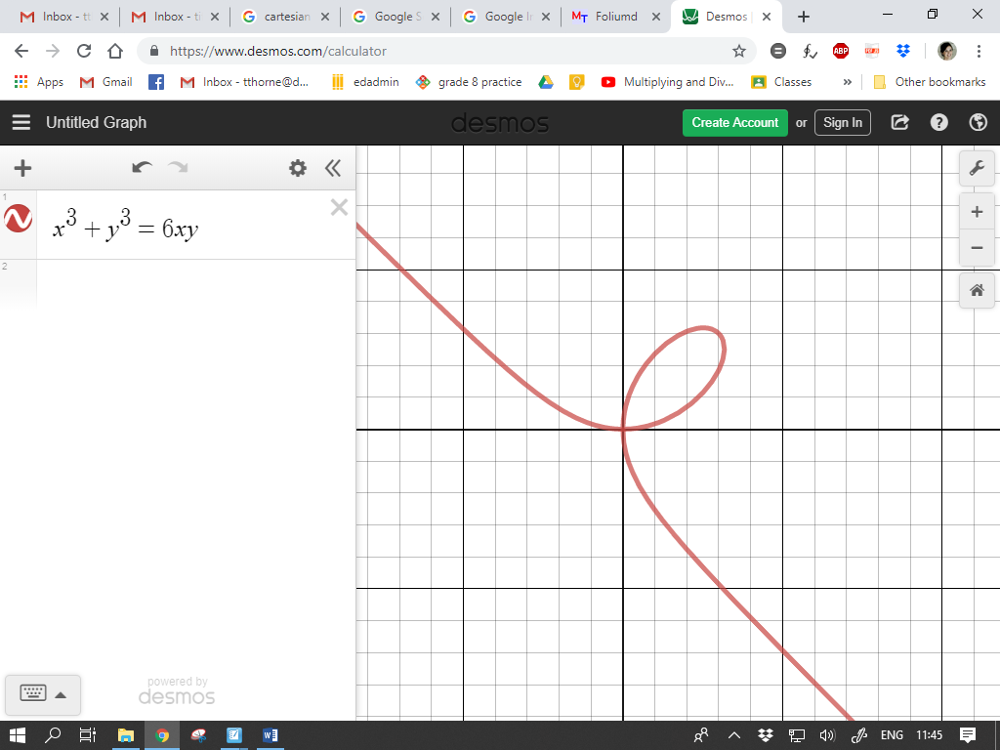



**[27]**

**QUESTION 6**

* 1. Consider $xsin x+1=0$

1. Show that $xsin x+1=0$ has a zero ( $x$ intercept) in the interval $x∈\left[-4; -3\right]$ (2)
2. Using the Newton Raphson method, calculate this solution, correct to 5 decimal places. (5)

(b) The graph of $h'(x)$, a linear function, is shown:

*x*



−6

2

1. Sketch $\left|h'(x)\right|$, showing all intercepts with the axes. (2)
2. Sketch $h''(x)$, showing all intercepts with the axes. (3)

(ii) Sketch $h(x)$. (4)

(c) (i) Show that . (7)

(ii) Hence show that this implies that:  
  (2)

(iii) Now prove that in fact  (4)

**[29]**

**QUESTION 7**

* 1. Determine the following integrals, showing all relevant working.

1. $\int{\frac{3x}{\sqrt{9+4x^{2}}} dx}$ (7)
2. $\int{\cos{8x\cos{5x dx}}}$ (5)
3.  (6)
   1. A curve is such that $\frac{dy}{dx}= \frac{4}{\sqrt{6-2x}}$ and $P(1;8)$ is a point on the curve. Find the equation of the curve. (6)
   2. 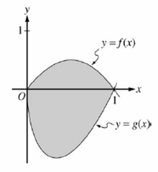Let *f* and *g* be the functions given by and  for . The graphs of these functions are shown in the figure below.

Find the area of the shaded region enclosed by the graphs of *f* and *g*. (5)

* 1. Determine, without using a calculator, the volume of the solid generated if part of the curve of  between  is rotated around the *x*-axis. (4)

**[33]**

**QUESTION 8**

The sketch given below represents 

A

B

*x*

*y*

* 1. Calculate the coordinates of A and B, the local maximum and minimum of *h*($x$). (8)
  2. Determine the equation of the three asymptotes. (7)
  3. From the graph, find the value(s) of $x$ if

 is real. (3)

* 1. Sketch , on the diagram provided. Show clearly the asymptotes. (5)

**[23]**

**QUESTION 9**

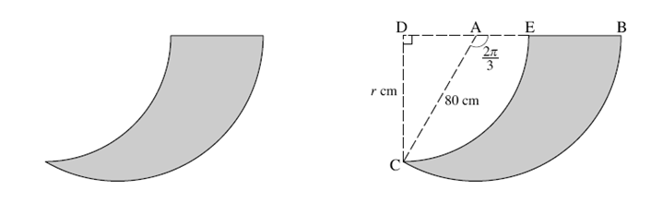

The diagrams above show the cross-section of a rudder of a boat, which is used in steering the boat.

CE is an arc of the circle with **centre D** and BC is an arc of the circle with **centre A**.

 and AC = 80 cm ; DC = $r$.

1. Calculate the area of sector ABC (leaving your answer **in terms of π**). (2)
2. Prove that $r=40\sqrt{3}$ (5)
3. Find the area of the cross-section (the grey area) of the rudder to **1 decimal place**. (7)

**[14]**