**Herzlia Highlands**

**Advanced Programme Mathematics**

**(***Calculus & Algebra***)**

**Grade 12**

**September 2019**

**Notes**

1. Calculators in radian mode.
2. Calculators in ***RADIAN MODE****.*
3. **NB:** Order of questions written on front of workbook.
4. There are **13** questions for a total of **200 marks.**
5. You have **2** hours to complete the exam.
6. Unless otherwise stated, answers to be given to 2 decimal places.
7. You should have 2 pages of formulae.

If you think there is a formula you need that is not in here – ASK!

1. Use mathematical induction to show that is divisible by 8   
     
     
    **[10]**
2. *Once upon a time in Mexico*  
     
     
     
     
     
     
     
     
     
     
     
     
     
     
     
   Sketch the graph of   
     
     
      
     
     
    **[15]**

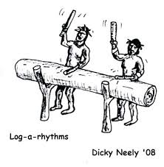

1. 1. Solve for x without a calculator  
        
        
       (6)
   2. Given    
        
      1. Determine whether  is increasing or decreasing. (3)
      2. What is the range of? (4)
      3. Find an expression for the inverse function . (4)  
           
           
          **[17]**
2. In the diagram, AC and BC are tangents to the circle with centre O.   
   radians and the radius is 5cm.  
   1. Calculate, giving reasons, the length of each tangent. (5)
   2. 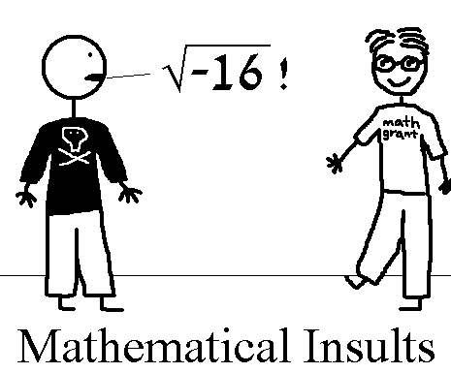Hence calculate the area of ACBD, i.e. the area enclosed by the tangents and arc ADB. (7)  
        
        
       **[12]**
3. In the following questions, determine  in the form   
     
   1.  (4)
   2. . (11)  
        
      {Hint: … then equate relevant parts to get simultaneous equations in *a* and *b*}   
       **[15]**
4. Given that  is a root of , Solve for all .  
     
     
    **[10]**
5. Given  . Determine all values of *p* if:  
     
   1.  has two vertical asymptotes. (5)
   2.  (4)  
        
       **[9]**
6. Given the following split domain (piecewise) function:  
     
     
     
     
   1. Determine *a* in terms of *b* if is continuous at . (3)
   2. Determine a second equation in *a* and *b* if  is also differentiable at . (4)
   3. Hence solve for *a* and *b*. (4)  
        
        
       **[11]**
7. If  and   
     
   1. Show that . (3)
   2. Determine all asymptotes of . (4)
   3. Show that . (4)
   4. Hence sketch , showing all relevant points, asymptotes   
      and intercepts. (5)  
        
       **[16]**

1. Determine the equation of the tangent to the curve   
     
     at the point .  
     
    **[12]**
2. Determine the following:  
   1. . (4)
   2. . (5)
   3. The value of *k* if . (7)
   4. $\int{\sqrt{2+x} dx }$. (4)
   5. $\int{cos2x.sin5x dx}.$ (7)
   6. $\int{3x.sinx dx}$ (integration by parts). (7)   
       **[34]**
3. The **velocity** of an object is given by   
     
    (t > 0)  
   1. When is the object at its closest, i.e. when will the **position** of the object be at a maximum or minimum and how do you know this answer is a minimum? (4)
   2. ***[This is to review after: too much for this exam]*** Split *v*(*t*) up into its partial fractions, i.e. *A*, *B* and *C*, such that  
        
        (8)
   3. If , find the distance travelled by this object from the 3rd to the 5th second of its travels, i.e. evaluate the following definite integral:  
        
        (15)  
       **[19]**
4. IEB ’18 final solid of revolution with solution via Newton:  
    A perfume bottle is in the shape of a truncated sphere with a flat  
   bottom as shown in the picture.  
     
     
   One half of the bottle can be modelled using the function ,   
   illustrated below (with units in cm). Imagine the bottle has been   
   turned on its side and the base of the bottle is on the y-axis.  
     
     
   1. Show that the *x*-value which results in a volume of 175ml after rotation about the x-axis is:  
        
       (10)
   2. Hence show that this volume of 175ml is achieved when the bottle is filled somewhere between a depth of 4 to 6cm. (2)
   3. Now use Newton’s method to solve for the exact depth to 5 decimal places, using an initial value of . (8)  
        
       **[20]**

**END OF PAPER**