# KING DAVID HIGH SCHOOL LINKSFIELD



**AP MATHEMATICS PAPER 2**

**GRADE 12**

**PRELIMINARY EXAMINATION AUGUST 2019**

**Total: 100 marks**

**Reading Time: 10 minutes Writing Time: 1 hour**

**Name:**

This paper comprises a question paper of **17** pages (including the front cover) and a separate data sheet. Check that your paper is complete.

**Write your name in the space above**.

Please read the following instructions carefully:

1. **You must answer only ONE of the three optional modules**.

Module A Statistics

**OR**  Module B Finance and Modelling

**OR**  Module C Matrices and Graph Theory

**Each module begins on a new page.**

2. Number all questions exactly as they appear on the question paper.

3. Pay careful attention to time management and mark allocation.

4. Write legibly and not in pencil.

5. Non programmable calculators may be used unless otherwise instructed.

6. All answers to be given to 2 decimal places unless otherwise stated.

7. **All necessary calculations must be clearly shown. You will NOT**

**receive full credit if you write down only the answers .**

|  |  |  |  |  |  |  |  |
| --- | --- | --- | --- | --- | --- | --- | --- |
| **Q1** | **Q2** | **Q3** | **Q4** | **Q5** | **Q6** | **Q7** | **TOTAL**  **100** |
|  |  |  |  |  |  |  |  |

**MODULE A – STATISTICS [100 marks]**

**Question 1**

[](https://www.google.com/url?sa=i&rct=j&q=&esrc=s&source=images&cd=&ved=2ahUKEwjetKOx0MjjAhXZA2MBHQO-AnQQjRx6BAgBEAU&url=https://www.iconfinder.com/icons/330253/flags_four_horizontal_mauritius_mu_stripes_waving_flag_icon&psig=AOvVaw14rD53EQjqInNHvPLsy1VP&ust=1563888389517402)

a)

How many flags of the design (ie 4 stripes) above can be made from 8 different

coloured materials if each stripe must be a different colour? (4)

b) A mother goes shopping with her 3 children and buys 17 items. On the way

home, the shopping bags break. Fortunately she has 4 smaller bags in her

handbag. In one bag, which she will carry, she puts 7 items. The other bags

contain 2, 3 and 5 items which she gives to the youngest, middle and eldest

child respectively. In how many ways can the items be distributed among the

4 bags? (5)

**[9]**

**Question 2**

a) What is the probability (correct to 5 decimal places) that 5 cards dealt from

a standard deck of 52 cards will all be of the same suit? (ie 5 spades or 5 hearts

or 5 diamonds or 5 clubs)? (5)

b) What is the probability (correct to 2 decimal places) that in a group of 6 friends at

least two will be born in the same month? (8)

**[13]**

**Question 3**

a) A random variable, X ~ N(μ ; σ2). On the same system of axes sketch the

functions N(0 ; 1); N(1 ; 4) and N(4 ; 1). Label your axes clearly and the

sketches must show clearly the effects of the different values of μ and σ. (6)

b) The mass of a party pack of Star Crisps is normally distributed with a mean

of 500 grams and a standard deviation of 30 grams.

(i) If I choose a party pack at random, what is the probability (correct to 4 decimal places) that it will **not** have a mass between 473 grams and 482 grams? (8)

(ii) If I choose 3 packs at random what is the probability (correct to

[](https://www.google.co.za/imgres?imgurl=http://weclipart.com/gimg/2FE2CF1053802722/depositphotos_23506027-Crisp-packet.jpg&imgrefurl=http://pictandpicture.org/cartoon-packet-of-crisps/&docid=-vQl5X5Ye1jbEM&tbnid=HJPwK9-OYPNSxM:&vet=12ahUKEwji2pnmzsjjAhWMUxUIHcphB-o4ZBAzKGEwYXoECAEQYw..i&w=812&h=1024&itg=1&hl=en&bih=566&biw=1366&q=packets%20of%20crisps&ved=2ahUKEwji2pnmzsjjAhWMUxUIHcphB-o4ZBAzKGEwYXoECAEQYw&iact=mrc&uact=8)4 decimal places) that none of the packs will have a mass between 473 grams and 482 grams? (4)

c) On checking a consignment of rifles and bullets, it was discovered that 20%

of the rifles and 30% of the bullets do not work at all. A random sample of

10 rifles and 500 bullets is taken. Calculate the probability that

(i) at least 2 of the rifles will work. (6)

(ii) between 340 and 355 of the bullets will work. (Use the normal

approximation to the binomial distribution giving reasons why this

is applicable.) (8)

**[32]**

**Question 4**

Records from a call centre showed that in 2017 the times taken for calls to be

answered were normally distributed with a mean of 29 seconds and a standard deviation of 2,7 seconds.



In 2018, a random sample of 20 calls was taken and the time taken for each call to be answered (in seconds) is given in the table below:

|  |  |  |  |  |  |  |  |  |  |
| --- | --- | --- | --- | --- | --- | --- | --- | --- | --- |
| 23 | 28 | 31 | 20 | 37 | 24 | 27 | 31 | 29 | 30 |
| 32 | 31 | 27 | 29 | 28 | 26 | 21 | 34 | 32 | 23 |

a) Calculate the 95% confidence interval for the mean time taken for a call to be

answered in 2018. (6)

b) Based on the data above, the call centre manager claims that the time taken for

a call to be answered in 2018 is less than that for 2017.

Clearly state this claim as a hypothesis and determine at the 5% significance

level whether this claim is justified or not. (8)

**[14]**

**Question 5**

For the events A and B, it is given that:

P(A ∩ B) = 0,32; P(A’ ∩ B) = 0,11and P(A ∪ B) = 0,65

a) Draw a Venn diagram to illustrate the complete sample space for the events

A and B. (6)

b) Write down the values of P(A) and P(B). (2)

c) Calculate P(A⏐ B’). (6)

**[14]**

**Question 6**

a) Donald has 15 friends – 9 boys and 6 girls. He is only allowed to invite 7 friends

to his 18th birthday party. What is the probability, correct to 3 decimal places,

that 4 of the friends that he invites are girls? (6)

b) A random variable X has a probability function defined as follows:

k(0,6)x if x ∈ {0 ; 1 ; 2 ; 3 ; . . .}

f( x ) =

0 otherwise

Determine:

(i) the value of k. (6)

(ii) P( x > 3) (6)

**[18]**

**MODULE B FINANCE AND MODELLING STARTS ON THE NEXT PAGE**

**MODULE B – FINANCE & MODELLING [100 marks]**

**Question 1:**

Jacob is in matric this year and plans to go on a road trip of America in five years’ time. He estimates that he will need R150 000 minimum to have an enjoyable trip. Jacob decides to start saving at the beginning of next year, 2020.

For the next three years, Jacob will be in university and will only manage to save R1000 per month at an interest rate of 11% per annum. Jacob will make these payments immediately from 1 January 2020. When Jacob enters the workplace, he will up his payment to R2500 a month, immediately from 1 January 2023. The interest rate will be 12% per annum compounded quarterly in 2023 and will increase to 15% per annum compounded monthly for 2024. Jacob realises that he will have to make a lump sum payment in order to achieve his goal amount. He plans to make this lump sum payment on 1 January 2024.

The graph below illustrates Jacob’s investment:

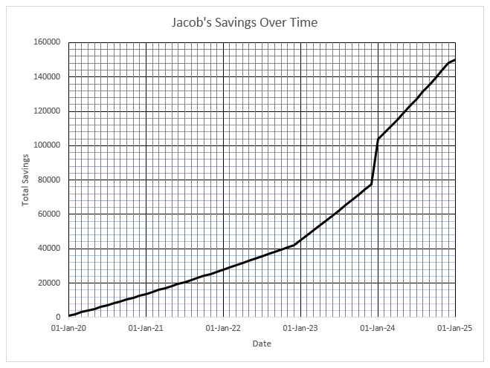

Answer the following questions based on the graph:

1. Write down how much Jacob would have managed to save halfway through

the 5 years, i.e. by the 1st July 2022.     (2)

1. Determine how long it would take to save half the amount needed, i.e. R75 000?                (4)
2. Calculate the approximate amount that Jacob would have to deposit on top

of his instalment on the 1st January 2024. (4)

**[10]**

**Question 2:**

Daniel buys high-quality camera and sound equipment to start a YouTube channel. The equipment in total costs him R90 000. He plans to upgrade in 5 years’ time in order to keep up with the latest technology. His equipment depreciates at a rate of 7% per annum on a reducing balance method.

1. Calculate the value of Daniel’s equipment in 5 years’ time. (3)
2. Daniel decides to invest money in a savings account in order to save up for

his upgrade in 5 years’ time. He will contribute R100 a month at an interest

rate of 11% per annum compounded monthly. He will start saving one month after he purchases the new equipment. Calculate how much Daniel will have saved at the end of 5 years. (4)

1. Should the value of the upgrade cost R90 000 plus inflation of 4.5% per

annum, will Daniel have enough money to buy the equipment after selling

his old equipment at book value and using his savings? Show workings. (5)

**[12]**

**Question 3:**

Rachel is in matric and has enrolled for a three-year Bachelor of Accounting Science degree at Wits University. The first-year fees for 2020 are R51 180.00. This figure will increase to R53 483.10 in 2021 and to R55 889.84 in 2022 due to inflation.

Neither Rachel, nor her parents, will be able to afford her university tuition. Rachel must take out a student loan with a bank. The bank has offered to loan Rachel her required tuition fees each year for the duration of her course at an initial interest rate of 9.6% per compounded biannually. After 18 months, the interest rate changes to 10.03% per annum compounded monthly. Rachel will have to start repaying the loan once she starts working in 2023.

1. Calculate the loan amount that Rachel will be required to pay back to the

bank at the end of 2022. (6)

1. What is the interest amount that has accumulated on the loan? (2)
2. Assume that the loan that Rachel will have to pay back from 1 January 2023

is R189 835.93. Calculate her **quarterly instalments** if Rachel plans to take

5 years to repay the loan, starting at the end of the first quarter of 2023.

Assume the same interest rate of 10.03% per annum **compounded monthly**. (7)

1. At the end of Rachel’s second year of work, she is given a substantial increase. Rachel decides to use this extra money to increase her instalment to R15 000 per quarter and pay off her loan quicker.
2. Calculate the outstanding balance on Rachel’s loan on 31 December 2024. (3)
3. How many more quarterly instalments will Rachel have to make to

pay off the loan? (4)

1. Determine the amount of the final payment that Rachel will have to make? (6)

**[28]**

**Question 4:**

With only 5 000 left in the wild, the African Wild Dog is an endangered species. The Kruger National Park is home to 500 African wild dogs. Wild dogs have one litter of an average of 7 pups per year. These pups have a survival rate of 40%. 50% of the wild dog population is female and the life expectancy is only 6 years.

1. Calculate the annual growth rate of the African wild dog population in the

Kruger Park correct to 3 decimal digits. (5)

1. Assuming the African wild dog population grows at a rate of 1.233

per annum, express the growth rate of the African wild dog as a recursive

formula. (2)

1. What will the African wild dog population be in 6 years’ time if the population

in the Kruger Park is currently 500? Give your answer to the nearest integer? (2)

**[9]**

**Question 5:**

Given the logistic population model:

$$\frac{∆P}{P}=-0.0001875P+0.15$$

1. What is the value of the intrinsic growth rate for this model?

Note: $\frac{∆P}{P}=r(1-\frac{P}{K})$ (2)

1. Calculate the carrying capacity of this model. (3)
2. If the proportional growth rate of the population is 0.055, what is the size of

the population? Give your answer to the nearest integer. (4)

1. If $P_{0}=102$ and the carrying capacity is 800, calculate the population after

3 cycles of this model. Give your answer to the nearest integer. (3)

**[12]**

**Question 6:**

Yellowstone National Park in the USA is famous for an eco-system revival. Wolves in the park were killed off entirely in 1930, eliminating any form of predator for the elk (a type of deer). The subsequent increase in elk numbers lead to many problems, including overgrazing, as the eco-system of the park could not withstand more than 17 000 elk. In 1995, 30 wolves were reintroduced to the park to be a natural predator of the elk, in an attempt to bring balance to this habitat.

At this time there were 15 500 elk in the park. Female elk give birth to one calf every 6 months. Each calf has a 50% chance of surviving to maturity. 50% of the elk are female. The elk live up to 12 years of age.

A female wolf gives birth to one litter of 3 pups per year. Of the 30 wolves reintroduced to the park, 12 were female. One wolf will kill about 48 elk per year. The lifespan of a wolf in Yellowstone is 5 years.

The cycle in this model is months. One month is assumed to be 4 weeks.

The predator-prey model for these two species is:

$$W_{n+1}=W_{n}+f.b.W_{n}.E_{n}-c.W_{n}$$

$$E_{n+1}=E_{n}+a.E_{n}\left(1-\frac{E_{n}}{K}\right)-b.E_{n}.W_{n}$$

1. What is the carrying capacity of the elk population? (1)
2. Calculate the death rate (*c*) of the wolves in the first month.

Round off your answer to five decimal places. (3)

$$Death rate \left(c\right)= \frac{cycle}{lifespan}$$

1. Calculate the attack rate of the wolves (*b*) in the first month.

Round off your answer to six decimal places. (5)

$$b.E_{n}.W_{n}=no. of elk killed by wolves per cycle$$

1. Calculate the monthly efficiency rate (*f*) at which wolves turn elk into food.

Round off your answer to six decimal places. (5)

$$f.b.W_{n}.E_{n}=the reproductive growth of the wolves per cycle$$

1. From the graphs below, select the one that best represents this population

model. (2)

Graph 2

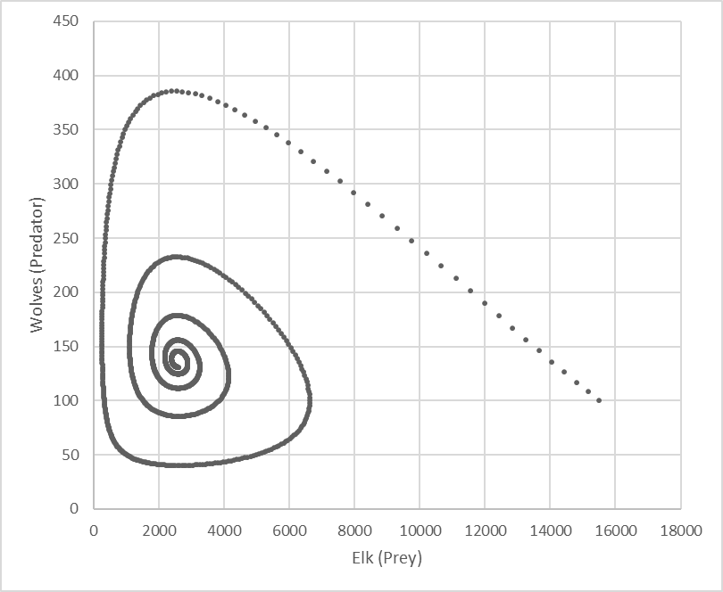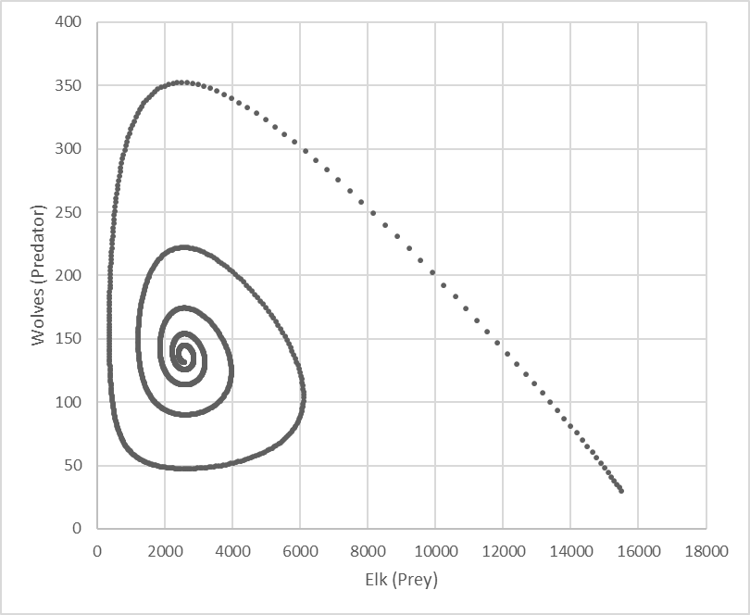Graph 1

Graph 3

Graph 4

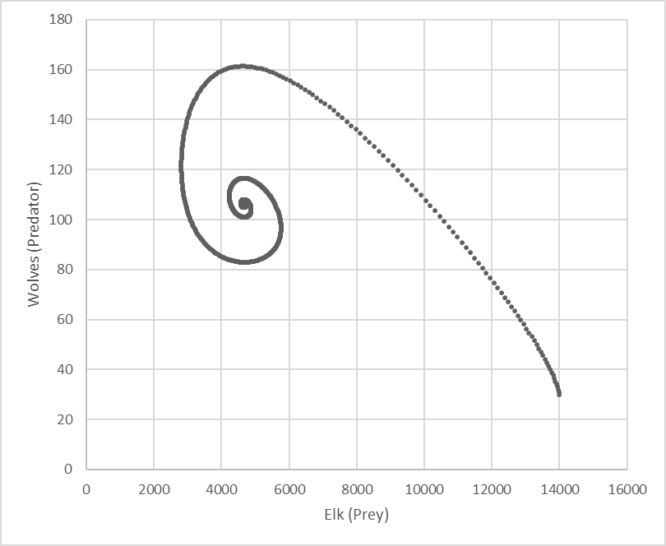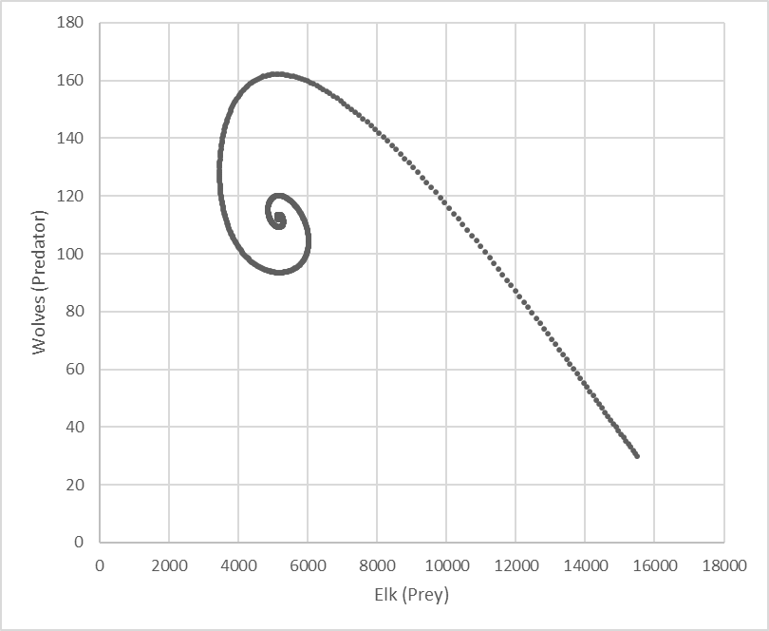

1. From your chosen graph, state the equilibrium populations for both species. (4)

**[20]**

**Question 7:**

From Wikipedia: *The Tower of Hanoi is a*[*mathematical game*](https://en.wikipedia.org/wiki/Mathematical_game)*or*[*puzzle*](https://en.wikipedia.org/wiki/Puzzle)*. It consists of three rods and a number of disks of different sizes, which can slide onto any rod. The puzzle starts with the disks in a neat stack in ascending order of size on one rod, the smallest at the top, thus making a*[*conical*](https://en.wikipedia.org/wiki/Cone)*shape.*

*The objective of the puzzle is to move the entire stack to another rod, obeying the following simple rules:*

* *Only one disk can be moved at a time.*
* *Each move consists of taking the upper disk from one of the stacks and placing it on top of another stack or on an empty rod.*
* *No larger disk may be placed on top of a smaller disk.*

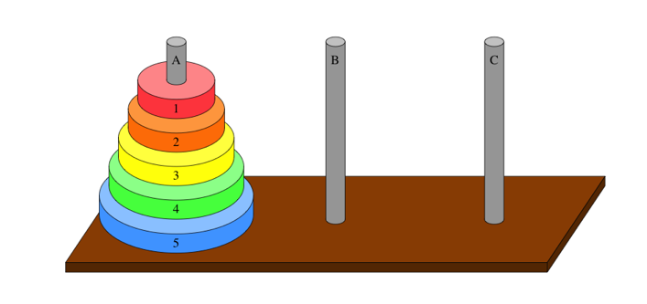

To move one disk, takes one move:

1. Disk 1 to Rod B

To move two disks, takes three moves:

1. Disk 1 to Rod B
2. Disk 2 to Rod C
3. Disk 1 to Rod C

To move three disks, takes seven moves:

1. Disk 1 to Rod B
2. Disk 2 to Rod C
3. Disk 1 to Rod C
4. Disk 3 to Rod B
5. Disk 1 to Rod A
6. Disk 2 to Rod B
7. Disk 1 to Rod B

a) Calculate how many moves it would take to move four disks. (3)

b) Determine the second-order difference equation that represents the

Tower of Hanoi problem in the form $T_{n+1}=aT_{n}+bT_{n-1}$. (6)

**[9]**

**MODULE C MATRICES AND GRAPH THEORY STARTS ON THE NEXT PAGE**

|  |  |  |  |  |  |  |
| --- | --- | --- | --- | --- | --- | --- |
| **MODULE C – MATRICES AND GRAPH THEORY [100 marks]** | | | | | |  |
|  | |  | | |  |  |
| **Question 1 (No calculator allowed in this question)** | | | | | |  |
|  |  | | | |  |  |
| a) |  | | | | |  |
|  | (i) Find AB | | | | | (4) |
|  |  | | | | |  |
|  | (ii) Show that AB is invertible. Provide proper reasoning for your answer. | | | | | (2) |
|  |  | | | | |  |
|  | (iii) Find | | | | | (3) |
|  |  | | | | |  |
| b) | Given the following:    Find *x*, *y*, *z* and *t*. | | | | | (8) |
|  |  | | | |  | **[17]** |
|  | | | | | |  |
| **Question 2** | | | | | |  |
|  |  | | | |  |  |
| a) | A system of three linear equations is given: | | | | |  |
|  | Using the definition, solve the system of equations. | | | | | (10) |
|  |  | | | |  |  |
| b) | Write down the matrices representing the following transformations in the form  : | | | | |  |
|  |  | | |  | |  |
|  | (i) | | | A Reflection in the line through the origin which makes an angle of with the positive *x*-axis. | | (2) |
|  |  | | |  | |  |
|  | (ii) | | | An enlargement centre (a;0) and scale factor *k*. | | (2) |
|  |  | | |  | |  |
|  | (iii) | | | A reflection in a line through the origin | | (2) |
|  |  | | |  | |  |
| c) | (i) | | | A Plane transformation has matrix . Describe geometrically what this transformation is. Show all your working. | | (4) |
|  |  | | |  | |  |
|  | (ii) | | | Hence describe the plane transformation represented by the matrix . Show all your working. | | (6) |
|  |  | | |  | |  |
|  |  | | |  | | **[26]** |
| **Question 3:** | | | | | |  |
|  |  | | | |  |  |
| a) | What are the differences and similarities between Eulerian and Hamiltonian circuits? | | | | | (3) |
|  |  | | | |  | |
| b) | What is the condition for a graph to possess an Eulerian circuit? | | | | | (1) |
|  |  | | | |  | |
| c) | What quick test can one do to determine whether a graph possesses a Hamiltonian circuit? | | | | | (1) |
|  |  | | | |  | |
| d) | Describe the difference between a tree and a spanning tree. | | | | | (2) |
|  |  | | | |  | |
| e) | The graph below shows a table with the distance between some of the major cities in South Africa.     |  |  |  |  |  |  |  |  | | --- | --- | --- | --- | --- | --- | --- | --- | |  | **J** | **D** | **CT** | **BFN** | **K** | **PE** | **EL** | | **JHB (J)** |  | 578 | 1405 | 398 | 472 | 1075 | 982 | | **Durban (D)** | 578 |  | 1753 | 634 | 811 | 984 | 674 | | **Cape Town(CT)** | 1405 | 1753 |  | 1004 | 962 | 769 | 1099 | | **Bloemfontein (BFN)** | 398 | 634 | 1004 |  | 177 | 677 | 584 | | **Kimberley (K)** | 472 | 811 | 962 | 177 |  | 742 | 780 | | **Port Elizabeth (PE)** | 1075 | 984 | 769 | 677 | 742 |  | 310 | | **East London (EL)** | 982 | 674 | 1099 | 584 | 780 | 310 |  | | | | | | |
|  | A courier company operates from Bloemfontein and approaches you to determine the shortest routes that they can take to reach each of the cities listed above. | | | | |  |
|  |  | |  | | |  |
|  | (i) | | Use the table only and find an optimal travelling salesman route. Show your working. | | | (5) |
|  |  | |  | | |  |
|  | (ii) | | Draw the connected graph that represents the information in the table. Indicate the weight of the edges clearly on your graph. | | | (4) |
|  |  | |  | | |  |
|  | (ii) | | Now apply Kruskal’s algorithm to find an optimum route. Indicate this route on your graph. | | | (6) |
|  |  | |  | | | **[22]** |
|  |  | |  | | |  |
| **Question 4:** | | | | | |  |
|  |  | | | |  |  |
| a) | Use Dijkstra’s algorithm in the digraph below to find the closest path between vertex 1 and all the other vertices. Show your working. | | | | | **[10]** |
|  |  | | | |  |  |
| **Question 5:**  The digraph shows the network paths between 5 vertices. | | | | | |  |
|  | | | | | | |
| a) | | Define the notion of an adjacency matrix A | | | | (2) |
|  | |  | | |  |  |
| b) | | Create the adjacency matrix A that shows the number of one step paths that start at each vertex. Explain why the adjacency matrix is not symmetric. | | | | (5) |
|  | |  | | |  |  |
| c) | | Use the graph to create a matrix that shows the number of two step paths that start at each vertex. | | | | (5) |
|  | |  | | |  |  |
| d) | | Is there another way to obtain the matrix that was created in (c) above? Motivate. | | | | (2) |
|  | |  | | |  |  |
| e) | | Make a list of all the three step paths between vertices C and B | | | | (3) |
|  | |  | | |  |  |
| f) | | An incidence matrix is defined as follows:    Use this definition to set up an incidence matrix M for the graph, if the edges are labelled as follows:  . | | | | (8) |
|  | |  | | |  |  |
|  | |  | | |  | **[25]** |