# KING DAVID HIGH SCHOOL LINKSFIELD



**AP MATHEMATICS PAPER 1**

**GRADE 12**

**PRELIMINARY EXAMINATION AUGUST 2019**

**Total: 200 marks**

**Reading Time: 10 minutes Writing Time: 2 hours**

**Name:**

This paper comprises a question paper of **8** pages (including the front cover) and a separate data sheet. Check that your paper is complete.

**Write your name in the space above**.

Please read the following instructions carefully:

1. Number all questions exactly as they appear on the question paper.

2. Pay careful attention to time management and mark allocation.

3. Write legibly and not in pencil.

4. Non programmable calculators may be used unless otherwise instructed.

5. **All necessary calculations must be clearly shown. You will NOT**

**receive full credit if you write down only the answers .**

**6.** **Please set your calculator to RADIAN mode.**

|  |  |  |  |  |  |  |  |
| --- | --- | --- | --- | --- | --- | --- | --- |
| **Q1**  **[18]** | **Q2**  **[6]** | **Q3**  **[15]** | **Q4**  **[10]** | **Q5**  **[17]** | **Q6**  **[12]** | **Q7**  **[16]** | **Q8**  **[11]** |
|  |  |  |  |  |  |  |  |
| **Q9**  **[12]** | **Q10**  **[24]** | **Q11**  **[21]** | **Q12**  **[10]** | **Q13**  **[9]** | **Q14**  **[12]** | **Q15**  **[7]** | **TOTAL**  **[200]** |
|  |  |  |  |  |  |  |  |

Question 1

Solve for x if . Where appropriate, leave answers in simplest surd form.

(a)  (7)

(b)  (6)

(c) ;  (5)

Question 2

If  is one root of, determine the values of a and b if a,b 

(6)

Question 3

Prove that the following statement is true for all 

 (15)

Question 4

(a) Solve for x if 

(i)  (3)

(ii)  (1)

(b) On the axes provided below, sketch the functions  and  (4)



(c) Hence, determine the values for which  if *x* > 0 (2)

Question 5

Give answers correct to 2 decimal places where appropriate.

Consider the function 

(a) Determine the equations of all asymptotes of this function. (6)

(b) Determine the x co-ordinates of any stationary points (6)

(c) Determine the x and y-intercepts of the curve. (3)

(d) Is the function increasing or decreasing at x = 0. Explain your answer. (2)

**DO NOT SKETCH THIS CURVE.**

Question 6

ABC is a semi-circle with centre O and radius a. Point C can move along the semi-circle.  radians.

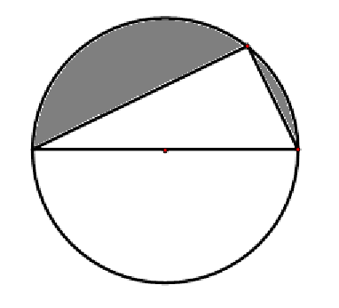

a) Find the perimeter of the shaded area in terms of a and θ (4)

(b) Show that A, the area of the shaded region is equal to  (6)

(c) Write down the domain of θ. (2)

C

θ

O

A

B

Question 7

The graph of is shown below.

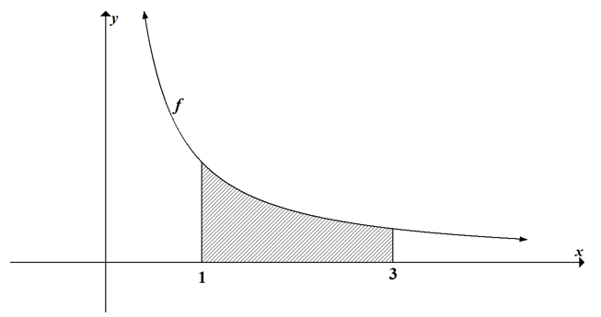

a) Determine an approximation for the area enclosed by the graph, the $x$-axis and

the lines x = 1 and x = 3 by using 6 rectangles of equal width. Round your

answer off to 3 decimal places. (10)

b) Determine the **exact** area of the region defined in part (a), correct to 3 decimal

places, showing ALL your calculations. (4)

c) Explain briefly why your answer in (a) is less than the actual answer. (2)

Question 8

(a) Prove the identity. for x ∈ (0 ;  (6) (b) Hence, determine  leaving your answer in surd form. (5)

Question 9

Consider the expression a(x) =

a) Decompose a(x) into partial fractions. (8)

b) Hence determine  (4)

Question 10

a) Determine, without simplifying,  if $y=\sqrt[3]{x^{2}+\sqrt{x^{3}}}$ (5)

b) Given: y = cos(ex + ).

(i) Determine the least positive value of x for which y is a minimum.

Leave your answer in log form. (5)

(ii) Prove that  (6)

c) If ey  =  determine . (8)

Question 11

The graph of  is sketched below.



Show all calculations in answering this question.

a) Rewrite f as the sum / difference of two terms. (4)

b) What is the domain of f? (4)

c) Determine the value(s) of the stationary point(s) of f(x). (11)

d) On which interval is f decreasing? (2)

Question 12

The graph of y = is rotated through one revolution about the x – axis.



Determine the volume of the solid of revolution obtained between the lines x = 0

and x = 2. Give your answer in terms of e and π. (10)

Question 13

.On your answer sheet write down the values of (a) ; (b) and (c) in the table below:

|  |  |  |
| --- | --- | --- |
| G(x) | F(x) | (F ο G)(x) |
| x + 2 | 3x + 2 | (a) |
| (b) |  |  |
|  | (c) | x |

(9)

Question14

Given: k(x) = 2x – sec x.

a) Show that  (7)

b) Hence use the Newton – Raphson method to solve sec x = 2x in the

interval (0 ; 1). Give your answer correct to 2 decimal places. (5)

Question 15

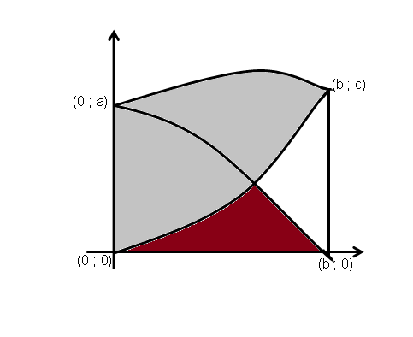

***g***

***f***

A

***h***

**A**

B

In the above sketch, the graphs of y = f(x) and y = g(x) intersect at x = d.

Write down expressions involving integrals for the following areas:

(a) Area A (3)

(b) Area B (4)