**GRADE 12 PRELIMINARY EXAMINATION**

**SEPTEMBER 2019**

**ADVANCED PROGRAMME MATHEMATICS: PAPER I**

**ALGEBRA AND CALCULUS**

**EXAMINER**: S. Kloppers **MODERATOR**: E. Nel

(Leeuwenhof Akademie)

Time: 2 hours 200 Marks

PLEASE READ THE FOLLOWING INSTRUCTIONS CAREFULLY

1. This question paper consists of 12 questions and 9 pages, and an Information Booklet of 4 pages (I – iv). Please check that your question paper is complete.
2. Read the questions carefully and answer all the questions.
3. Clearly show ALL calculations, diagrams et cetera you have used in determining the answers.
4. An approved calculator (non-programmable and graphical) may be used, unless stated otherwise.
5. Diagrams have not been drawn to scale.
6. Pace yourself. Aim to answer 50 marks in 30 minutes.
7. Number your answers EXACTLY as the questions are numbered.
8. It’s in your own interest to write legibly and to present the work neatly.
9. Write only in black or blue pen.

**MODULE 1 ALGEBRA AND CALCULUS**

**QUESTION 1 [17 Marks]**

Solve for $x$, showing your working:

1.1 $\ln\left(1+\sqrt{x}\right)=3$; give the answer in terms of $e.$ (3)

1.2 $-\frac{2}{x-2}=\left|2x-4\right|$ (8)

1.3 Consider $f\left(x\right)=ln⁡(x+1)$.

1.3.1 Write down the equation of the vertical asymptote of $f$. (1)

1.3.2 State the range of $f.$ (1)

1.3.3 Write the equation of $f^{-1}$ in the form $f^{-1}\left(x\right)=$… (2)

1.3.4 Write down the equation of the asymptote of the reflection of $f^{-1}$ about the $x$-axis. (1)

1.3.5 Determine the values of $x>-1$ for which $f\left(x\right)>1,5$ (1)

**QUESTION 2 [25 MARKS]**

2.1 A function is defined as follows:

$$f(x)=\left\{\begin{aligned} \\ \begin{matrix}3a+3ax & if & x<-3 \\ 3a^{2}-x^{2} & if & -3≤x≤2 \\ 4x-4 & if & x>2\end{matrix} \\ \end{aligned}\right.$$

2.1.1 Determine the value of $a$ such that $f$ is continuous at $x=-3$ and that $f$ will decrease if $x<-3.$ (6)

2.1.2 Determine whether $f$ will be differentiable at $x=2.$ (6)

2.2 It is given that $f\left(x\right)= 2^{x}-4$ and $g\left(x\right)=\left|x\right|$.

Sketch on separate sets of axes showing clearly the intercepts with the axes and any asymptotes.

2.2.1 $h\left(x\right)=g(f\left(x\right))$ (7)

2.2.2 $k\left(x\right)=f(g\left(x\right))$ (6)

**QUESTION 3 [8 MARKS]**

Below is the graph $2{\left(x^{2}+y^{2}\right)}^{2}=25\left(x^{2}-y^{2}\right)$.

It is in the shape of the infinity sign which is called the lemniscate of Bernoulli.

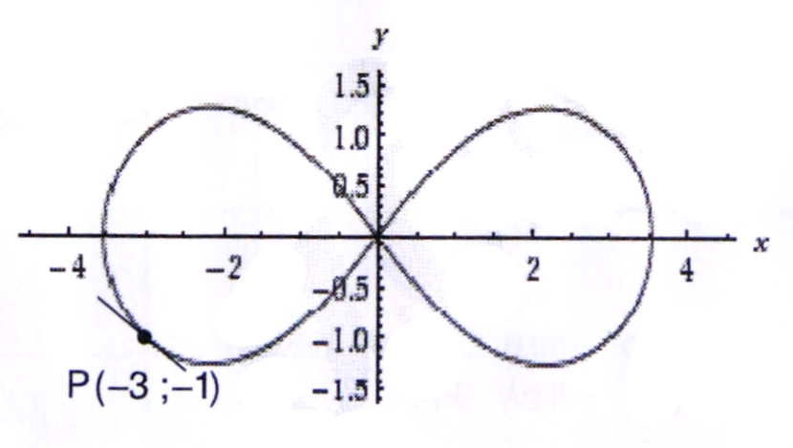Use implicit differentiation to determine the equation of the tangent at the point

$P\left(-3 ; -1\right)$. (8)

**QUESTION 4 [16 MARKS]**

4.1 Determine $\frac{dy}{dx}$ and simplify your answers to positive exponents:

4.1.1 $y={\left(\frac{2x+1}{3x-1}\right)}^{4}$ (6)

4.1.2 $y=\sin^{2}\left(3+2x\right)$ (5)

4.2 Determine $f^{'}(x)$ if $f\left(x\right)=\frac{e^{5x}}{lnx}$ (5)

**QUESTION 5 [32 MARKS]**

5.1 Determine the following integrals:

5.1.1 $\int{\frac{x}{\sqrt{x^{2}-9}}dx}$ (6)

5.1.2 $\int{\cos^{2}\left(\frac{1}{2}x\right)dx}$ (6)

5.1.3 $\int{3xsin3xdx}$ (6)

5.1.4 $\int{\frac{e^{3x}+1}{e^{x}}}dx$ (5)

5.2 An identity is given:

$\frac{cos\left(-2x\right) +\cos^{2}x + 3\sin^{2}x}{2 - 2\sin^{2}x}=\sec^{2}x$

5.2.1 Prove the given identity, ignoring any restrictions. (6)

5.2.2 Hence, or otherwise, determine the integral:

$\int{\frac{cos\left(-2x\right)+\cos^{2}x+3\sin^{2}x}{2-2\sin^{2}x}dx}$ (3)

**QUESTION 6 [10 MARKS]**

Use mathematical induction to prove that

$\ln{x+2\ln{x+3\ln{x+…+n\ln{x}} = \frac{n}{2}\ln{x^{n+1}}}}$ for all $n∈N$ (10)

**QUESTION 7 [14 MARKS]**

Solve for $x$ in the complex number system if

$x^{4}+x^{3}-15x^{2}-23x+12=0$ and $-1-\sqrt{2}$ is a root. (14)

**QUESTION 8 [15 MARKS]**

8.1

8.1.1 Resolve into partial fractions: $\frac{6x^{2}-x+11}{\left(x^{2}+3\right)\left(x-1\right)}$ (6)

8.1.2 Evaluate: $\int{\frac{6x^{2}-x+11}{\left(x^{2}+3\right)\left(x-1\right)} dx}$ (4)

8.2 Write the following limit (Riemann sum) as a definte integral:

$\lim_{n→∞}{\frac{2}{n} \sum{\left({\left(\frac{2i}{n}\right)}^{3}+\frac{2i}{n}\right)}}$ (5)

**QUESTION 9[15 MARKS]**

In the given sketch the shaded region is defined on the interval $\left[0 ; \frac{2π}{3}\right]$ and is bounded by the functions $f\left(x\right)=2\sin{3x}$ and $g\left(x\right)=\frac{1}{2}{\left(x+1\right)}^{2}-7$.

The two functions do not intersect anywhere on the interval.

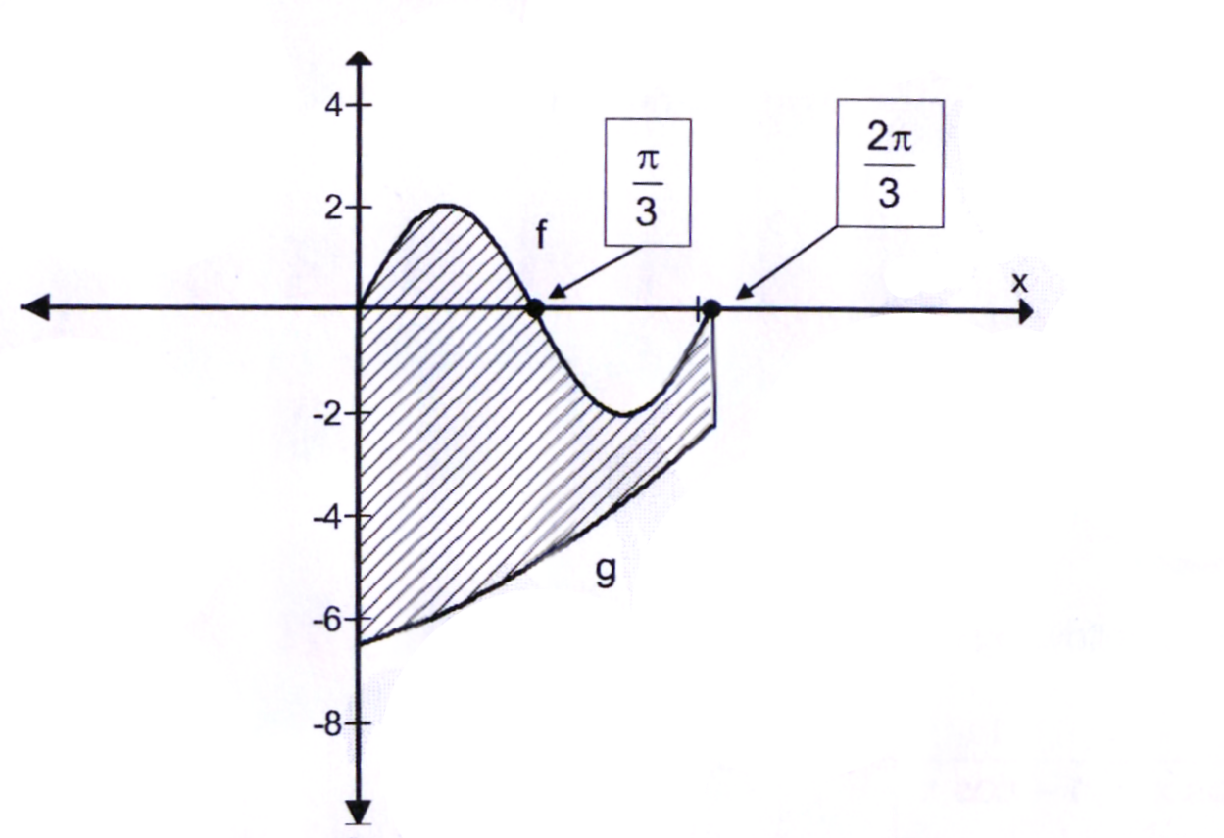

9.1 Show that the maximum distance between the two graphs in this interval can be obtained by solving the equation $6cos3x=x+1$. (6)

9.2 Use the Newton - Rapson Method to write down a recursive formula that can be used to solve the equation in 9.1. Hence, taking $x=0,8$ as an initial value, determine the answer correct to five decimal digits. (Show at least THREE iterations). (9)

**QUESTION 10 [30 MARKS]**

Given: $f\left(x\right)=\frac{2x^{2}+9x-5}{x-2}$

10.1 Determine the equation of each asymptote of the function $f.$ (4)

10.2 Determine the coordinates of the turning points of the function $f$, (correct to 2 decimal places) and by means of calculations,

determine whether they are local maxima or minima. (12)

10.3 Determine the $x-$ and $y-$ intercepts of the function $f.$ (4)

10.4 Sketch the graph of $f(x)$. (10)

**QUESTION 11 [8 MARKS]**

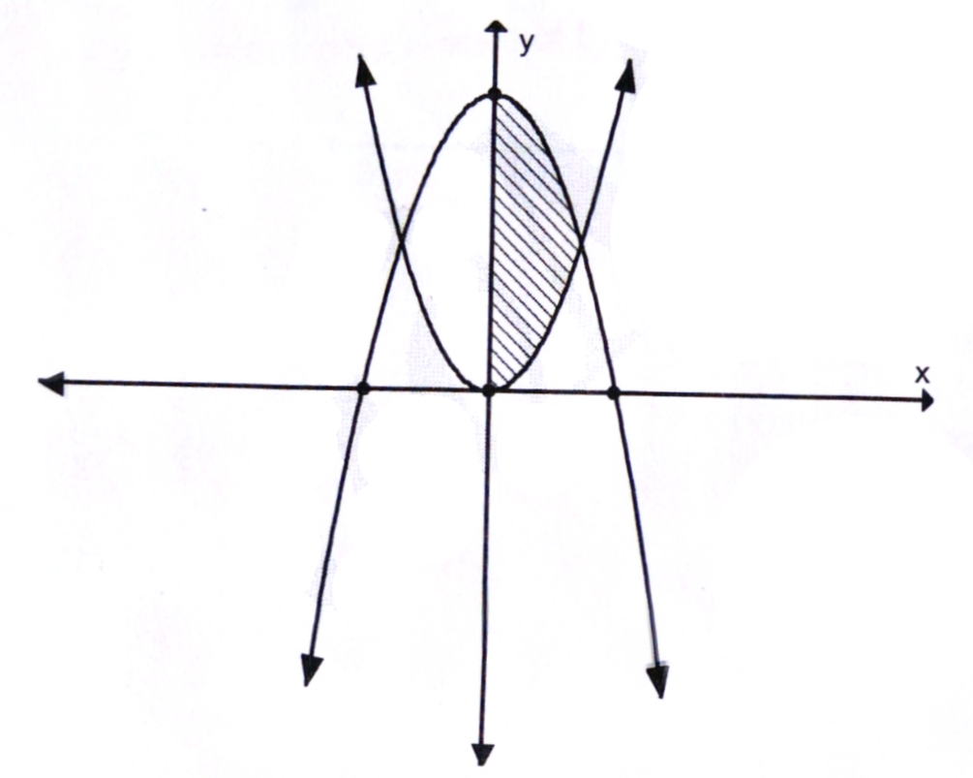The shaded area in the cartesian plane is bounded by $y=x^{2},$ $y=8-x^{2}$ and

$x=0$ is rotated about the $x-axis.$

Calculate the volume of the solid of revolution thus formed. Give the answer in terms of $π.$ (8)

**QUESTION 12 [10 MARKS]**

**Make sure your calculator is in radian mode.**

6

•

A

B

O

D

C

15

15

A circle is drawn above. CD is perpendicular to AB and when CD is extended it passes through the circle centre O. D is the midpoint of AB. The lengths of CD and AB are 6 cm and 30 cm respectively.

12.1 Show that the radius of the circle is 21,75 cm. (5)

12.2 Determine the length of arc ACB, correct to TWO decimal places. (2)

12.3 Calculate the area of the segment ACBD, correct to TWO decimal places. (3)

**TOTAL: 200**