

**Advanced Programme Mathematics Paper 1**

**Grade 12**

**Preliminary Examination**

**2019**

**Duration: 2 hours Examiner: R. Obermeyer**

**Marks: 200 Moderator: P. Pitout**

**Date: 20 August 2019 External Moderator: I. L. Atteridge**

**INSTRUCTIONS:**

* **See overleaf for Instructions.**
* **This paper consists of 9 pages (including cover), an answer sheet and an information sheet.**

**NAME: ____________________________________**

|  |  |  |  |  |
| --- | --- | --- | --- | --- |
| **Question** | **Level Tested** | **Suggested Time Allocation** | **Possible mark** | **Mark Obtained** |
| 1 | 1 – 4 | 5 mins | **9** |  |
| 2 | 1 – 4 | 11 mins | **18** |  |
| 3 | 1 – 4 | 20 mins | **33** |  |
| 4 | 1 – 4 | 5 mins | **9** |  |
| 5 | 1 – 4 | 6 mins | **10** |  |
| 6 | 1 – 4 | 11 mins | **18** |  |
| 7 | 1 – 4 | 5 mins | **8** |  |
| 8 | 1 – 4 | 17 mins | **26** |  |
| 9 | 1 – 4 | 22 mins | **39** |  |
| 10 | 1 – 4 | 18 mins | **30** |  |
|  |  | **TOTAL:** | **200** |  |
|  |  | **PERCENTAGE:** | |  |

**Teacher’s Signature:** ________________________

**Controller’s Signature:** _______________________

**Moderator’s Signature:** _______________________

**Instructions**

**PLEASE READ THE FOLLOWING INSTRUCTIONS CAREFULLY**

1. This question paper consists of 9 pages, an answer sheet and an Information Sheet. Please check that your paper is complete.
2. The answer sheet must be detached and handed in with your answer booklet.
3. Read the questions carefully.
4. Answer all the questions.
5. Number your answers exactly as the questions are numbered.
6. You may use an approved non-programmable and non-graphical calculator, unless otherwise stated.
7. Round your answers off to **one** decimal digit where necessary unless otherwise stated.
8. It is in your own interest to write legibly and to present your work neatly.
9. Please hand in this question paper.
10. Answer all questions **underneath** each other.
11. Start each new question on a **new** page.



**QUESTION 1**

Jerry wants to prove the formula that is sometimes used in a Reimann sum, by using Proof by Induction:

$$\sum_{i=1}^{n}{i^{3}=\frac{n^{2}{\left(n+1\right)}^{2}}{4}}$$

and thus that, $1+8+27+…+n^{3}=\frac{n^{2}{\left(n+1\right)}^{2}}{4};for all n∈ N$

He does the following steps:

|  |  |
| --- | --- |
| **Step** |  |
| **1** | **Let $n=1$:** |
| **2** |  |
| **3** | $∴$**statement is true for $n=1$** |
| **4** | **Let $n=k$:** |
| **5** | $1+8+27+…+k^{3}=\frac{k^{2}{\left(k+1\right)}^{2}}{4}$ |
| **6** | **Let $n=k+1$** |
| **7** | $RHS=\frac{{\left(k+1\right)}^{2}{\left(k+2\right)}^{2}}{4}$ |
| **8** |  |
| **9** |  |

1. Jerry made an error in Step 4. Write the correct version of this step (1)
2. Jerry could not finish Step 8. Write down this part of the proof (8)

**[9]**

**QUESTION 2**

1. Solve for $x$***,*** without the use of a calculator, if

$\log_{5}{(x-3)-}\log_{\frac{1}{5}}{(x-2)}-\log_{5}{2}=2$ (8)

1. Below is the function of $f(x)=\ln\left|x\right|$

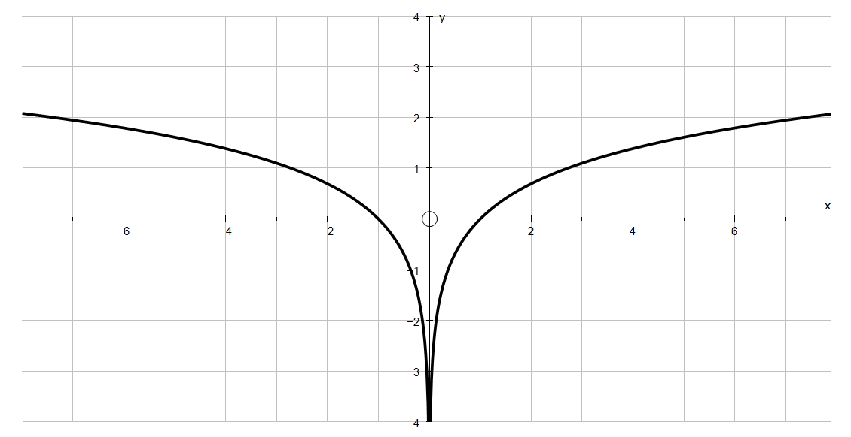

On the Answer Sheet provided draw the function of $g(x)=\left|f(x)\right|-1$ clearly showing any intercepts with the axes. (10)

**[18]**

**QUESTION 3**

1. Expand ${\left(\sqrt{2016i^{2016}}-1\right)}^{2}$, without the use of a calculator, leaving your answer in the form: $a+bi$ and including surds if necessary. (6)
2. Given: $f(x)=x^{4}+ax^{3}+3x^{2}+bx+2$ with $f\left(-2+\sqrt{2}\right)=0$ and $f\left(-2-\sqrt{2}\right)=0$. Determine the value(s) of $a$ and $b$ if $x∈C$. (7)
3. Solve the following equations:
4. $\left|2x^{2}-3x\right|=1$ (7)
5. $3e^{x}-\frac{2}{e^{x}}=1$ (6)
6. $\ln\left(e^{2x}-6\right)=x$ (7)

**[33]**

**QUESTION 4**

The dimensions of Junior Pacman are given below. Note that Junior Pacman has a radius **half** that of Daddy Pacman, and that $D\hat{E}F=A\hat{B}C$.





Length of Major arc DF is 15,71 cm and $D\hat{E}F=\frac{π}{3}$

1. Determine the perimeter of Daddy Pacman. (6)
2. Determine the area of Junior Pacman. (3)

**[9]**

**QUESTION 5**

Consider the function:

$f(x)=\left\{\begin{matrix}-{\left(x-1\right)}^{2} & if & x<1 \\ \left|x-3\right| & if & 1≤x<3 \\ -2^{x}+8 & if & 3≤x\end{matrix}\right.$

1. Discuss the continuity of $f(x)$ at $x=3$. (5)
2. Is $f(x)$ differentiable at $x=1$? Justify your answer algebraically, showing all of your working. (5)

**[10]**

**QUESTION 6**

Determine the following limits, if they exist:

1. $\lim_{x→0}{\frac{sin 2x ∙ tan x}{5x^{2}}}$ (5)
2. $\lim_{x→2}{\frac{x-2}{\sqrt{x+1}-\sqrt{3}}}$ (7)
3. $\lim_{x→∞}{\frac{5x^{2}-2x+3}{\sqrt{9x^{4}+5}}}$ (6)

**[18]**

**QUESTION 7**

1. Show that the equation $x^{3}-3x+1=0$ has a root (zero) between $x∈[-2;-1]$. (3)
2. Use Newton’s method to obtain this negative root of $x^{3}-3x+1=0$ correct to **4** decimal places. (5)

**[8]**

**QUESTION 8**

1. Determine $f^{'}(x)$ by first principles if $f(x)=\sqrt{2x+3}$. (6)
2. Determine $f^{'}(x)$ given that: $f(x)=x^{3}\ln{(3x)}$. (6)
3. Find the gradient of the graph of $y=2 \tan^{2}\left(\frac{θ}{2}-3\right)$ when $θ=\frac{π}{4}$. (7)
4. Given: $f(x)=\frac{1}{2x^{2}}$. Determine a formula for $f^{(n)}(x)$. (7)

**[26]**

**QUESTION 9**

Given: $f(x)=\frac{x^{2}+5x+6}{x+1}$

1. Find the co-ordinates of:
2. the intercepts with the axes (6)
3. the stationary points (correct to 1 decimal digit) (10)

1. Find the equations of:
2. the vertical asymptote (3)
3. the oblique asymptote (3)
4. Discuss the concavity of $f(x)$ by means of suitable calculations, and hence classify the stationary points found in (a). (12)
5. Use all the workings above to draw a neat sketch of $f(x).$ (5)

**[39]**

**QUESTION 10**

1. Determine the following integrals:
2. $\int{\frac{3}{\sqrt{4x-1}} dx}$ (5)
3. $\int{\frac{3x}{\sqrt{4x^{2}-1}} dx}$ (6)
4. $\int{\frac{3x}{\sqrt{4x-1}} dx}$ (Hint, use integration by parts) (9)
5. Determine the volume of the solid generated by rotating the area bounded by the curves $y=x$ and $y=x^{2}$ about the $x$-axis, as indicated by the shaded regions below.



(10)

**[30]**

**Name ………………………………………..**

**Question 2 (b)**

