GRADE 12 EXAMINATION

JULY 2019

**ADVANCED PROGRAMME MATHEMATICS**

**PAPER 1: CALCULUS AND ALGEBRA**

|  |  |
| --- | --- |
| Examiner: Mrs Eiselen | Moderators: Mrs A van den Berg; Mrs R Narsai |

**Time: 2 hours Marks: 200**

**PLEASE READ THE FOLLOWING INSTRUCTIONS CAREFULLY**

1. This question paper consists of **7** questions and 7 pages.
2. **ANSWER QUESTIONS 3(e), 4(a) and 4(b) ON THE QUESTION PAPER ON THE AXES PROVIDED.**
3. Read and answer all the questions carefully.
4. Number your answers exactly as the questions are numbered.
5. You may use an approved, non-programmable, and non-graphical calculator, unless otherwise stated.
6. Round off your answers to **one decimal digit** where necessary, **UNLESS STATED OTHERWISE**.
7. All the necessary working details must be clearly shown.
8. It is in your own interest to write legibly and to present your work neatly.

Name:____________________________________________________

*Marking Grid (for Educators’ use only)*

|  |  |  |  |  |  |  |  |  |
| --- | --- | --- | --- | --- | --- | --- | --- | --- |
| **Question Number** | **1** | **2** | **3** | **4** | **5** | **6** | **7** | **Total** |
| **Marks Earned** |  |  |  |  |  |  |  |  |
| **Total for Question** | **74** | **53** | **42** | **4** | **7** | **10** | **10** | **200** |

**QUESTION 1 [74]**

a) Consider  .

(1) Determine values of  for which  (7)

(2) Determine values of  for which  (10)

b) 

Given that  continuous at , find the value(s) of . (5)

c) 

(1) Given that  is a zero of , find the polynomial of degree 2 which is a related factor of . (3)

(2) Now fully factorize . (7)

d) If  and 

Calculate the values of  and . (12)

e) Solve the following equation for 

 (3)

f) Prove by First Principles  if  (8)

g) Find the gradient of the curve  at (2 ; 3) (12)

h) Find the equation of the tangent to  at the y-intercept. (7)

**QUESTION 2 [53]**

a)  (12)

b)  (6)

c) Determine  (6)

d)  (11)

e) 

(1) Express  as a polynomial in  (2)

(2) Write  as a sum of partial fractions (6)

(3) Determine  (10)

**QUESTION 3 [42]**

Given that  and . If .

a) Show that  (8)

b) Define the horizontal asymptotes of  (10)

c) Calculate  (10)

d) Determine the intercepts of  (4)

e) Sketch  (10)

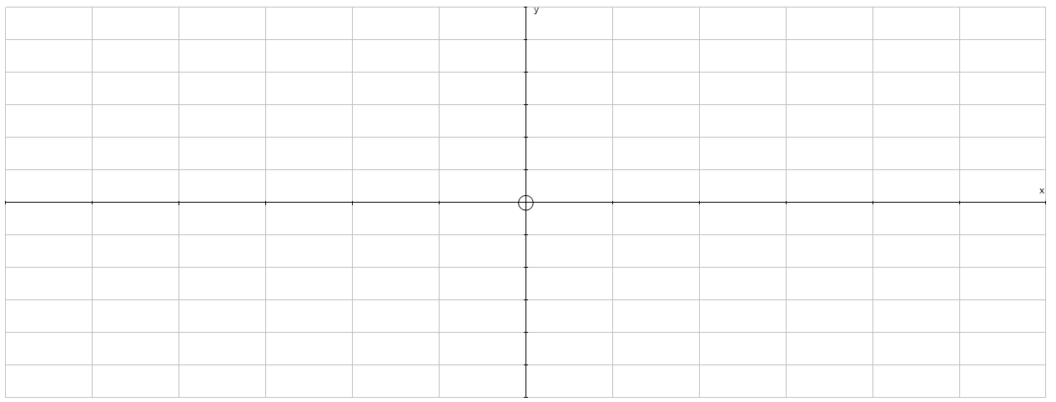

**QUESTION 4 [4]**

a) Sketch  and (2)



b)  (2)



**QUESTION 5 [7]**

**A**

**B**

**C**

**D**

**E**

**F**

Given  , the derivative of 

Giving clear reasons, state at which of the marked values of  (A to F)  will have

(1) its greatest value (2)

(2) points of inflection (3)

(3) determine whether  has a turning point. Motivate your answer. (2)

**QUESTION 6 [10]**

Prove, by Mathematical Induction that . (10)

**QUESTION 7 [10]**

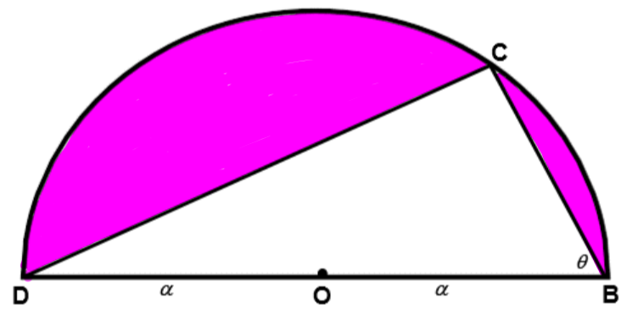

(1) Show that the area of the shaded region is  (4)

(2) Hence,

a) find the value of  for which the area of A is equal to the area of the semi-circle. (3)

b) find the value of  for which the area of A would be a maximum (3)

Reference: Questions adapted from past IEB examination papers