GRADE 12 EXAMINATION

JULY 2019

**ADVANCED PROGRAMME MATHEMATICS**

**PAPER 2: ELECTIVE (MATRICES AND GRAPH THEORY)**

|  |  |
| --- | --- |
| Examiner: Mrs Eiselen | Moderators: Mrs A van den Berg; Mrs R Narsai |

**Time: 1 hour Marks: 100**

**PLEASE READ THE FOLLOWING INSTRUCTIONS CAREFULLY**

1. This question paper consists of **12** questions and 9 pages.
2. Read and answer all the questions carefully.
3. Number your answers exactly as the questions are numbered.
4. You may use an approved, non-programmable, and non-graphical calculator, unless otherwise stated.
5. Round off your answers to **one decimal digit** where necessary.
6. All the necessary working details must be clearly shown.
7. It is in your own interest to write legibly and to present your work neatly.
8. **ANSWER QUESTIONS 7 – 12 ON THE EXAMINATION PAPER.**
9. **EXTRA DIAGRAM SHEETS ARE AVAILABLE ON REQUEST.**

Name:____________________________________________________

*Marking Grid (for Educators’ use only)*

|  |  |  |  |  |  |  |  |  |  |  |  |  |  |
| --- | --- | --- | --- | --- | --- | --- | --- | --- | --- | --- | --- | --- | --- |
| **Question Number** | **1** | **2** | **3** | **4** | **5** | **6** | **7** | **8** | **9** | **10** | **11** | **12** | **Total** |
| **Marks Earned** |  |  |  |  |  |  |  |  |  |  |  |  |  |
| **Total for Question** | **9** | **6** | **8** | **6** | **10** | **10** | **8** | **10** | **8** | **6** | **12** | **7** | **100** |

**SECTION A: MATRICES**

**QUESTION 1 [9]**

1.1 Matrix  is defined by 

Given the determinant of  is 2, obtain:

a) the value of . (2)

b)  . (3)

1.2 Obtain the value(s) of  for which the matrix  is singular. (4)

**QUESTION 2 [6]**

Matrices C and D are given by:

 and 

a) obtain  where  is the transpose of  . (2)

b) Find and simplify an expression for the determinant of . (2)

c) State the value of  such that the inverse of D does not exist. (2)

**QUESTION 3 [8]**

Planes  have equations:

|  |  |
| --- | --- |
|  |  |
|  |  |
|  |  |

where .

a) Use Gaussian elimination to find the value of  such that the intersection of the planes  have infinitely many solutions. (4)

b) Find the equation of the line of intersection of the planes when  takes this value. (4)

**QUESTION 4 [6]**

|  |
| --- |
|  |

Apply row reduction and the principle above to determine the determinant of the 4 x 4 matrix below:



**QUESTION 5 [10]**

a) Obtain the matrix, *A*, associated with an anticlockwise rotation of  radians, about the origin. (4)

b) Find the matrix, *B*, associated with a reflection in the *x*-axis. (2)

c) Hence obtain the matrix, *P*, associated with an anticlockwise rotation of  radians about the origin followed by reflection in the *x*-axis, expressing your answer using exact values. (4)

**QUESTION 6 [4]**

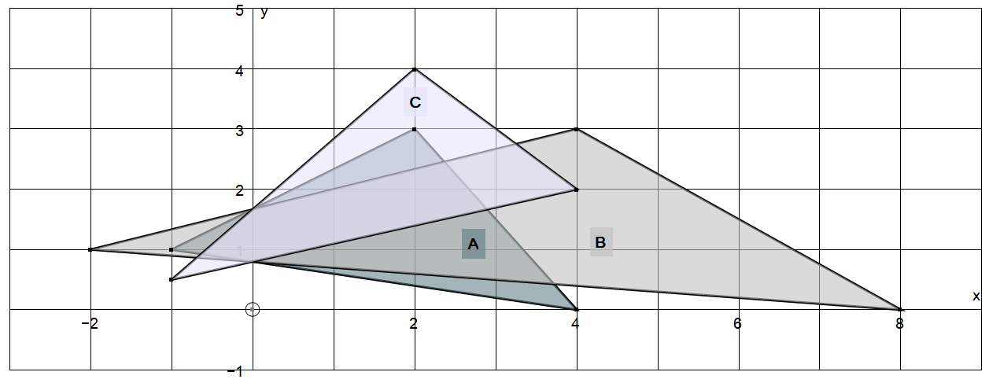

a) Triangle A is mapped onto Triangle B. Describe, with the aid of a matrix, the transformation it undergoes. (5)

b) Triangle A is mapped onto Triangle C. Describe, with the aid of a matrix, the transformation it undergoes. (5)

**QUESTION 7 [8]**

a) What must be added to Graph 2 to make the two graphs isomorphic?

**A**

**B**

**D**

**F**

**C**

**E**

Graph 1:

**P**

**Q**

**S**

**R**

**T**

**U**

Graph 2:

b) Draw a graph from the following adjacency matrix (4)



**QUESTION 8 [10]**

Determine an Eulerian circuit for the following graph, by using the Chinese Postman Algorithm. Clearly show the process, the final weight and a circuit starting and ending at vertex P.

**R**

**18**

**21**

**Q**

**P**

**19**

**10**

**30**

**14**

**W**

**17**

**27**

**U**

**13**

**25**

**15**

**S**

**11**

**23**

**V**

**T**

**22**

**X**

**QUESTION 9 [8]**

By applying Dijkstra’s Algorithm, determine the shortest path from W to S. Clearly show the process, the final weight and the path from W to S.

**R**

**18**

**21**

**Q**

**P**

**19**

**10**

**30**

**14**

**W**

**17**

**27**

**13**

**U**

**25**

**15**

**S**

**23**

**V**

**T**

**QUESTION 10 [6]**

Natalie is having a kitchen tea for her friend, Emma, who is getting married. She wants to throw a surprize party for Emma’s closest friends. The invitations are given telephonically. The vertices represent the friends and the edges represent the knowledge of the next friend’s phone number.

a) What is the minimum number of calls that must be made to let every friend know about the tea party. (2)

b) If each person can make a maximum of two calls, will the whole team be informed? Explain why. (2)

c) Who has most of the friends phone numbers? (2)

**B**

**C**

**F**

**N**

**M**

**L**

**K**

**J**

**QUESTION 11 [12]**

In the graph below, determine a range of weights between which an optimal circuit would lie.

a) Remove Vertex A and use Kruskal’s, or Primm’s, for the lower bound. (7)

b) Start at Vertex A for the upper bound. (5)

**A**

**E**

**B**

**C**

**D**

**G**

**F**

**3**

**7**

**4**

**8**

**6**

**7**

**2**

**4**

**5**

**3**

**11**

**QUESTION 12 [7]**

Show that  ; for all integers,  where ; where  (7)

**TIP: **