

### ADVANCED PROGRAMME MATHEMATICS: PAPER I

### MATRIC

**PRELIMINARY EXAMINATIONS SEPTEMBER 2019**

#### Marks: 200 Examiner: M Brown

#### Time: 2 Hours Moderator: R Bourquin

#### Reading Time: 10 Min

_______________________________________________________________________________________

**PLEASE READ THESE INSTRUCTIONS CAREFULLY:**

1. This question paper consists of 9 pages and an Information Sheet.

Please check that your paper is complete.

2. Read the questions carefully.

3. **Answer ALL the questions.**

4.Number your answers exactly as the questions are numbered.

5. Diagrams are not necessarily drawn to scale.

6. All the necessary working details must be clearly shown. Answers only will not necessarily be awarded full marks.

7. Approved non-programmable and non-graphical calculators may be used unless otherwise stated.

8. Ensure that your calculator is in **RADIAN** mode.

9. Round off your answers to two decimal digits, unless otherwise indicated.

10. It is in your own interest to write legibly and to present your work neatly.

______________________________________________________________________________

**QUESTION 1**

(a) Solve for *x*, where :

(1)  (4)

(2)  (5)

(3)  (6)

(b) Given:  and , where *k* is a constant

(1) Show that the expression  simplifies to . (6)

(2) Find the value of *k* for which  has equal roots. (3)

[24]

**QUESTION 2**

Given:  and  ,

(a) Find the values of:

(1)  (1)

(2)  (3)

(3)  (2)

(b) Find a quadratic equation with roots of  and . (6)

(c) Illustrate  on an Argand diagram and express  in Modulus- Argument form. (7)

[19]

**QUESTION 3**

A pattern on a square tile is created from 7 equal sectors as shown below. The circle is

inscribed in the square. The total shaded area in the tile measures .



$$A$$

$$B$$

(a) Determine the radius, , of the circle to one decimal. (7)

(b) Hence, determine the area of the square tile to one decimal digit. (3)

(c) Determine minor arc length AB to one decimal. (3)

[13]

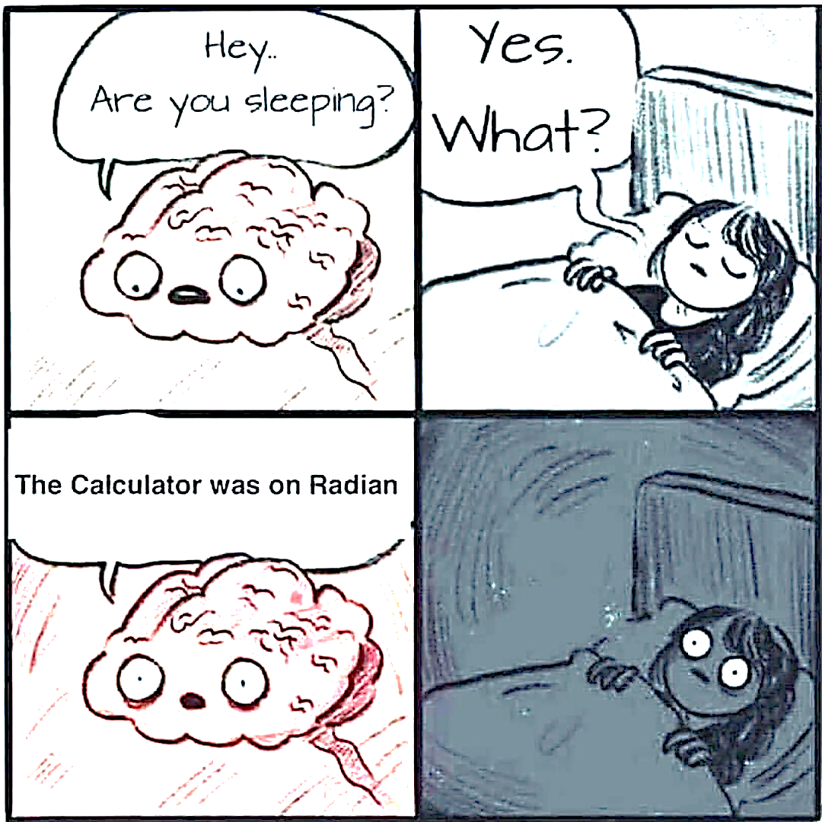

?

**QUESTION 4**

(a) Differentiate, with respect to *x*:

(1)  (3)

(2)  (4)

(3)  (3)

(4)  (7)

(b) The graph of  (the derivative of ) is given below.

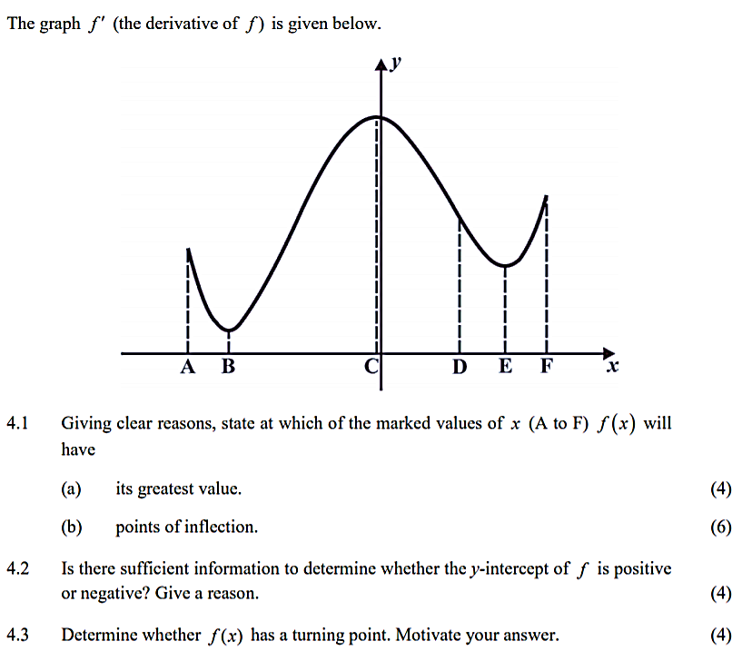

State at which value(s) of the marked values of *x* (A to F),  will:

(1) have a positive gradient. (2)

(2) be concave up. (3)

(3) have its greatest value. (2)

(4) have points of inflection. (2)

[26]

**QUESTION 5**

(a) Given: 

(1) Simplify  to the form  (2)

(2) Hence, sketch  , clearly indicating intercepts and asymptotes. (4)

(b) The intensity of the sound, D, measured in decibels (dB) is given by formula

, where L is the power if the sound in watts per square

centimetre  and  is the power of the sound just below

the threshold of hearing.

Find the power of the sound L  experienced by the audience in the

front of an orchestra, measured at 107 dB. Give your answer in scientific notation

correct to two decimal digits. (6)

[12]

**QUESTION 6**

Use mathematical induction to prove that  is divisible by 8 for all .

[12]

**QUESTION 7**

(a) The diagram shows the graph of the function



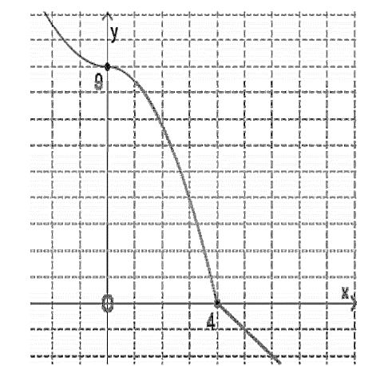

**A (3 ; 4)**

**B (6 ; -2)**

Using the diagram and the given points **A** and **B**, and without solving for *p* and *q ,*

draw separate sketches, clearly showing all intercepts with the axes, of:

(1)  (3)

(2) The inverse function, . (5)



(b) The functions ,  and  are defined, for , by:



Given that .

(1) Determine the coordinates of the intercepts of , correct to one decimal

digit. (3)

(2) Determine the coordinates of the stationary points of . (9)

(3) Determine the equations of the asymptotes of . (8)

(4) Sketch the graph of , including intercepts with the axes (correct to

one decimal digit), stationary points and asymptotes. (9)

[37]

**QUESTION 8**

Assume that the functions ,  and  are continuous and differentiable for all

real values, as are their derivatives. In the table, the functions are evaluated at a point

where . However, two of the values are omitted. It is also given that .

|  |  |  |  |  |  |
| --- | --- | --- | --- | --- | --- |
|  |  |  |  |  |  |
| 1 | 2 | ? | 6 |  | ? |

Showing all calculations, determine:

(a)  (3)

(b)  (6)

[9]

**QUESTION 9**

Parts of the functions of  and  are shown, intersecting at A.

 and 

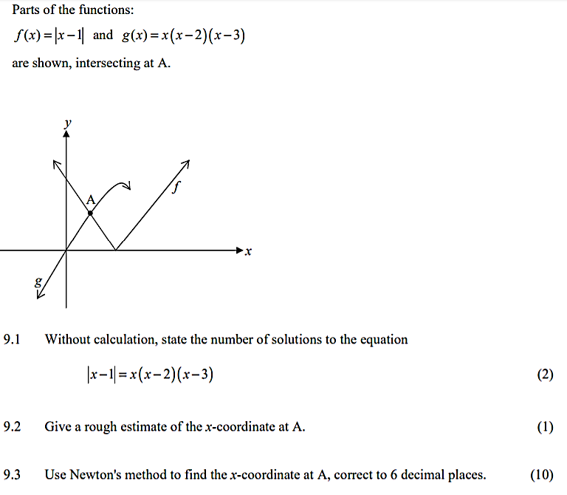

(a) Without calculation, state the number of solutions of the equation

 (2)

(b) Give a rough estimate of the *x*-coordinate at A. (1)

(c) Use Newton’s method to find the *x*-coordinate of A, correct to six decimal digits.(10)



[13]

**QUESTION 10**

(a) Determine the following:

(1)  (3)

(2)  (6)

(3)  (6)

(4)  (6)

(b) The diagram below shows a section of the curve of  that intersects

the *y*-axis at A. The tangent to the curve at , intersects the *y*-axis at B.

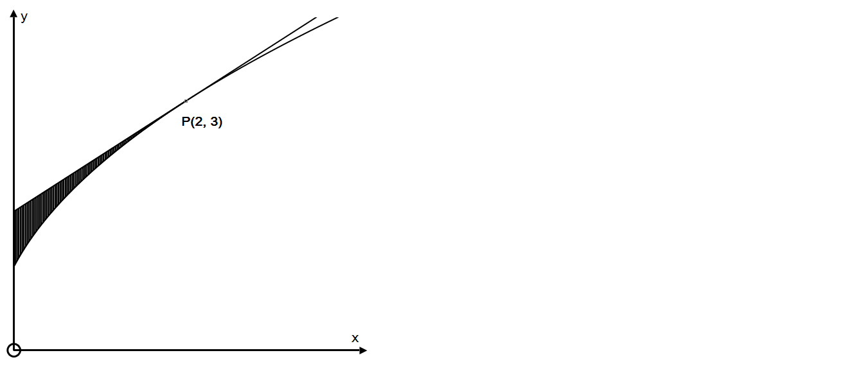

**B**

**A**

(1) Determine the equation of the tangent BP. (6)

(2) Determine the area of ​​the shaded section ABP, correct to two decimal

digits. (4)

(3) Determine the volume of the solid of revolution formed by rotating the

shaded region about the *x*-axis. (4)

[35]

**TOTAL: 200 marks**

______________________________________________________________________________