**ST. DAVID’S MARIST INANDA**



**ADVANCED PROGRAMME MATHEMATICS**

**PRELIMINARY EXAMINATION**

**PAPER 1: CALCULUS and ALGEBRA**

**GRADE 12**

**3 SEPTEMBER 2019**

**EXAMINER: MRS S RICHARD MARKS: 200**

**MODERATOR: MRS C KENNEDY TIME: 2 hours**

**NAME:_____________________________________________________________**

INSTRUCTIONS:

* This paper consists of 24 pages and a separate 2-page formula sheet. Please check that your paper is complete. The last 2 pages are blank for working out.
* Please answer all questions on the Question Paper.
* You may use an approved non-programmable, non-graphics calculator unless otherwise stated. PLEASE ENSURE YOUR CALCULATOR IS IN **RADIAN** MODE.
* Round answers to 2 decimal places, unless stated otherwise.
* It is in your interest to show all your working details.
* Work neatly. Do NOT answer in pencil.
* Diagrams are not drawn to scale.

|  |  |  |  |  |  |  |  |  |  |  |  |  |  |
| --- | --- | --- | --- | --- | --- | --- | --- | --- | --- | --- | --- | --- | --- |
| **QUESTION** | **Q1**  **[29]** | **Q2**  **[16]** | **Q3**  **[11]** | **Q4**  **[24]** | **Q5**  **[10]** | **Q6**  **[17]** | **Q7**  **[23]** | **Q8**  **[10]** | **Q9**  **[9]** | **Q10**  **[33]** | **Q11**  **[8]** | **Q12**  **[10]** | **TOTAL**  **[200]** |
| **LEARNER’S**  **MARKS** |  |  |  |  |  |  |  |  |  |  |  |  |  |

**QUESTION 1**

1. Solve for x, without using a calculator and showing all working:
2.  (6)

1.  (6)

b) Sketch  on the axes provided. (5)



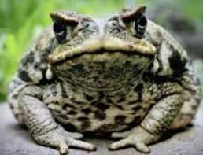c) The number of Cane toads K, in a particular area of Western Australia after

t years can be determined by using the equation:



i) Determine the number of toads at the start of the

study, that is at t = 0. (2)

ii) How many toads, to the nearest integer, will there be after exactly one year? (2)

1. It will be considered an epidemic if there are more than 900 toads in a particular area. After how many years will there be 900 toads? (6)

iv) Determine the number of toads in the area as  ? (2)

**[29]**

**QUESTION 2** Note 

a) Determine, in standard form  with a, b, c and d real

co-efficients, a cubic equation which has roots -2 and  (8)

b)Determine the values of a and b, where a and b are real numbers that satisfy

the equation:  (8)

**[16]**



**QUESTION 3**

Use Mathematical induction to prove that for all  that:

 (11)

**[11]**

**QUESTION 4**

a) Given  and 

Determine  in simplest from and state its domain. (8)

1. Determine the value of the limit if it exists:

 (4)

c) Given the function:



i) Determine the real value of k if h(x) is continuous at . (5)

ii) Is h(x) differentiable at ? Assume  Justify your answer. (7)

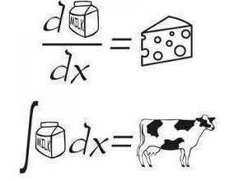

**[24]**

**QUESTION 5**

a) Given . Use Newton’s method to solve 

Use  as an initial value. Give your answer correct to 3 decimal places. (6)

b) A chord of a circle which subtends an angle of  at the centre, cuts off a segment

equal in area to  of the area of the whole circle.

Show that  (4)





**[10]**

**QUESTION 6**

The sketch, not necessarily drawn to scale, represents:



a) Calculate the coordinates of A and B, the relative maximum and relative minimum of h(x). (9)

b) Give the equations of the three asymptotes. (4)

c) From the graph, determine the value(s) of x if  is real. (4)

**[17]**

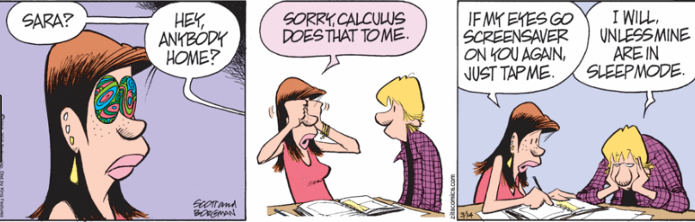

**QUESTION 7**

a) Determine the equation of the tangent to the curve defined by the equation

 at the point . (10)

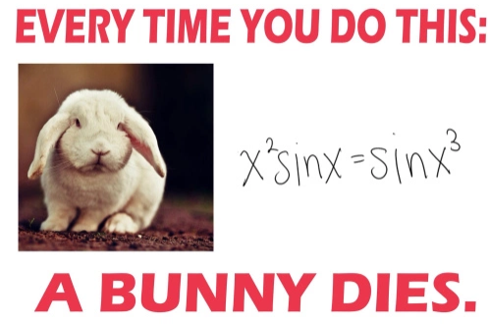

b) Determine the nth derivative of  (6)

c) Determine  . Simplify your answer. (7)

**[23]**

**QUESTION 8**

The concentration  in milligrams/cm3 of a particular drug in a patient’s bloodstream is determined using the formula:

 ,where T is the time in hours which has elapsed since the drug was taken.

a) If the patient took the drug at 7:00 in the morning, at what time will the

concentration be a maximum? (8)

b) What is this maximum concentration? (2)

**[10]**

**QUESTION 9**

The area under the curve  above the x-axis and in the interval  is calculated using Riemann sums. If n rectangles are used, then an expression for the area simplifies to:



a) Calculate the area if 18 rectangles are used. (3)

b) Calculate the exact area under the curve. (1)

c) Why do the answers in a) and b) differ in value? (2)

d) Calculate the percentage error if 18 rectangles are used. (3)

**[9]**

**QUESTION 10**

1. Determine the following integrals:
2.  (6)
3.  (Hint: ) (8)
4.  (by parts) (8)
5. i) Decompose  into partial fractions. (6)

ii) Hence determine the following integral:

 (5)

**[33]**

**QUESTION 11**

The sketch shows the graphs of  and  for the interval 

1. Determine the x-coordinate of the point of intersection P. (4)





1. Hence or otherwise determine the area of the shaded region. (4)

**[8]**

**QUESTION 12**

The diagram shows part of the curve  and the line 

An area A is formed bounded by the axes and the graphs ofthe curve  and the line 

Calculate the volume of the solid formed when the shaded area A is rotated about the x-axis. (10)

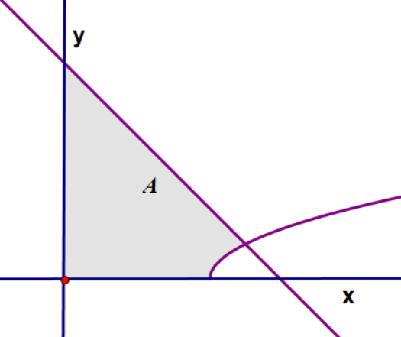

**[10]**

**[Total: 200 marks]**



