

Departments of Mathematics

|  |  |
| --- | --- |
| **GRADE 12** | |
| **ADVANCED PROGRAMME**  **PRELIMINARY EXAMINATION – PAPER 1** | |
| **DATE:**  **8 July 2019** | **TIME:**  **2 hours** |
| **TOPIC:**  **Calculus & Algebra** | **TOTAL MARKS:**  **183** |
| **EXAMINER:**  **Mrs. M. Kaur** | **MODERATOR:**  **Mr. P. Statham** |

***PLEASE READ THE FOLLOWING INSTRUCTIONS CAREFULLY:***

1. This question paper consists of 10 questions and 12 pages.
2. A separate blue information (formula) sheet will be provided to you.
3. Answer ALL the questions and clearly show the calculations you have used to determine your answers.
4. You may use an approved scientific calculator (non-programmable and non-graphical) unless specified otherwise.
5. Please note that diagrams are not drawn to scale.
6. It is in your own interest to write legibly and to present your work neatly.
7. PLEASE FILL IN YOUR NAME AND CIRCLE YOUR TEACHER’S NAME ON THE BACK PAGE.

**THIS PAGE IS INTENTIONALLY LEFT BLANK**

**QUESTION 1**

1.1 It is given that , where  and  are real numbers.

Find the complex number  such that

 , where  is the complex conjugate of . (8)

**[8]**

**QUESTION 2**

2.1Prove, by mathematical induction, that for all ,

 (14)

**[14]**

**QUESTION 3**

3.1 Solve for in each of the following, showing all your working.

(a)  (5)

(b)  (7)

3.2 A colony of bacteria that grows according to the law of uninhibited growth is modelled by the function  where  is measured in grams

and  is measured in days.

(a) Determine the initial amount of bacteria. (2)

(b) What is the population after five days? (2)

(c) What is the doubling time for the population? (4)

**[20]**

**QUESTION 4**

4.1 Solve for  if 

 (6)

4.2 (a) Sketch the curve of  and  on the same

set of axes. (4)

|  |  |  |  |  |  |  |  |  |  |  |  |  |  |  |  |
| --- | --- | --- | --- | --- | --- | --- | --- | --- | --- | --- | --- | --- | --- | --- | --- |
|  |  |  |  |  |  |  |  |  |  |  |  |  |  |  |  |
|  |  |  |  |  |  |  |  |  |  |  |  |  |  |  |  |
|  |  |  |  |  |  |  |  |  |  |  |  |  |  |  |  |
|  |  |  |  |  |  |  |  |  |  |  |  |  |  |  |  |
|  |  |  |  |  |  |  |  |  |  |  |  |  |  |  |  |
|  |  |  |  |  |  |  |  |  |  |  |  |  |  |  |  |
|  |  |  |  |  |  |  |  |  |  |  |  |  |  |  |  |
|  |  |  |  |  |  |  |  |  |  |  |  |  |  |  |  |
|  |  |  |  |  |  |  |  |  |  |  |  |  |  |  |  |
|  |  |  |  |  |  |  |  |  |  |  |  |  |  |  |  |
|  |  |  |  |  |  |  |  |  |  |  |  |  |  |  |  |
|  |  |  |  |  |  |  |  |  |  |  |  |  |  |  |  |

(b) Use your sketch to solve for  if  (2)

**[12]**

**QUESTION 5**

The functions  and  are defined as follows:

 and 

5.1 (a) Find and expression for  (1)

(b) Solve the equation  (3)

5.2 (a) The inverse of  is . Find  (3)

(b) Draw the graph of and  on the same set of axes, clearly

indicating the intercepts with the axes and asymptotes. (6)

|  |  |  |  |  |  |  |  |  |  |  |  |  |  |  |  |
| --- | --- | --- | --- | --- | --- | --- | --- | --- | --- | --- | --- | --- | --- | --- | --- |
|  |  |  |  |  |  |  |  |  |  |  |  |  |  |  |  |
|  |  |  |  |  |  |  |  |  |  |  |  |  |  |  |  |
|  |  |  |  |  |  |  |  |  |  |  |  |  |  |  |  |
|  |  |  |  |  |  |  |  |  |  |  |  |  |  |  |  |
|  |  |  |  |  |  |  |  |  |  |  |  |  |  |  |  |
|  |  |  |  |  |  |  |  |  |  |  |  |  |  |  |  |
|  |  |  |  |  |  |  |  |  |  |  |  |  |  |  |  |
|  |  |  |  |  |  |  |  |  |  |  |  |  |  |  |  |
|  |  |  |  |  |  |  |  |  |  |  |  |  |  |  |  |
|  |  |  |  |  |  |  |  |  |  |  |  |  |  |  |  |
|  |  |  |  |  |  |  |  |  |  |  |  |  |  |  |  |
|  |  |  |  |  |  |  |  |  |  |  |  |  |  |  |  |

**[13]**

**QUESTION 6**

6.1 A function is defined as follows:



(a) Sketch the graph of , showing all intercepts with the axes

and end points. (6)

|  |  |  |  |  |  |  |  |  |  |  |  |  |  |  |  |
| --- | --- | --- | --- | --- | --- | --- | --- | --- | --- | --- | --- | --- | --- | --- | --- |
|  |  |  |  |  |  |  |  |  |  |  |  |  |  |  |  |
|  |  |  |  |  |  |  |  |  |  |  |  |  |  |  |  |
|  |  |  |  |  |  |  |  |  |  |  |  |  |  |  |  |
|  |  |  |  |  |  |  |  |  |  |  |  |  |  |  |  |
|  |  |  |  |  |  |  |  |  |  |  |  |  |  |  |  |
|  |  |  |  |  |  |  |  |  |  |  |  |  |  |  |  |
|  |  |  |  |  |  |  |  |  |  |  |  |  |  |  |  |
|  |  |  |  |  |  |  |  |  |  |  |  |  |  |  |  |
|  |  |  |  |  |  |  |  |  |  |  |  |  |  |  |  |
|  |  |  |  |  |  |  |  |  |  |  |  |  |  |  |  |
|  |  |  |  |  |  |  |  |  |  |  |  |  |  |  |  |
|  |  |  |  |  |  |  |  |  |  |  |  |  |  |  |  |
|  |  |  |  |  |  |  |  |  |  |  |  |  |  |  |  |

(b) Algebraically, explain why cannot be differentiable at  (5)

6.2 The graph of a piece wise function is given below. Write a definition

for the function. (6)



 x

 x

 x

y

x

 x

6.3 Evaluate the following limits:

(a)  (5)

(b)  (3)

**[25]**

**QUESTION 7**

7.1 Differentiate the following with respect to . DO not simplify your answers.

(a)  (3)

(b)  (4)

(c)  (3)

7.2 Find the coordinates of the stationary point of the curve given

by the equation:

 (8)

7.3 Find the gradient at  if  (9)

**[27]**

**QUESTION 8**

8.1 It is given that 

(a) For which values of  is . (4)

(b) Decompose  into partial fractions. (5)

(c) Hence determine  (3)

8.2 Part of the curve defined by  is sketched below:

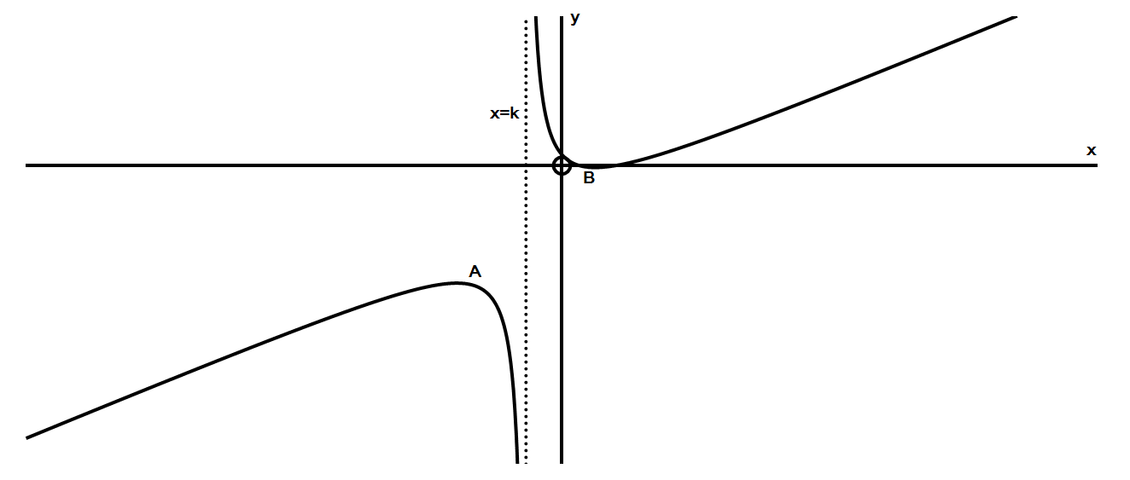

(a) Write down the equations of the asymptotes. (4)

(b) If  and  are the turning points of , find the - coordinates

of the turning points. (8)

**[24]**

**QUESTION 9**

9.1 Prove that  (5)

9.2 If 

(a) Show that there is an *x*-intercept in the interval  (2)

(b) Apply the Newton-Raphson procedure to find the *x*-intercept

correct to 5 decimal places. (6)

9.3 The figure below consists of sector  of circle with centre joined to a sector  of a different circle, also with centre  .

Given that the arc length ,  and  is a straight

line of length 

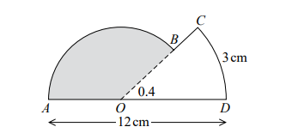

(a) Find the length of . (2)

(b) Find the area of the shaded sector . (3)

**[18]**

**QUESTION 10**

10.1 Integrate the following indefinite integrals:

(a)  (4)

(b)  (4)

(c)  (by parts) (7)

10.2 The diagram shows the graph of . Determine the area of

the shaded region. (7)

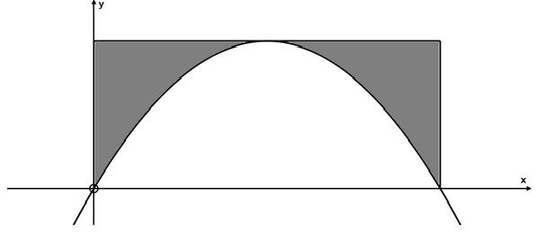

**[22]**

**MARK RECORD SHEET**

**FOR OFFICIAL USE ONLY**

NAME OF LEARNER:

NAME OF TEACHER: SMITH KAUR

|  |  |
| --- | --- |
|  | **CALCULUS**  **& ALGEBRA** |
| **1** | **/ 8** |
| **2** | **/14** |
| **3** | **/ 20** |
| **4** | **/ 12** |
| **5** | **/ 13** |
| **6** | **/ 25** |
| **7** | **/ 27** |
| **8** | **/ 24** |
| **9** | **/ 18** |
| **10** | **/ 22** |
| **TOTAL** | **/ 183** |
|  | **%** |