# KING DAVID HIGH SCHOOL LINKSFIELD



**GRADE 12**

**ADVANCED PROGRAMME MATHEMATICS**

**PAPER 2 – OPTIONS**

**PRELIMINARY EXAMINATIONS AUGUST 2020**

**Total: 100 marks**

#### Reading Time: 10 minutes Writing Time: 1 hour

**NAME**: ___________________________________________________________

This paper contains **20** pages and an information sheet of 2 pages.

Check that your paper is complete.

**Please read the following instructions carefully:**

1. Number all questions exactly as they appear on the question paper.

2. Pay careful attention to time management and mark allocation.

3. Write legibly and not in pencil.

4. Non programmable calculators may be used unless otherwise instructed.

5. All necessary calculations must be clearly shown. You will NOT

receive full credit if you write down only the answers and show no

working out.

**6. You must answer only ONE of the three modules (A ; B or C).**

7. **ENSURE THAT YOUR CALCULATOR IS IN DEGREE MODE**.

|  |  |  |  |  |  |  |  |  |
| --- | --- | --- | --- | --- | --- | --- | --- | --- |
| **Module A** | Q1  [30] | Q2  [21] | Q3  [16] | Q4  [25] | Q5  [8] |  |  | TOTAL  [100] |
|  |  |  |  |  |  |  |  |  |
| **Module B** | Q1  [5] | Q2  [9] | Q3  [15] | Q4  [22] | Q5  [16] | Q6  [25] | Q7  [8] | TOTAL  [100] |
|  |  |  |  |  |  |  |  |  |
| **Module C** | Q1  [15] | Q2  [23] | Q3  [10] | Q4  [10] | Q5  [18] | Q6  [10] | Q7  [14] | TOTAL  [100] |
|  |  |  |  |  |  |  |  |  |

**MODULE A – STATISTICS [100 marks]**

**Question 1: [30]**

1.1 After the airing of a particularly controversial programme, a radio station received 80 letters of complaint. The letters were classified according to the following table:

|  |  |  |  |
| --- | --- | --- | --- |
|  | Annoyed | Angry | Furious |
| Male | 16 | 15 | 10 |
| Female | 10 | 23 | 6 |

The station’s general manager wants to read a “typical” letter of complaint and asks the producer of the programme to select a letter at random.

Determine the probability that the writer of the letter is  
  
(a) male, given that the writer is angry. (4)

(b) furious, given that the writer is female. (4)

1.2 A jar contains 18 toffees, 20 jelly babies and 27 chocolates. If three sweets are randomly taken from the jar and eaten, what is the probability that no toffee is chosen. (6)

1.3 Research has shown that after watching an advert for a popular fast food chain kiddie’s meal, the probability of a child wanting the meal is 0,45.

(a)      A couple with their three children were sitting watching TV when the ad mentioned above airs. They want to know the probability that at least two of their children will want the meal advertised.                                           (7)

(b)      Using the normal approximation, find the probability that out of a group of 100 children, at least 30 children will want the meal after watching the advert. Provide reasons as to why this is applicable.                               (9)

**Question 2: [21]**

2.1 The number of customers, X, in a shop at 10:00 has a probability distribution given by:

$P\left(X=x\right)= \frac{1}{k}\left(2x+1\right),$ where $x∈\{0 ;1 ;2 ;3\}$

(a) Show that the value of $k=$ 16. (4)

(b) Hence determine the expected mean and standard deviation. (7)

2.2 A probability density function is defined as follows:

$f\left(x\right)=\left\{\begin{aligned}\frac{1}{x^{2}} ; \frac{1}{2}≤x≤a \\ 0 ;elsewhere\end{aligned}\right.$

(a) Show that the value of *a* is 1. (5)

(b) Find the mode for the above density function. (5)

**Question 3: [16]**

3.1 Given that $X\sim N(6,25)$

(a) calculate $P(5≤X≤7)$ (4)

(b) find a value of *t* such that $P\left(X<t\right)=0,85$ (4)

3.2 It is known that X is normally distributed with mean $μ$ and standard deviation $σ$. It is given that $3σ^{2}=2μ$ and that $P\left(X<\frac{μ}{3} \right)=0,015$. Find $μ$ and $σ$. (8)

**Question 4: [25]**

4.1 In a particular community, it was found that the proportion of people carrying a dreaded virus was 0,081.

(a) Determine a 95% confidence interval of people carrying the dreaded virus if a sample of 209 people from the community was taken. (8)

(b) What do researchers need to do to narrow the confidence interval? (2)

4.2 Social media usage is very high among teenagers these days. A recent study showed that the average number of hours spent on social media a day is 9 hours with a standard deviation of 3 hours. An app records the hourly usage of 10 random users:

|  |  |  |  |  |  |  |  |  |  |  |
| --- | --- | --- | --- | --- | --- | --- | --- | --- | --- | --- |
| User | 1 | 2 | 3 | 4 | 5 | 6 | 7 | 8 | 9 | 10 |
| Usage | 12,5 | 15 | 8,9 | 10,2 | 20 | 17,5 | 5,6 | 7,7 | 9,2 | 13 |

(a) Conduct a hypothesis test at the 5% significance level to determine whether, based on this sample, it is fair to claim that the mean usage is 9 hours. (10)

(b) Based on this sample, determine a 99% confidence interval for the mean usage. (5)

**Question 5: [8]**

During an AP Mathematics prelim, 9 learners ask to go to the bathroom. Four learners are girls and five are boys. The examiner lines up the learners in a row and then allows the learners to go to the bathroom one at a time:

1. Calculate the number of ways that the learners can be arranged in the

line to go to the bathroom, if a girl may not go to the bathroom after another girl. (3)

(b) Find the probability that a girl goes to the bathroom first and a boy goes to

the bathroom last. Note, the restriction in part (a) is not applicable. (5)

**END**

**MODULE B – FINANCE & MODELLING [100 marks]**

**Question 1**

A car depreciates on average at a rate of 16% p.a. on a reducing balance over 5 years. If the depreciation rate of the vehicle is 13% p.a. for the first two years, what is the depreciation rate per annum over the remaining 3 years? The rate remains the same for the last 3 years. Write your answer as a percentage to two decimal places.

**[5]**

**Question 2**

Clara takes out a loan of R70 000 to buy some equipment for a photography business she is starting. She intends to pay the loan back in monthly instalments of R6000 a month and the loan earns interest of 12% p.a. compounded monthly.

a. Model the outstanding balance of this loan as a recursive formula. (5)

b. What is the interest paid from month 8 to month 9? (4)

**[9]**

**Question 3**

On his 18th birthday, Michael decides to start saving to go on a long tour of Asia when he turns 30. He takes out an investment where he makes 144 payments of R1500, starting in a month’s time, up to his 30th birthday. His investment earns an interest rate of 12,6% p.a. compounded monthly.

a. What is the value of his investment on his 30th birthday? (5)

Michael receives birthday bonuses from the company he works for on his 25th, 26th and 27th birthdays. Each bonus is worth R10 000 and he invests these into the savings account, along with his monthly payments of R1500.

b. If Michael wishes for his investment to accrue to R500 000 on his 30th birthday, still

making 144 payments, calculate his new monthly instalment if it changes a month

after his 27th birthday. (10)

**[15]**

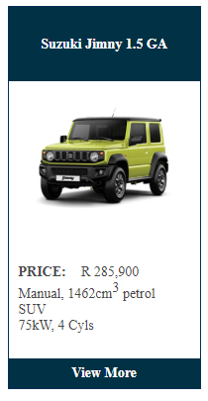**Question 4**

You have just started your first job out of university and decide to buy a brand-new *Suzuki Jimny* that costs R285 900. Based on your credit record, a financial institution offers to finance your vehicle - which you repay by means of a loan in **monthly** instalments of R6000 at an interest rate of 14,2% p.a. compounded **quarterly**.

a. Calculate the equivalent interest rate per annum, compounded monthly. Leave your answer as a percentage to 4 decimal places. (4)

b. If you pay a 10% deposit up front, calculate how long it will take until your car is “paid off”. (6)

c. Calculate the value of your last payment, which is less than R6000. (6)

d. After 36 months, you decide to refinance your vehicle through a different financial institution. If the Interest rate is decreased to 12% p.a. compounded monthly, and you intend on paying off the vehicle in the same amount of time, calculate your new monthly payments. (6)

**[22]**

**Question 5**

There are currently 11 500 elephants in the Kruger National Park, of which 60% are female. On average, an elephant lives up to 56 years of age and gives birth to one calf every 3 years. The survival rate of a new-born elephant is 85%.

The large population of elephants is causing destruction to the terrain in the park. Some people have suggested culling to combat this. A prominent ranger has put forward a proposal of culling 2500 elephants per year. He has backed up the call to cull using a Malthusian Model.

a. Find the birth rate, death rate and hence the growth rate of the elephant

population. (6)

b. Construct the ranger’s Malthusian model using an annual cycle. (4)

c. What is the population size after 7 years? (3)

d. How many elephants should be culled to reach a steady state? (3)

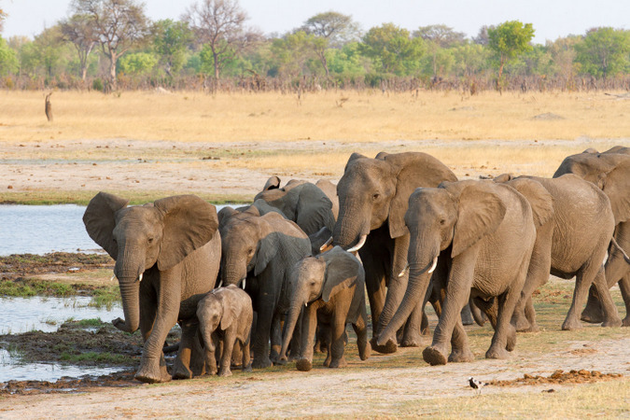 **[16]**

**Question 6**

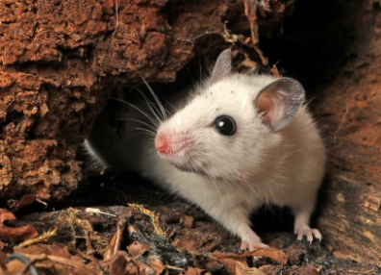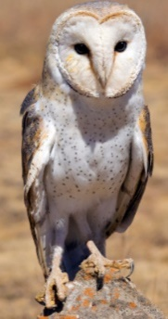A wildlife researcher at a South African university studied the relationship between *Western Barn Owls* and *Natal Multimammate Mice* in a 4km2 area in Eastern Gauteng. Farmers had a rodent problem and introduced owls to control the rodent population in the area. At the time of her study, there were 13 750 mice and 6 owls. The area can only sustain 15 000 mice. The researcher wanted to predict the impact of the owls and built a Lotka-Voltera model to predict the future monthly populations of both owls and mice.

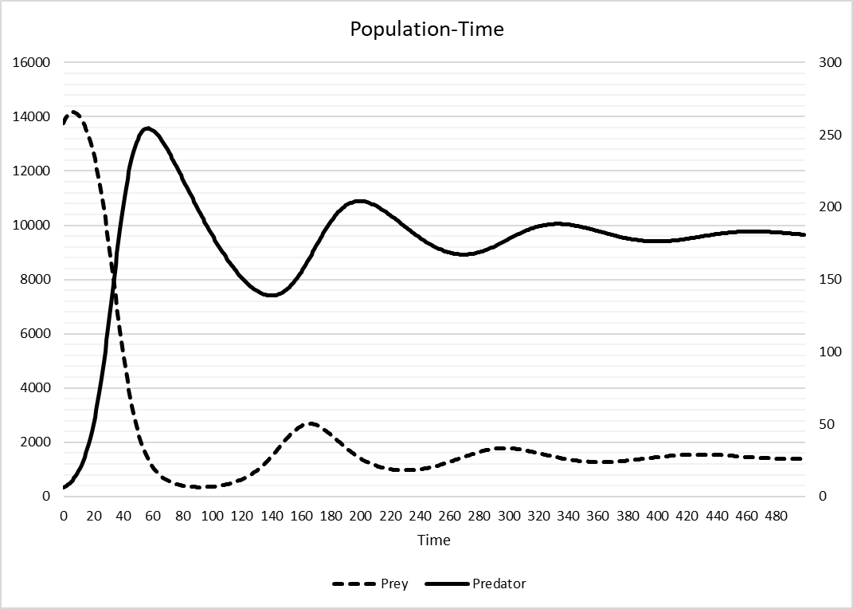Below is a graph showing the change in both mice and owl populations over time:

a. Explain what happens to both populations and why, from the 60th month to the 160th

month. (4)

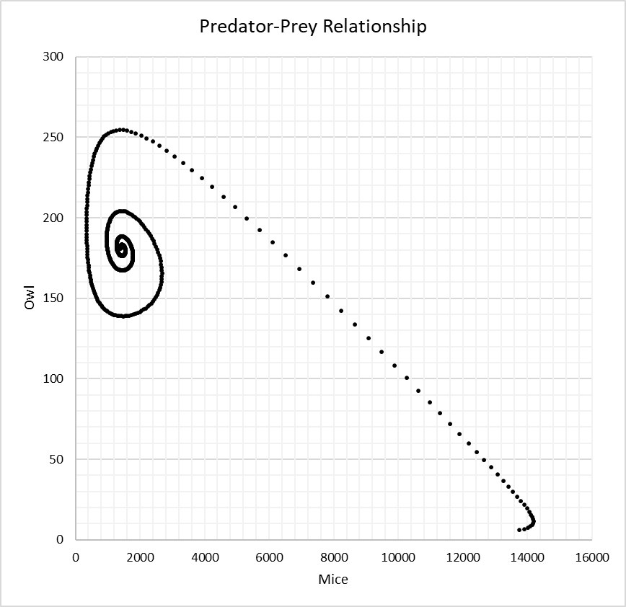Below is a phase plot describing the owl and mice relationship:

**G**

**F**

**E**

**D**

**C**

**B**

**A**

**A**

b. Match the following descriptions to the marked regions on the phase plot

(A, B, C, D, E, F or G):

i. The maximum mice population. (2)

ii. The point at which the predator population is decreasing most rapidly after its first

recovery from a decreasing population to an increasing population. (2)

iii. Where the change in owl and mice population sizes are greatest from one month to

the next. (2)

c. The researcher notices that 83 mice were killed by owls in the first month. Calculate

the attack rate of owls on mice. Leave your answer to 3 decimal places. (4)

d. Given the following model:

$$O_{n+1}=O_{n}+0,000009.M_{n}.O_{n}-C.O_{n}$$

What is the definition of parameter *C*? (1)

e. What would be the impact on both owl and mice populations be if parameter *C* were to increase? (2)

f. The researcher comes up with the following Lotka-Voltera model:

$$M_{n+1}=M_{n}+0,2M_{n}\left(1-\frac{M_{n}}{K}\right)-0,001M_{n}.O_{n}$$

$$O_{n+1}=O_{n}+0,000009M_{n}.O_{n}-0,013.O_{n}$$

What does parameter K represent and what is its value? (2)

g. Given the populations are at equilibrium when there are 1445 mice in the area, how many owls are in the area for there to be equilibrium? (6)

**[25]**

**Question 7**

Claudia is a sunflower farmer and eager mathematician. She collects data over multiple seasons and decides to model the germination of her seeds. She works out that, on average, 3 seeds from one living sunflower germinate in the next season, whilst 5 germinate in the season after that. Sunflowers only last one season and she plants 5 new sunflowers each season.

The number of sunflowers on her farm each season looks like this:

a. Why would a second-order difference equation be more appropriate than a first -order

difference equation to model the number of sunflowers per season? (2)

b. Construct a second-order difference equation $\left(T_{n+1}=aT_{n}+bT_{n-1}+c\right)$ to predict the

number of sunflowers that Claudia will have in future seasons. (4)

c. Claudia’s property can only sustain 9000 sunflowers at a time. Will she be able to go

to a sixth season at this rate? (2)

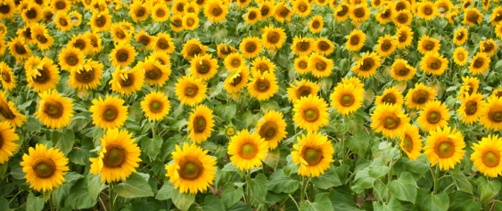 **[8]**

**END**

|  |  |  |  |
| --- | --- | --- | --- |
| **MODULE C – GRAPH THEORY & MATRICES [100 marks]**  **Question 1** | | |  |
|  |  |  |  |
| a) | Given the set of equations: | |  |
|  |  |  |  |
|  | Use Gaussian row reduction to write the augmented matrix in upper triangular form. | | (4) |
|  |  | |  |
| b) | For which values of *k* will this system: | |  |
|  | (i) | Have a unique solution? | (2) |
|  |  |  |  |
|  | (ii) | Have infinitely many solutions? | (2) |
|  |  |  |  |
|  | (iii) | Have no solution at all? | (2) |
|  |  |  |  |
| c) | If *k* = 4, use Gauss-Jordan reduction to solve the system | | (5) |
|  |  |  |  |
|  |  |  | **[15]** |
| **Question 2 (Copy of diagram on diagram sheet)** | | |  |
|  |  |  |  |
| a) | The quadrilateral A(3;7), B(4;2), C(-1;1) and D(-2;4) is dilated to form AB’C’D’ and then transformed to AB”C”D”. | |  |
|  | (i) | Find the center of dilation, and the matrix representing the dilation. | (2) |
|  |  |  |  |
|  | When rotating a polygon through an angle  anti-clockwise about the centre (a;b), the initial point is translated back to the origin, rotated and then translated away from the origin.  For this purpose, the transformation is given by: | |  |
|  |  |  |  |
|  | (ii) | Give the angle and centre of rotation that transformed the diagram AB’C’D’ on to AB”C”D” correct to the nearest integer value. | (8) |
|  |  |  |  |
| b) | The triangle **T** has vertices at the points where *k* is a constant. Triangle **T** is transformed onto the triangle **T’** by the matrix  .  Given that the area of triangle **T’** is 364 square units, find the value of *k.* | | (4) |
|  |  |  |  |
| c) | Find the invariant points on the transformation defined by | | (4) |
|  |  | |  |
| d) | Without using a calculator, find the matrix which represents a reflection in the line *y* = 2*x*. Leave the matrix entries in the form . | | (6) |
|  |  | |  |
| e) |  | |  |
|  | (i) | Find | (3) |
|  |  |  |  |
|  | The transformation represented by a matrix **B** followed by the transformation represented by the matrix **A** is equivalent to the transformation represented by the matrix **P**. | | |
|  |  |  |  |
|  | (ii) | Find **B,** giving your answer in simplest form. | (4) |
|  |  |  |  |
|  |  | | **[23]** |
|  |  | |  |
| **Question 3** | | |  |
|  |  |  |  |
| a) | Jed claims:  “Given two non-zero square matrices, **A** and **B**, then | |  |
|  |  |  |  |
|  | (i) | Explain why Jed’s claim is incorrect, giving a counter example. | (2) |
|  |  |  |  |
|  | (ii) | Refine Jed’s claim by making it fully correct. | (1) |
|  |  |  |  |
|  | (iii) | Prove your answer in part (b) is correct. | (3) |
|  |  |  |  |
| b) | For which values of *k* is the matrix  singular given  that . | | (4) |
|  |  | |  |
|  |  |  | **[10]** |
|  |  |  |  |
| **Question 4:** | | |  |
|  |  |  |  |
| a) | Explain why it is not possible to draw a graph with exactly 5 vertices and with degree sequence 1, 3, 4, 4 and 5. | | (2) |
|  |  |  |  |
| b) | A connected graph has exactly 5 vertices and contains 18 edges. The degree of the vertices are | |  |
|  | (i) | Calculate *x*. | (3) |
|  |  |  |  |
|  | (ii) | State whether the graph is Eulerian, semi-Eulerian or neither. Motivate your answer. | (2) |
|  |  |  |  |
| c) | Draw a graph which satisfies all of the following conditions:   * The graph has exactly 5 vertices * The vertex degree order is 2, 2, 4, 4 and 4 * The graph is not Eulerian. | | (3) |
|  |  | |  |
|  |  |  | **[10]** |
|  |  |  |  |
| **Question 5: (Copy of diagram on diagram sheet)** | | |  |
| The figure represents a network of roads 85 km in weight. Daniel wishes to travel from town A to town H, and wants to do so in the shortest possible distance. | | | |
|  |  |  |  |
|  | (a) | Use Dijkstra’s algorithm to find the shortest path from A to H. State the shortest path and its length in km’s. | (6) |
|  |  |  |  |
|  | (b) | The town council must travel each of these roads to check for potholes and possible road damage. Use any of your algorithms, or your own intuition, to work out the journey of minimum weight that can be travelled for this purpose. State clearly which roads you will travel twice. The inspection must start and end at town F. | (6) |
|  |  |  |  |
|  | (c) | After inspection, the council decides that roads BD and BE must be closed for repairs. Daniel needs to cost and instillation of fibre between all the cities. Use Prim’s algorithm to find the minimum cost fibre network. Clearly indicate the weight of this network. | (6) |
|  |  |  |  |
|  |  |  | **[18]** |
|  |  |  |  |
| **Question 6: (Copy of table on diagram sheet)** | | |  |
|  |  |  |  |
| The table shows the least times, in seconds, that it takes a robot to travel between six points in an automated warehouse. These six points are an entrance, A, and five storage bins, B, C, D, E and F. The robot will start at A, visit each bin, return to A. The total time taken for the robot’s route is to be minimised. | | |  |
|  | | | |
|  |  | |  |
| a) | Show that there are two nearest neighbor routes that start from A. You must make the routes and their lengths clear. | | (4) |
|  |  |  |  |
| b) | Start by deleting F, and all its pathways, find a lower bound for the time taken for the robot’s route. | | (3) |
|  |  |  |  |
| c) | Use your results to write down the smallest interval which you are confident contains the optimal time for the robot’s route. | | (3) |
|  |  |  |  |
|  |  |  | **[10]** |
|  |  |  |  |
| **Question 7:** | | |  |
|  |  |  |  |
| a) | A connected graph **V** has ***n*** vertices. The sum of the degrees of all the vertices inV is ***m*.** The graph **T** is a minimum spanning treeof **V.** | |  |
|  |  |  |  |
|  | (i) | Write down, in terms of *m*, the number of edges in V. | (1) |
|  |  |  |  |
|  | (ii) | Write down, in terms of *n*, the number of edges in T. | (1) |
|  |  |  |  |
|  | (iii) | Hence, write down an inequation, in terms of *m* and *n*, comparing the number of edges in T and V. | (2) |
|  |  |  |  |
| b) | The graphs G1 and G2 are given. **(Copy of diagram on diagram sheet)** | | |
|  | By using the definition of isomorphic graphs, show clearly whether the two graphs are isomorphic. | | (10) |
|  |  |  |  |
|  |  |  | **[14]** |

***PLEASE TURN OVER FOR DIAGRAM SHEETS***

**USE PENCIL SO YOU CAN ERASE IF NECESSARY**

**DIAGRAM SHEETS: NAME: __________________________________________**

|  |  |
| --- | --- |
| **QUESTION 2a)** |  |
|  |  |
| **QUESTION 5** |  |
| **QUESTION 6** |  |
|  |  |
| **QUESTION 7b)** |  |

**END**