# KING DAVID HIGH SCHOOL LINKSFIELD



**GRADE 12**

**ADVANCED PROGRAMME MATHEMATICS**

**PAPER 1 – ALGEBRA & CALCULUS**

**PRELIMINARY EXAMINATIONS AUGUST 2020**

**Total: 200 marks**

#### Reading Time: 10 minutes Writing Time: 2 hours

**PLEASE WRITE YOUR NAME BELOW.**

**NAME:** _______________________________________________________________

This paper contains **8** pages and an information sheet of **(iv)** pages.

Check that your paper is complete.

**Please read the following instructions carefully:**

1. Number all questions exactly as they appear on the question paper.

2. Pay careful attention to time management and mark allocation.

3. Write legibly and not in pencil.

4. Non programmable calculators may be used unless otherwise instructed.

5. All necessary calculations must be clearly shown. You will NOT receive full credit if

you write down only the answers and show no working out.

6**. ENSURE THAT YOUR CALCULATOR IS IN RADIAN MODE**.

|  |  |  |  |  |  |  |  |  |  |  |  |  |
| --- | --- | --- | --- | --- | --- | --- | --- | --- | --- | --- | --- | --- |
| Q1  [16] | Q2  [18] | Q3  [6] | Q4  [15] | Q5  [17] | Q6  [19] | Q7  [6] | Q8  [25] | Q9  [10] | Q10  [41] | Q11  [17] | Q12  [10] | TOTAL  [200] |
|  |  |  |  |  |  |  |  |  |  |  |  |  |

**QUESTION 1 (16 MARKS)**

(a) (i) Decompose  into its partial fractions. (6)

(ii) Hence determine  (4)

(b) In each case part of the graph of  is shown.

It is also given that  . Determine, in terms of e, the area

of the shaded region in each diagram.

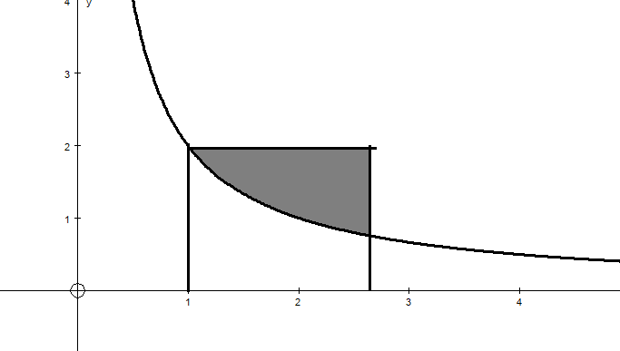 (i)

**>>**

**>>**

e

1

(3)

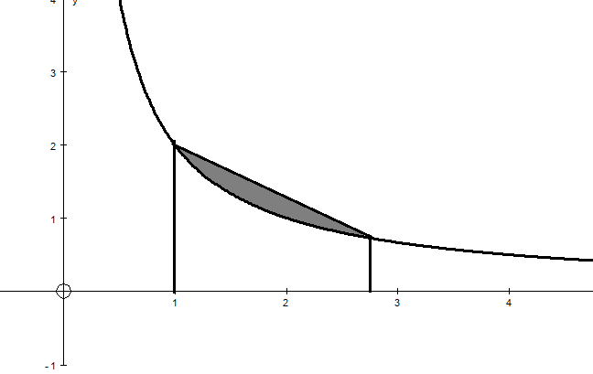 (ii)

e

1

(3)

**P.T.O.**

**QUESTION 2 (18 marks)**

E is the centre of two concentric circles.

EA = AB = ED = DC = r and 

See the sketch below.

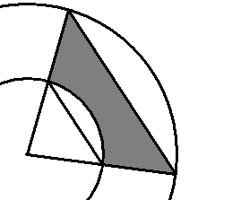

E

A

C

B

D

θ

(a) Determine the perimeter of the shaded region in terms of r and θ (6)

(b) Determine the area of the shaded region in terms of r and θ (4)

(c) If r = 1, determine the maximum area of the shaded region correct to 2 decimal

places. (8)

**QUESTION 3 (6 marks)**

g(x) is continuous at x = a and is defined as follows:



Determine the values of a. (6)

**P.T.O.**

**QUESTION 4 (15 marks)**

Given:  The graph of y = h(x) is sketched below:



(a) (2)

(b) Write down the equation(s) of any asymptotes of y = h(x). (4)

(c) Show that the stationary points occur when . (6)

(d) Determine the x and y intercepts of y = h(x). (3)

**QUESTION 5 (17 marks)**

(a) Prove that  . (2)

(b) Hence solve for x if  (7)

(c) If f(x) = ln(𝑥 − 1) + 2 and g(x) =ex – 2 + 1 determine (g ο f)(x) and state its domain

and range. (8)

**P.T.O.**

**QUESTION 6 (19 marks)**

A sketch of the graph of f(x) = sinx – cos x for  is shown below. The area bounded by the graph of f and the x – axis between the x − intercepts marked A and B has been shaded.

Y

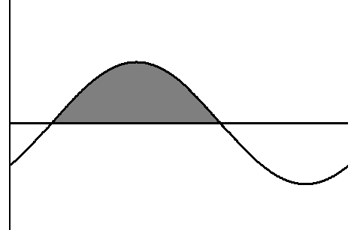

*f*

X

O

B

A

(a) Determine the coordinates of A and B, leaving your answers in terms of . (4)

(b) Determine the area of the shaded region. (6)

(c) The volume generated when the graph of  rotates around the -axis between

x = 0 and x = k is equal to  units3. Calculate the smallest possible value

of k if k > 0. (9)

**P.T.O.**

**QUESTION 7 (6 marks)**

The function f(x) has the following properties:

* f(−2) = 0
*  if x ∈(−∞ ; 1)
* if x ∈(1 ; ∞)
* 
* 
* 
* 
* 

Draw a neat sketch of y = f(x) using the information above. (6)



**P.T.O.**

**QUESTION 8 (25 marks)**

 (8)

(b) Determine the equation of the tangent to the curve

 (8)

(c) Determine  (4)

 (5)

**QUESTION 9 (10 marks)**

f(x) = 1 + x – 2 tan x.

(a) Show that f(x) has a zero in the interval [0 ; 1]. (4)

(b) Use the Newton – Raphson method to calculate this zero correct to 4 decimal

places. **All working must be clearly shown.** (6)

**QUESTION 10 (41 marks)**

(a) (i) Prove that . (5)

(ii) Hence determine . (8) (b) Integrate the following:

 (5)

 (5)

 (6)

**P.T.O.**

 (6)

 (6)

**QUESTION 11 (17 marks)**

(a) (i) If  show that x = a2 – b2 and y = 2ab. (5)

(ii) Hence find x and y if . (4)

(b) When proving 6n + 4 is divisible by 5 using mathematical induction, it is necessary

to first prove the statement is true for n = 1 and then assume the statement is

true for n = k.

**You are only** **required to prove** that 6n + 4 is divisible by 5, if n ∈and

**n = k + 1.** (8)

**QUESTION 12 (10 marks**)

The area under the curve of f(x) from x = 1 to x = b can be calculated by constructing n rectangles of equal width and then using a Riemann sum as follows:



(a) What is the function f(x)? (1)

(b) What is the value of b? (2)

(c) If the region is divided into 8 rectangles, what is the estimated area? (3)

(d) What is the value of  (2)

(e) Is your answer to (c) bigger than or less than your answer in (d)?

Briefly explain your answer. (2)