**BRESCIA HOUSE HIGH SCHOOL**

GRADE 12 EXAMINATION

JULY 2016

**MEMO**

**MATHEMATICAL LITERACY: PAPER 1**

Time: 3 hours 150 marks

EXAMINER: Mrs J Hultzer MODERATOR(S): Mrs E Buytenhuys; Mrs K. Raeburn

# QUESTION 1

* 1. On a dairy farm, the farmer has fixed expenses of R16 450,00 per month. Her variable expenses work out to R190,00 per cow per month.
     1. Give an example of one of the items that would fall under: (2)
        1. fixed expenses

Paying off machinery; rent; wages etc ✓ any one

* + - 1. variable expenses

Vet fees, electricity, fodder etc ✓ any one

* + 1. Her cows produce an average of 17 litres of milk per day,

Calculate her income from each cow per 30-day month if she is paid:

1. Rl,00 / litre for milk (2)

17 litres × Rl,00 × 30 days = R510,00 ✓a✓m

1. Rl,20/ litre for milk (2)

17 litres × Rl,20 × 30 days = R612,00 ✓a✓m

* + 1. She uses the following equation to calculate her expenses:

Expenses = R16 450,00 + R190,00 x number of cows

1. Write an equation to calculate the income generated by each cow in a 30 day month. (3)

Income = R612 x number of cows ✓✓✓a  
[ Income = R1,20 x 17 x 300 ✓✓]

1. Complete the table below in the ***Insert*** provided by filling in the missing values A – E : (5)

|  |  |  |  |  |  |  |  |
| --- | --- | --- | --- | --- | --- | --- | --- |
| No. Cows | 0 | 1 | 20 | 40 | 65 ✓a | 80 | 100 |
| Expenses | R16 450 ✓a | R16 640 | R20 250 | R24 050 | R 28 800 | R31 650 | R35 450 ✓a |
| Income at  R1,20 / litre | R0,00 ✓a | R612 | R12 240 | R24 480 | R39 780 | R48 960 | R61 200 ✓a |

1. A graph showing her income from milk sold at a rate of R1,00 / litre is provided on the set of axes in the ***Insert***. Complete the graph by:
2. supplying the necessary labels (3)
3. drawing the graph showing her income from milk sold at a rate of R1,20 per litre (2)
4. drawing the graph showing her expenses (3)

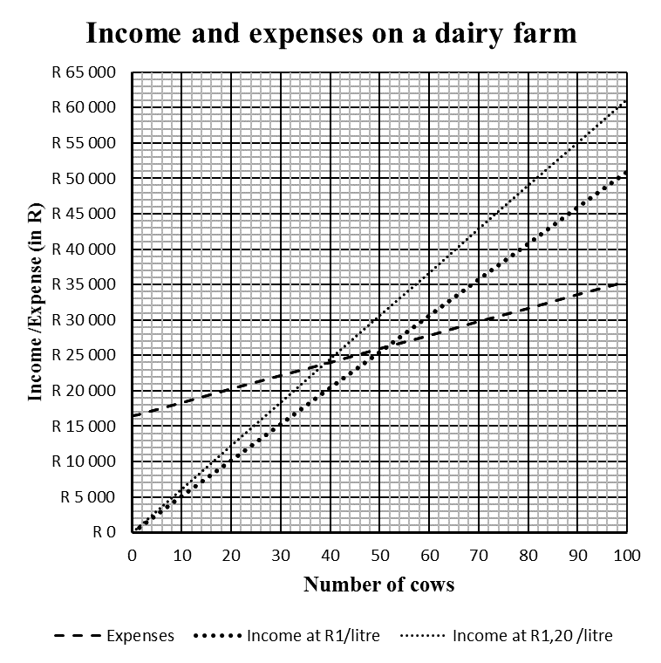

✓a

✓a

½ ✓a

✓a

✓a

✓a

✓a

½ ✓a

X✓a

Y✓a

✓a Broken lines

* + 1. ***Use your graph*** to answer the following questions:

1. How many cows should the farmer keep in order to break even, if she sells her milk at Rl,00 per litre? Use the letter **‘X’** on your graph to show where you took your reading. (2)

51 cows ✓a **X** ✓a (52 cows ✓a )

1. By what percentage can she reduce her number of cows to break-even if she sells her milk at R1,20 per litre? (4)

✓a from 1.1.4b

 × 100%  
= 30% (4)

 × 100% = - ✓a✓a × 100% ✓m

= -23,529…%

≈ Reduce 23,5% ✓ca

1. How much income will the farmer generate if she has 90 cows and sells her milk at R1,20 / litre? Use the letter **‘Y’** on your graph to show where you took your reading. (2)

R55 000,00 ✓a **Y** ✓a (Accept 54 000 – 56 000 check graph)

1. How much profit / loss will the farmer generate if she has 90 cows and sells her milk at R1,20 / litre? (3)

R55 000,00 – ✓m R34 000,00 ✓a from (c) = R21 000,00 profit ✓ca must

include ‘profit’ (Check graph)

* 1. Lauren gets a loan of R3 000,00 from a money-lender over 12 months. The first financial statement that she receives from the money-lender is shown below:

|  |  |  |  |
| --- | --- | --- | --- |
| **FINANCIAL STATEMENT** | | | |
| Lauren Ndamase | | | |
| Reference number: 02938194 | | | |
| **Date** | **Transaction** | **Amount** | **Balance** |
| 20130501 | Opening balance |  | ‑ R3 000,00 |
| 20130601 | Debit: interest | ‑ R75,00 | ‑ R3 075,00 |
| 20130601 | Administrative fee | ‑ R6,25 | ‑R3 081,25 |
| 20130601 | Electronic transfer: credit | R300,00 | ‑ R2 781,25 |
| 20130701 | Debit :interest | **A** | **B** |
| 20130701 | Administrative fee | **C** | **D** |
| 20130701 | Electronic transfer: credit | **E** | **F** |

* + 1. Give a reason why negative numbers are used in this statement. (2)

It shows money owed. ✓✓a

* + 1. Calculate the administrative fee for the year. (2)

R6,25 × 12 ✓m = R75,00 ✓a

* + 1. How much interest is charged per month? (1)

R75,00 ✓a

* + 1. What is the monthly interest rate? (3)

 ✓a × 100% ✓m = 2,5% ✓ca

* + 1. What type of interest has the money lender applied to this loan if the same amount of interest is charged every month? (1)

Simple interest ✓a

* + 1. Calculate the values of A ‑ F in the table. (10)

A ‑ ✓a R75,00 ✓a

B ‑ R2 781,25 – R75,00 ✓m = ‑ R2 856,25 ✓a

C – R6,25 ✓a

D ‑ R2 856,25 – R6,25 = ‑ R2 862,50 ✓a ✓a

E + ✓a R300,00 ✓a

F ‑ R2 862,50 + R300,00 = – R2 562,50 ✓a

* + 1. The loan is paid off after 12 instalments. However, the last instalment is only R269,24. Calculate the total amount Lauren had to pay back. (3)

R300,00 × 11 months + R269,24 = R3 300,00 ✓a + R269,24 ✓a

= R3 569,24 ✓ca

**[55]**

# QUESTION 2

* 1. Study ***Figure 1.1*** and ***Figure 1.2*** and answer the questions that follow:
     1. Determine the height of the hub in cm. (2)

70 m ✓a = 7 000 cm ✓ca.

* + 1. Determine the minimum height above ground level of the tip of the blade when the blades are turning. (2)

70 m ‑ 40 m ✓m = 30 m ✓a

* + 1. a) Calculate diameter of the swept area of the blades. (2)

2 × 40 m ✓m = 80 m ✓a

1. Calculate circumference of the swept area of the blades. (3)

C = × 80 ✓a m ✓Formula

= 251,3274…m

≈ 251,3 m ✓a

1. Calculate area of the swept area of the blades if the following formula is used. (2)

Area =  × (radius)2

A = × (40 m ✓a )2

= 5 026,5482…m2

≈ 5 026,5 m2 ✓a

* 1. At a specific moment the tips of the turning blades are moving at a speed of 360 km/h. Calculate the speed in m/s? (4)

360 km : 1 hour × 60 min × 60seconds = 360 000 m ✓a : 3600 seconds ✓a

=  m :  s ✓m

= 100 m / s ✓ca

* 1. The Reinforced Concrete Foundation is made from a square concrete slab having a side measuring 22,5 m and depth of 1,5 m.
     1. Write the length of the slab to the depth of the slab as a ratio. (2)

22,5 m : 1,5 m ✓a = 15 : 1 ✓Simp

* + 1. Calculate the top area of the foundation. (2)

Area: (22,5 m)2 = 506,25 m2 ✓a✓Formula

* + 1. Show that the volume of the foundation is 759,375 m3. (2)

Volume = area of the face × depth

Volume = 506,25 m2 ca from 2.2.1 × 1,5 m ✓a✓m

= 759,375 m3 (Given)

* + 1. What is the capacity of the foundation in litres if the volume is 759,375 m3? (3)

1 cm3 : 1 m

759,375 m3 × (100)3 = 759 375 000 cm3 ✓Conversion

1 cm3 : 1 ml = 759 375 000 cm3 : *x* ml

 = 

*x* = 759 375 000 ml ✓ca

*x* = 759 375 000 ml ÷ 1 000

*x* = 759 375 litres ✓Conversion

* + 1. The foundation is made from concrete which is a combination of cement, water, sand and gravel mixed in measured amounts. The cement, sand and gravel is mixed in the ratio 1 : 2 : 3 . This mixture makes approximately one cubic metre of concrete.

|  |  |  |
| --- | --- | --- |
| **Material needed** | **By volume** | **By weight** |
| **Cement** | 1bag or 0,03 m3 | 110 pounds |
| **Water** | 24 litres | 53 pounds |
| **Sand** | 0,06 m3 | 106 kg |
| **Gravel** | 0,09 m3 | 302 pounds |

1. How many bags of cement are needed to pour this foundation? (2)

1 m3 : 1 bag = 759,375 m3 : *x* bags

 = 

*x* = 759,375 bags ✓a

*x* ≈ 760 ✓Round

1. Calculate the mass of one bag of cement, to the nearest kilogram, if 2,22 pounds = 1 kg (3)

2,22 pounds : 1 kg = 110 pounds : *x* kg

 = 

2,22*x* = 110

 =  ✓m

*x* = 49,549… kg ✓a

*x* ≈ 50 kg ✓Round

1. Calculate how much sand you would need if you had 530 kg of cement. (2)

Concrete is mixed in the ratio 1 cement : 2 sand : 3 gravel

50kg cement : 106 kg sand  
530 kgcement : *x* kg sand

✓m

*x* = 1 123,6 kg ✓a

**[31]**

# QUESTION 3

* 1. What is the name of the double-decker bridge? (2)

Biko Bridge ✓a✓a

* 1. Name the streets that form part of the R72. (2)

Settlers Way, Fleet Street, Fitzpartick Rd ✓a✓a (‑1 for each incorrect extra street)

* 1. 1. Write the scale of this map in the form 1 : _____? (3)

5,6 cm ✓a : 1 000 m ✓a = 1 : 17 857 ✓Conversion

* + 1. What is the width of the C.W. Malan Turning Basin at the point where the banks are ‘parallel’ to each other?

1. in centimetres? (2)

2,2 cm ✓a✓a (Accept 2 – 2,4)

1. in metres (2)

1 cm : 178,57 m

2,2 cm × 178,57 m = 393 m ✓a✓a (Accept 380 – 420 m)

* + 1. Passenger liners and cargo ships regularly enter and leave this port. Use the scale of the map to calculate the maximum possible width of a ship that can enter or leave this port?

Mouth of the port is 1 cm ✓a ∴ maximum width is 178 m ✓ca

(Accept 0,9 – 1,1 → 180 – 220 m) (2)

* 1. Write a set of directions including street names and compass directions to help Mrs Wiseman find the quickest way to the hospital using main roads only. (6)

Travel south on Esplanade Road ✓a where the road bends it becomes Currie Street

Continue along Currie Road in a northerly direction ✓a

At the 4th intersection turn left into Fleet Street ✓a continue in this westerly direction

At the 8th street on the right turn right into Buffalo Street ✓a

Buffalo Street runs into Albany Street turn left ✓a and the hospital will be on the RHS ✓a

* 1. Which road is found at 33° 01’ S and 27° 55’ E? (2)

Norden Road✓a✓a (accept Fitzpatrick)

**[21]**

# QUESTION 4

|  |  |  |  |
| --- | --- | --- | --- |
| **Energy consumed per household in some sub-Saharan African countries** | | | |
| **Western and central sub-Saharan African countries** | **Household energy use per person *(kgoe)*** | **Southern sub-Saharan African countries** | **Household energy use per person *(kgoe)*** |
| Ethiopia | 6 | Namibia | 92 |
| Senegal | 77 | Congo | 119 |
| Eritrea | 83 | Kenya | 253 |
| Sudan | 144 | Angola | 307 |
| Cote d'lvoire | 152 | Botswana | 307 |
| Benin | 172 | South Africa | 323 |
| Togo | 185 | Zambia | 324 |
| Ghana | 193 | Tanzania, United Rep | 341 |
| Congo, Dem Rep | 209 | Mozambique | 343 |
| Cameroon | 279 | Zimbabwe | 456 |
| Nigeria | 559 | Gabon | 573 |

* 1. Looking at household energy use per person in **southern** sub-Saharan African countries:

1. What is the mode for this set of data? (2)

307 kgoe ✓a✓a

1. Calculate the mean use per person. (4)

 = 

= 312,5454…

≈ 312,5 kgoe

* 1. Study the box-and-whisker plots for the two sub-Saharan regions below and answer the questions that follow:

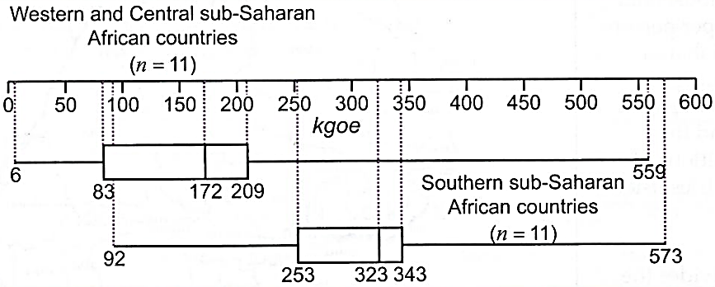

* + 1. Why are there dotted lines on these box-and-whisker plots? (2)

For easy reading / accurate values ✓a✓a

* + 1. Why are the box-and-whisker plots for the two regions shown on the same grid? (2)

For easy comparison ✓a✓a

* + 1. Fill in the missing values in the table on the ***Insert*** provided to show the summarised data for each region. (5)

|  |  |  |
| --- | --- | --- |
|  | **Western and central sub-Saharan African countries** | **Southern sub-Saharan African countries** |
| Minimum value | 6 | 92 ✓a |
| First quartile (Ql) | 83 | 253 ✓a |
| Median | 172 | 323 ✓a |
| Third quartile (Q3) | 209 | 343 ✓a |
| Maximum value | 559 | 573 ✓a |

* + 1. For the household energy use for Western and Central sub-Saharan African countries calculate the:

1. range (2)

Range: 559 – 6 ✓a = 553 kgoe ✓a (P1U)

1. inter-quartile range i.e. IQR (2)

IQR: 209 – 83 ✓a = 126 kgoe ✓a

* + 1. Which southern sub-Saharan African countries fall in the top 25% of household energy use? (2)

Mozambique, Zimbabwe and Gabon ✓a✓a (‑1 for each incorrect)

* + 1. What percentage of Southern sub-Saharan African countries use more than 253kgoe? (1)

75% ✓a

* + 1. Compare the range and inter-quartile range for the two data sets. Which value for the western and central sub-Saharan African countries appears to be an outlier? (2)

Western and central sub-Saharan Africa has a much larger range and IQR✓. 559✓a

**[24]**

# QUESTION 5



Summary data, Ceres Project

|  |  |  |  |  |  |  |
| --- | --- | --- | --- | --- | --- | --- |
| **Number of Turbines** | **MW each** | **Total MW** | | **Construction date** | **Lat.** | **Long.** |
| 197 | 3.4 | 670 | | Second half of 2016? | S 34.61° | E 137.74° |
| Additional data on Ceres Project | | |  | | | |
| **Owner/operator** | | | Suzlon | | | |
| **Project cost** | | | Aus$1.3 billion | | | |
| **Capacity factor** | | | More than 38% expected | | | |
| **Annual generation** | | | About 2000 GWh/yr expected | | | |
| **Annual CO2 emissions** | | | About two million tonnes | | | |
| **Equivalent number of rooftop solar systems** | | | About 500 000 (assuming an average of 2.5kW each) | | | |

|  |
| --- |
|  |

* 1. What will the project cost in South African Rand if the exchange rate is Aus$1 : R11,107476? (2)

Aus$1 : R11,107476 = Aus$1.3 billion : R*x*

 =  ✓m

*x* = R14,4397188 billion  
 (R14 439 718 800) ✓a (Accept rounded value)

* 1. How much electricity, to two decimal places, will Ceres generate in one month? (3)

2000 GWh/yr ÷ 12 ✓m = 166,66…

= 166,67 ✓a GWh/month ✓Units

* 1. About 41,6% of the population of South Africa are without jobs, which is a serious social issue. The energy sector itself has the potential to employ large numbers of people – jobs will be created as the electricity sector expands to meet demand. The projected electricity demand for the year 2020 is expected to be 267 TWh.
     1. South Africa has a population of 52,98 million.

1. Write the population figure using digits only. (1)

52 980 000 ✓a

1. Write the population figure from (a) in words. (2)

Fifty two million ✓a , nine hundred and eighty thousand ✓a

1. Write the population figure from (a) in scientific notation. (2)

5,298 ✓a × 107 ✓a

* + 1. Calculate the number of unemployed people in the country. (2)

 × 52,98 million ✓m = 22,03968 million ✓a (22 039 680)

* + 1. Draw a suitable graph on the axes provided in the Insert to display the following information: (6)

✓a

✓a

✓a

✓a

✓a

✓a Bar graph

**[19]**