

***A World of Education…an Education for the World!***

**GRADE 12 –MATHEMATICS PAPER 1**

**EXAMINER:** Mrs K. Hulme **DATE:** 12 July 2011

**MODERATOR:** Ms B. Maganbhai **TOTAL:** 150

**TIME:**  3 hr

**CANDIDATE’S NAME:**  _______________________________________________________________________________

**INSTRUCTIONS TO CANDIDATES:**

* Answer all questions in the Answer Booklet provided.
* Rule a right hand margin on each page and rule off after each question.
* All written work must be done using blue or black ink. Diagrams and graphs must be drawn neatly using pencil.
* No correction fluids may be used
* Non-programmable calculators may be used unless otherwise stated.
* Round off to TWO decimal places unless otherwise stated.
* It is in your own interests to work neatly and to show all necessary steps in calculations.
* **THIS EXAMINATION CONSISTS OF 7 PAGES**

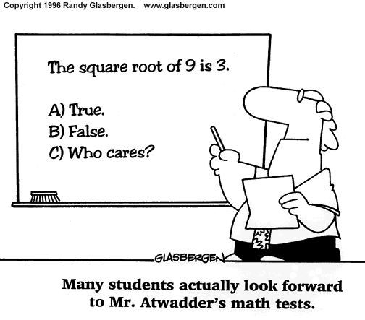

**SECTION A – KNOWLEDGE AND ROUTINE PROCEDURES**

**QUESTION 1:**

a) Given: 1 – 2 + 4 – 8 + 16 …

(i) State whether this is an arithmetic or geometric series (1)

(ii) Determine the sum of the first 30 terms (2)

b) The 4th term of an arithmetic sequence is -3 and the 20th is -35.

(i) Determine the common difference and the first term (4)

(ii) Determine the sum of the first 20 terms (2)

c) Given: $4k-2 ;k+1 ;k-3$ are the first three terms of a geometric sequence

(i) Determine the value of $k$ if $k∈Z$ (6)

(ii) Write down the first three terms of the sequence (2)

**[17]**

**[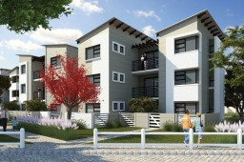](http://mypaddocks.co.za/wp-content/uploads/2010/10/Exterior-3D-Perspective-View-1-800x400.jpg)QUESTION 2:**

[http://mypaddocks.co.za](http://mypaddocks.co.za/)Dwayne Verne takes out a loan of R650 000,00 at 11,25% compounded monthly over a period of 15 years to buy an apartment at The Paddocks. He repays the loan by means of equal monthly repayments.

a) Calculate the monthly repayment (7)

b) What is the total amount he would have paid over the 15 years? (1)

c) If the annual inflation rate is 6,5%; what will the price of his house be in 15 years’ time?

(3)

**[11]**

**QUESTION 3:**

a) Given that $f\left(x\right)={\left(\frac{1}{5}\right)}^{x}$ sketch the graphs of $f$ and $f^{-1}$ on the same set of axes. Indicate at least two points on each graph (including the intercepts) and label each graph clearly. The axis of reflection must also be shown. (5)

b) Given $f\left(x\right)=-x^{2}+4x-3$

(i) Calculate the $x-$ and $y-$ intercepts of the graph of $f$ (4)

(ii) Calculate the coordinates of the turning point of $f$ (3)

(iii) What is the largest possible value of $-x^{2}+4x-3$? (1)

(iv) Make a neat sketch graph of $f$. Indicate the coordinates of all important points. (3)

(v) On the same system of axes, draw a straight line that will help you solve the equation ${-x}^{2}+4x=2$. Show all workings to justify the straight line shown (4)

(vi) Use the graph to determine the values of $x$ for which $-x^{2}+4x-3≥0$ (2)

**[22]**

**QUESTION 4:**

**YOU MAY NOT USE A CALCULATOR IN THIS QUESTION**

All relevant working must be shown. An answer alone will not be awarded any marks

a) Simplify completely: $3^{-\frac{1}{2}}∙\left[\sqrt{12}+3\sqrt{3}\right]$ (4)

b) Solve for $x$: $\frac{2x+1}{x-1}≥1$ (6)

c) Solve simultaneously for $x$ and $y$:

$2y-x=3$

$y^{2}-2x^{2}-x=1$ (8)

**[18]**

**QUESTION 5:**

a) If $f\left(x\right)=4x^{2}-4$; determine $f^{'}\left(x\right)$ from first principles (4)

b) Determine:

$$\lim_{x→-2}{\frac{x^{2}+6x+8}{x+2}}$$

(i) (2)

(ii) $\frac{d}{dt}\left[\left(2t-3\right)\left(t+1\right)\right]$ (2)

**[8]**

**SECTION B – COMPLEX PROCEDURES AND PROBLEM-SOLVING**

**QUESTION 6:**

a) Match the graph of $f$ in the left column with that of its derivative in the right column:



1

i





ii

2

iii

3

(3)

b) Use the following graph of $g'$ (passing through (-2 ; 0); (2 ; 0) and (0 ; -4) to sketch graphs of $g$ and $g''$ WITHOUT finding the equation of : (8)



c)

## (1pro·jec·tile

noun   
\prə-ˈjek-təl, -ˌtī(-ə)l, chiefly British ˈprä-jik-ˌtī(-ə)l\

## Definition of PROJECTILE

1

**:** a body [projected](http://www.merriam-webster.com/dictionary/projected) by external force and continuing in motion by its own inertia; especially **:** a missile for a weapon (as a firearm)

2

**:** a self-propelling [weapon](http://www.merriam-webster.com/dictionary/projectile) (as a rocket)

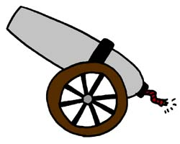

## 

The equation of motion for any projectile is $s\left(t\right)=-\frac{1}{2}g∙t^{2}+v_{0}∙t+h_{0}$ where

$g=$ acceleration due to gravity (a constant 9,8 $m.s^{-2}$)

$v_{0}=$ the object’s initial velocity

$h_{0}=$ the object’s initial height

If a cannonball is fired from a hillside 75m above the ground with an initial velocity of $100m.s^{-1}$; what is the greatest height (to 1 dp) the cannonball will reach? (6)

d) A window is constructed by adjoining a semicircle to the top of a rectangular window (see below). The solid lines in the diagram represent lengths of wood used in the frames of the window.

(i) If the total amount of wood used is 500 cm, show

that the length $y$ of the rectangular portion of the window is given by the formula $y=250-x-\frac{π}{4}x$ (4)

(ii) Hence find the values of $x$ and $y$ that would result in a window of maximum area (6)

**[27]**

**QUESTION 7:**

a) Mrs Humble instructed her pupils to sketch a graph for a function she wrote on the board. This is what they read:

James read this as $y=2x+1$ while Rory read it as $y=2^{x}+1$

(i) Write down 2 values of $x$ which would generate the same $y$ values for both options, showing full workings (i.e. do NOT use your calculator) (4)

(ii) On the same set of axes, sketch the graphs of $y=2x+1$ and $y=2^{x}+1$. Indicate on the graphs your results for (i) as well as any intercepts on the axes. (6)

b) Use **TWO DIFFERENT** methods to show that $f\left(x\right)=\frac{3}{x}+4$ and $g\left(x\right)=\frac{3}{x-4}$ are inverses of each other (9)

c) Claudia borrows R100 000,00 to buy a car. She pays interest of 13,75% p.a. compounded monthly, and she can afford monthly instalments of R2 313,88. Over what time period does she repay the loan? (8)

**[27]**

**QUESTION 8:**

a) Find the value(s) of $k$ for:

$$\sum_{r=1}^{∞}{\left(4∙k^{1-r}\right)}=5$$

(5)



b) A flea jumps $\frac{1}{2}$ m to the right, then $\frac{1}{4}$ m to the left, then $\frac{1}{8}$ m to the right, and so on. To what point (relative to its starting point) is the flea zooming in?

(5) **[10]**

**QUESTION 9:**

The Elite Pottery Shoppe makes two kinds of birdbaths: a fancy glazed and a simple unglazed. An unglazed birdbath requires 30 minutes to make using a pottery wheel and 3 hours in the kiln. A glazed birdbath takes one hour on the wheel and 18 hours in the kiln. The company’s one pottery wheel is available for at most 8 hours per day and the three kilns can be used for at most 60 hours per day. The company has a standing order for 6 unglazed birdbaths per day, so it must produce at least that many. The shop’s profit on each unglazed birdbath is R10,00 and the profit on each glazed birdbath is R40,00. By finding all constraints and graphing a feasible region on the set of axes provided in the Answer Book, determine how many of each kind of birdbath the company should produce each day to maximise profits.

**[10]**