ST MARY’S DSG, KLOOF

GRADE: 12 SEPTEMBER 2008

MATHEMATICS: PAPER 2
(LO3 and LO4)

TIME: 3 HOURS TOTAL: 150 MARKS

INSTRUCTIONS:

1. This question paper consists of 8 pages.

2. There are 2 sections. Answer each section on a new sheet of paper.

3. Write your name and teacher’s name on each sheet of paper.

4. A formula sheet and 2 diagram sheets have been provided.

5. Please give all answers correct to 1 decimal place unless otherwise indicated.

6. Hand in diagram sheet A with Section A and diagram sheet B with section B

7. Read all the questions carefully.

8. Number your answers exactly as they have been numbered.

9. An approved non-programmable and non-graphical calculator may be used, unless otherwise specified.

NAME: ________________________________________

Question 1

Given a circle with centre O and a point (3; 4)
 | 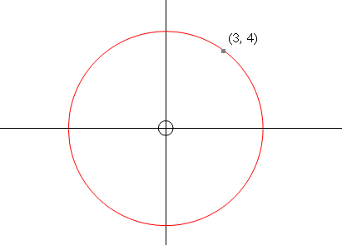 |  |  |  | a. | Find the equation of the circle. | (2)
 |  |  |  |  | b. | Find the equation of the new circle when the original has been translated 2 units to the right and 3 units up. | (3)
 |  |  |  |  | c. | Find the equation of the new circle if the original is enlarged by a factor of 2 through the origin | (2)  [7]
Question 2

Given the rhombus$\text{PQRS}$, with $P$ the point (1; 2), $S$ (5; -3) and $R$ (10; 1), $T$is the point of intersection of $\text{PR}$and$\text{QS}$.
 | 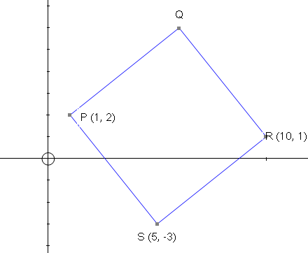 |  |  |  | a. | Determine the co-ordinates of Q. | (2)
 |  |  |  |  | b. | Find the equation of the line SQ. | (3)
 |  |  |  |  | c. | Show that the co-ordinates of T are $\left(5\frac{1}{2};1\frac{1}{2}\right)$ | (2)
 |  |  |  |  | d. | Determine the magnitude of $Q\hat{T}R$ correct to 1 decimal place. | (1)
 |  |  |  |  | e. | Determine the magnitude of $P\hat{S}R$ correct to 1 decimal place. | (5)
 |  |  |  |  |  |  | [13]
Question 3
The circle with centre F has the equation $x^{2}+y^{2}−4x=2y−4\text{.}$ The circle is inscribed by $Δ$OGE. E is on the x-axis and GEto the x-axis.
 | 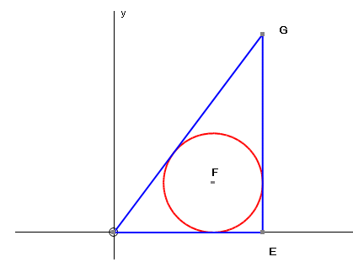 |  |  |  | a. | Determine the co-ordinates of the centre of the circle with centre F. | (4)
 |  |  |  |  | b. | Find the radius of the circle. | (1)
 |  |  |  |  | c. | Determine the equation of the line GE. | (3)
 |  |  |  |  |  |  | [8]

Question 4

A skydiver, on successive attempts, tries to land on a marked white spot on the ground. His actual metres for ten jumps are:

43; 19; 68; 3; 27; 54; 36; 11; 24; 32

a. |  |  | Determine the five number summary for this data. |  |  |  | (5)
b. |  |  | Calculate the mean error in metres, correct to 2 decimal places. |  |  |  | (3)
c. |  |  | The table below appears on your diagram sheet.  Use it to calculate the:
  Distance from the white spot in meters  ($x_{i})$ | $$x_{i}−\bar{x}$$ | $$(x_{i}−\bar{x})^{2}$$
 |  |  | i. | Variance, correct to 2 decimal places |  |  | (2)
 |  |  | ii. | Standard Variation, correct to 2 decimal places |  |  | (2)
 |  |  |  |  |  |  | [12]
Question 5
a. |  |  | Write the following as a single trigonometric ratio:  $$\frac{\text{cos}(A−{\text{360}}^{∘})+\text{tan}(−{\text{180}}^{∘}+A)\text{.}\text{sin}(−A)}{1−{\text{tan}}^{2}({\text{180}}^{∘}−A)}$$ |  |  |  | (7)
b. |  |  | If $\text{sin}{\text{74}}^{∘}=x$ and $\text{sin}{\text{16}}^{∘}=y$, prove that $\text{sin}{\text{58}}^{∘}=x^{2}−y^{2}$ |  |  |  | (4)
c. |  |  | If $\text{sin}θ=t$, determine $\frac{1}{\text{tan}θ}$ in terms of t. |  |  |  | (3)
 |  |  |  |  |  |  | [14]

Question 6

 | The diagram below shows the graphs of $f(x)=\text{cos}\text{bx}$and $g(x)=\text{sin}(x−c)$for the interval $−\text{180}≤x≤\text{180}$. Use the graph to answer the following questions.
 | 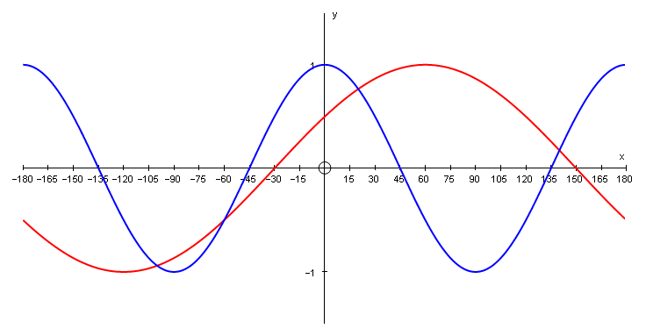
a. |  | Determine the values of b and c. | (2)
b. |  | Write down the period of the graph of $f(x)$. | (1)
c. |  | What is the maximum value of g(x)? | (1)
d. |  | For what value(s) of x will $f(x)\text{.}g(x)≤0$if $−{\text{90}}^{∘}≤x≤{\text{90}}^{∘}$ | (4)
e. |  | For what value(s) of x will $g(x)$increase as x increases. | (2)
f. |  | Find the equation of the graph of $g(x)$ if it is reflected about the x-axis and translated ${\text{30}}^{∘}$to the right. | (2)
 |  |  | [12]
Question 7
a. |  | Prove that $\frac{2{\text{cos}}^{2}{\text{40}}^{∘}−2{\text{sin}}^{2}\text{40}}{8\text{sin}{\text{10}}^{∘}}=\frac{1}{4}$ | (4)
b. | i. | Show that the maximum value of $\text{sin}A\text{.}\text{cos}A=\frac{1}{2}$ | (3)
 | ii. | Determine the values of A for which $\text{sin}A\text{.}\text{cos}A$will have a maximum value if $0^{∘}≤A≤{\text{180}}^{∘}$ | (2)
 |  |  | [9]
 |  | TOTAL SECTION A: 75
SECTION B

Question 8

a. |  | Given: $\frac{2\text{tan}x−\text{sin}2x}{2{\text{sin}}^{2}x}=\text{tan}x$
 | i. | Prove the above identity. | (7)
 | ii. | For what value of x is the identity not valid in the interval $0^{∘}≤x≤{\text{180}}^{∘}$ | (3)
b. |  | Solve for x if $\text{sin}2x=−0,\text{582}$for $x∈[−{\text{180}}^{∘};{\text{180}}^{∘}]$ | (4)
c. |  | Determine the general solution of $\text{sin}2x=\text{cos}(x+{\text{30}}^{∘})$ | (4)
 |  |  | [18]
Question 9

Fifty girls wrote an entrance exam to attend a local high school. The following frequency table appears on your diagram sheet.
Marks | Frequency per class interval | Cumulative frequency
$$0≤x≤\text{20}$$ | 4
$$\text{21}≤x≤\text{40}$$ | 11
$$\text{41}≤x≤\text{60}$$ | 20
$$\text{61}≤x≤\text{80}$$ | 10
$$\text{81}≤x≤\text{100}$$ | 5

a. |  | Complete the table on the diagram sheet by filling in the cumulative frequency column. | (4)
b. |  | Draw the ogive of the above data on the axes on the diagram sheet. | (4)
c. |  | Use the diagram to determine the approximate median and the inter-quartile range for the marks achieved in the entrance test. | (4)
d. |  | What percentage of pupils gained more than 60% for their test? | (3)
 |  |  | [15]

Question 10
 |  | 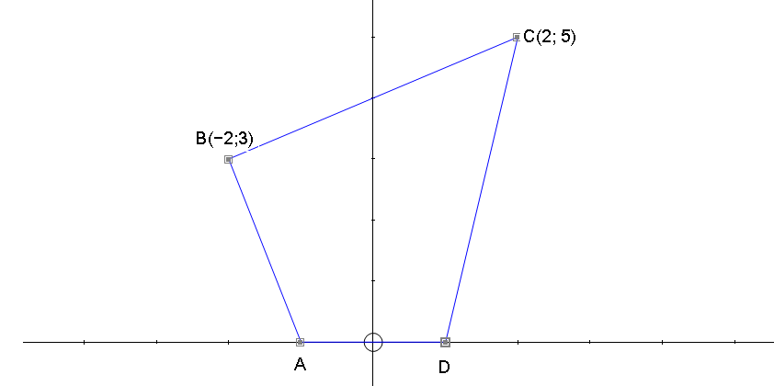
a. |  | If ABCD is rotated 180º about the origin to produce the quadrilateral A’B’C’D’. Write down the co-ordinates of C’. | (2)
b. |  | ABCD is enlarged by a factor of 3 to form the quadrilateral A’’B’’C’’D’’.  Write down the ratio of Area ABCD: Area A’’B’’C’’D’’. | (2)
c. |  | Determine the equation of the circle with centre B which passes through the point C. | (4)
 |  |  | [8]
Question 11
The diagram below represents the circle O, centred at the origin with a tangent to the circle at point P(-3; -1)
 |  | 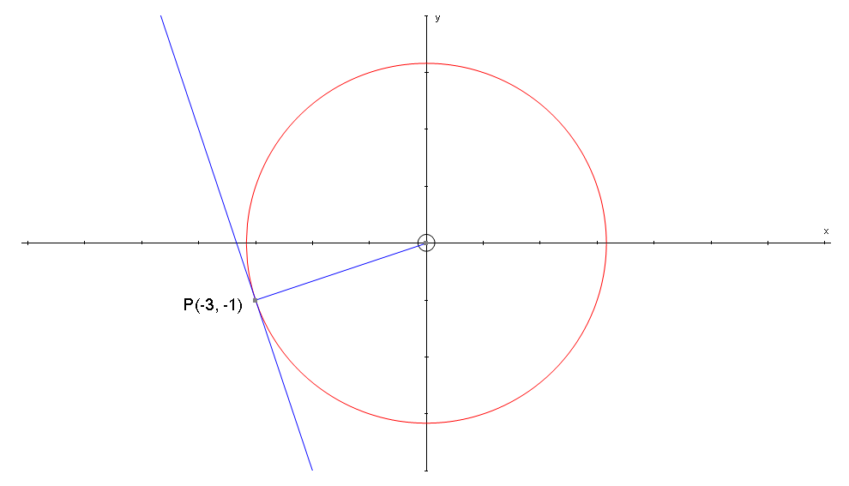
a. |  | Determine the equation of OP. | (2)
b. |  | Hence, determine the equation of the tangent passing through P. | (3)
c. |  | P is rotated about the origin through an angle of 30º to a new point Q.  Determine the co-ordinates of Q, without using a calculator. Leave your answer in surd form. | (6)
 |  |  | [11]

Question 12
 | Find the equation of the line if the line $y=2x+4$is rotated through 90º clockwise. |  | [5]
Question 13
The hexagonal shaped nut or bolt we often use is cut from a cylindrical rod of iron. Usually the machinist knows the “flat distance” (x) from one side of the nut to the opposite side.

Each nut is classified according to the flat distance (x)(eg 10mm or $34$inch, etc), which determines the size spanner we use. By convention, the length of one side (s) of the hexagonal nut is $23$ of the “flat distance” (x)
d
s
x

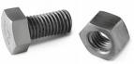

a. |  | Use the Theorem of Pythagoras and the diagram to find a formula for the diameter of the cylindrical rod (d) in terms of the flat distance (x). | (4)
b. |  | Use your formula to determine the size of the distance (d) for a 22mm nut. | (3)
 |  |  | [7]

Question 14
Parking bays need to be erected along 30m of kerbing. A very easy parking bay to pull into and one that will be used is at 50º to the kerb. Each bay is 3,2m wide. AB = 4 metres, AC = x metres and CD = y units.

Use the diagram to answer the following questions, round off your answers to 1 decimal digit.

Curb
A
C
D
E
B
x
y
30m
4m
50º
3,2m
l
a. |  | Find the length $\left(l\right)$ of each bay. [11] | (3)
b. |  | Find the length $\left(x\right)$ | (2)
c. |  | Find the length of $y$ | (3)
d. |  | How many parking bays can be made if there is 30m of kerbing? | (3)
 |  |  | [11]
 |  | TOTAL SECTION B: 75

Name:___________________________________

Diagram sheet A

Question 4

Distance from the white spot in meters  ($x_{i})$ | $$x_{i}−\bar{x}$$ | $$(x_{i}−\bar{x})^{2}$$
$$\sum{}(x_{i}−\bar{x})^{2}$$

Name:___________________________________

Diagram sheet B

Question 9

a.
Marks | Frequency per class interval | Cumulative frequency
$$0≤x≤\text{20}$$ | 4
$$\text{21}≤x≤\text{40}$$ | 11
$$\text{41}≤x≤\text{60}$$ | 20
$$\text{61}≤x≤\text{80}$$ | 10
$$\text{81}≤x≤\text{100}$$ | 5
Total

b.
