

**MATHEMATICS PAPER 3**

**21 March 2012**

**SECTION B GEOMETRY**

**GRADE12**

TOTAL MARKS: 60

EXAMINER: MODERATOR: L

Final mark: /40

Percentage: ________

NAME:_______________________

Instructions

* Work neatly and accurately.
* SHOW WORKING OUT WHERE NECESSARY!
* Calculators may be used unless otherwise stated.
* Round off your answers to ONE decimal place where applicable unless stated otherwise.
* Answer all questions in the booklet.

|  |  |  |
| --- | --- | --- |
| QUESTION | **MAXIMUM MARKS** | **MARKS OBTAINED** |
| **1** | **11** |  |
| **2** | **8** |  |
| **3** | **4** |  |
| **4** | **12** |  |
| **5** | **5** |  |
| **Total** | **(40)** |  |

**Question 1**

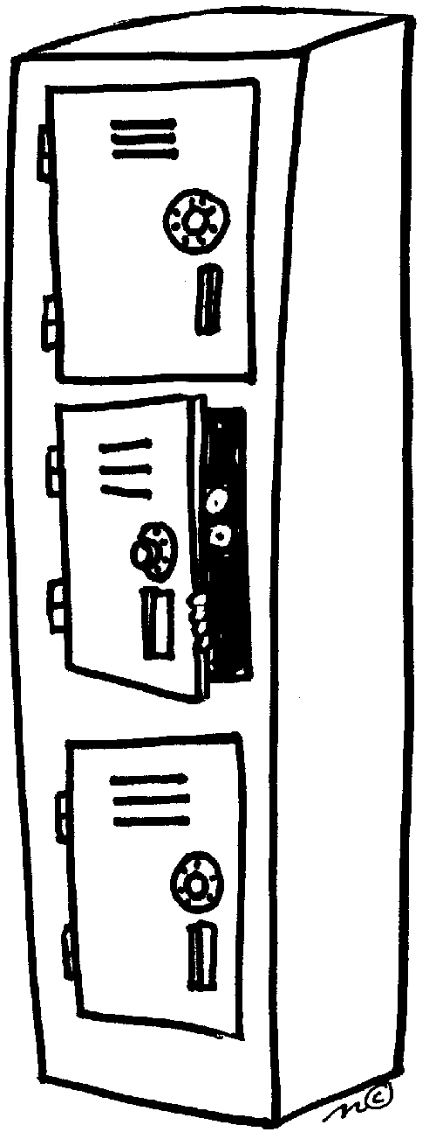Daniel is suffering from temporary stress- induced amnesia and has forgotten the combination to the lock on his locker. He does however remember that all 4 digits were prime numbers and there were no repeated numbers.

* 1. How many possible codes are there for his locker based on the above information? (3)

|  |
| --- |
|  |
|  |

1.2 Sarah remembers that Daniel mentioned that the number was even. How

many combinations are possible based on this information and the information in 1.1? (3)

|  |
| --- |
|  |
|  |

* 1. Jake solves the problem by kicking open the locker. Daniel then starts obsessively arranging the

textbooks inside. If he has 6 textbooks in how many ways can the textbooks be arranged if there are no restrictions? (2)

|  |
| --- |
|  |
|  |

* 1. Daniel does not like it if his English and Maths textbooks touch. If he has one English and one

Maths textbook, in how many ways can all six textbooks be arranged so that Maths and English are **not** together?

(3)

|  |
| --- |
|  |
|  |
|  |
|  |

**Question 2**

Kayla is planning the after party for the matric dance. She is considering the following clubs: Storeyville (S), Taboo (T) and Latinova (L). She gets opinions from a total of 150 people and sets the data out in a Venn diagram[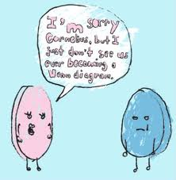](http://www.google.co.za/imgres?q=venn+diagram+jokes&um=1&hl=en&sa=N&biw=1024&bih=585&tbm=isch&tbnid=l1AHdP-eGgl0sM:&imgrefurl=http://siunstuffed.blogspot.com/2012/03/visual-literacy-venn-diagrams-in.html&docid=rK847LtCb5JBkM&imgurl=http://1.bp.blogspot.com/-VhcMhkPQk3A/T1vhkzBw1CI/AAAAAAAAABE/a9ib6PS9LmI/s1600/435VennTshirt.jpg&w=435&h=444&ei=b-DZT67HAcm2hAfAgrDkAw&zoom=1&iact=hc&vpx=87&vpy=130&dur=1421&hovh=227&hovw=222&tx=126&ty=105&sig=107729987976765507952&page=1&tbnh=126&tbnw=119&start=0&ndsp=16&ved=1t:429,r:10,s:0,i:103)



Calculate the probability that a student chosen at random will:

2.1 Not like Storeyville or Taboo (2)

|  |
| --- |
|  |
|  |

2.2 Prefer only 2 of the given options. (2)

|  |
| --- |
|  |
|  |

2.3 Show with all working, whether preferring Storeyville or Taboo is independent or not. (4)

|  |
| --- |
|  |
|  |
|  |
|  |

**Question 3**

$P\left(A\right)=0,55$ and $P\left(B\right)=0,4$ and the $P\left(A∩B\right)=0,25$ Calculate:

3.1 $P(A^{'})$ (1)

|  |
| --- |
|  |
|  |

3.2 $P(A \text{or} B)$ (1)

|  |
| --- |
|  |
|  |

3.3 $P(A^{'} \text{or}{ B}^{'} )$ (1)

|  |
| --- |
|  |
|  |

3.4 $P(A^{'} \text{and B} )$ (1)

|  |
| --- |
|  |
|  |

**Question 4**

The table shows the results of experiments giving the average number of mosquito bites per 15 minutes versus the wind speed.

|  |  |  |  |  |  |  |
| --- | --- | --- | --- | --- | --- | --- |
| **Wind speed (km/h): *x*** | 0,5 | 2 | 4 | 6 | 8 | 14 |
| **Bites/15 min** | 50 | 36 | 25 | 22 | 12 | 5 |

4.1 Draw a scatter plot using the grid below. (3)

4.2 Calculate the value of r, the Pearson correlation coefficient, and comment on the strength of the correlation. (4)

|  |
| --- |
|  |
|  |
|  |
|  |

4.3 Determine the equation of the least squares regression line, and use it to calculate the wind speed if there are 100 bites per minute. Is this an accurate prediction? Give a reason for your answer. (5)

|  |
| --- |
|  |
|  |
|  |
|  |

**Question 5**

The following advertisement appeared in a local newspaper:

**9 out of every 10 women were delighted with our new anti-aging cream**

[](http://www.google.co.za/imgres?q=pretty+young+woman&hl=en&biw=1024&bih=585&gbv=2&tbm=isch&tbnid=MotSmRIjhkn1eM:&imgrefurl=http://www.dreamstime.com/royalty-free-stock-photos-royalty-free-stock-photos-pretty-young-woman-leaning-table-image16678498&docid=eVwWIh6xAvdyOM&imgurl=http://www.dreamstime.com/pretty-young-woman-leaning-on-a-table-thumb16678498.jpg&w=371&h=450&ei=KuzZT4DfBsrBhAex4PnFAw&zoom=1&iact=hc&vpx=191&vpy=118&dur=1250&hovh=247&hovw=204&tx=130&ty=120&sig=107729987976765507952&page=1&tbnh=128&tbnw=104&start=0&ndsp=23&ved=1t:429,r:1,s:0,i:74)**BABY FACE**

**IS IT NOT TIME YOU TRIED IT?**

*study conducted amongst 30 women over a period of three months

5.1 If this claim were true, how many women in a sample size of 500 should be happy

with the product? (1)

|  |
| --- |
|  |
|  |

5.2 Give two reasons why the research undertaken by the manufacturer should not be

considered valid. (2)

|  |
| --- |
|  |
|  |

5.3 The advertising company has used the word “every” in its advert. Why is this

misleading, particularly considering the South African demographic? (2)

|  |
| --- |
|  |
|  |