ST MARY’S DSG, KLOOF

GRADE: 12 SEPTEMBER 2009

MATHEMATICS: PAPER 2
(LO3 and LO4)

TIME: 3 HOURS TOTAL: 150 MARKS

INSTRUCTIONS:

1. This question paper consists of 12 pages and 2 loose diagram sheets.

2. There are 4 sections. Answer each section on a new sheet of paper.

3. Write your name and teacher’s name on each sheet of paper.

4. A formula sheet and 2 diagram sheets have been provided.

5. Please give all answers correct to 1 decimal place unless otherwise indicated.

6. Hand in diagram sheet 1 with Section B and diagram sheet 2 with section C

7. Read all the questions carefully.

8. Number your answers exactly as they have been numbered.

9. An approved non-programmable and non-graphical calculator may be used, unless otherwise specified.

SECTION A (36 MARKS) START THIS SECTION ON A NEW FOLIO SHEET

QUESTION 1

$Δ$ABC has coordinates A( -1; 4) , B( 3 ; 1) and C( 3 ; 6)

y

C(3;6)

A(- 1;4)

θ B(3;1)

0 E x

(a) Give the length of BC. (1)

(b) Prove that $Δ$ABC is isosceles. (3)

(c) Give the gradient of AC. (2)

(d) If BE // AC, give the co-ordinates of E. (2)

(e) A circle is drawn with B as centre, passing through points A and C.

(i) Give the equation of the circle. (3)

(ii) ABD is the diameter of this circle. Give the co-ordinates of D. (2)

(f) Give the equation of the tangent to this circle that passes through A. (4)

(g) Calculate the size of the angle θ. (4)

[21]

QUESTION 2

(a) Evaluate to two decimal places, using your calculator,

(i) – cos² 138º (1)

(ii) $\text{tan} \frac{θ}{2} + \frac{2}{\text{sin} θ} \text{if} θ = \text{107}°$ (2)

(b) Given: 2sin θ = 3cos θ

(i) Write down the value of tan θ . (1)

(ii) If 0º < θ < 90º, use a sketch to evaluate:

$\frac{3}{{\text{sin}}^{2} θ} − \frac{1}{\text{tan} θ}$ (4)
[8]

QUESTION 3

Zena and Charles played nine rounds of golf on their summer holidays. Their scores are shown on the back-to back stem and leaf diagram.

ZENA CHARLES
______________________________________________________
3 0 0 2

1 4 1 1 1 2

9 3 1 0 0 5 2

6 5 4 6 8

(a) Arrange five-number summaries for both players. (5)

- In Crazy Golf the player with the lowest score wins. Charles
actually made the highest score that summer but was still
chosen as the better player. Give a reason for this choice. (2)
[7]

SECTION B (44 MARKS)

The following question must be answered on the answer sheet provided.

QUESTION 4

The following data represents the percentage of family income allocated to
groceries for a sample of 50 shoppers.

Percentage | Frequency
16-25 | 5
26-35 | 15
36-45 | 17
46-55 | 10
56-65 | 3

This is the ogive graph of the data:
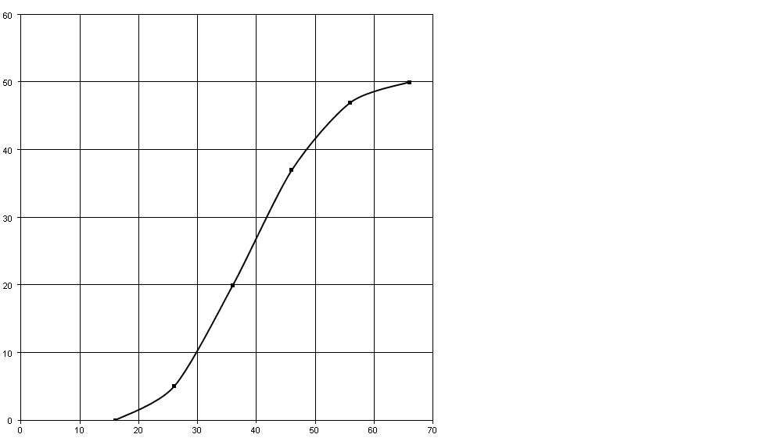
Percentage
Cumulative Frequency

- Indicate on the graph where you would read the values of Q_{1,} Q₂ and Q₃ .
Give an estimate of each of these values. (4)

(b) Draw a box and whisker plot beneath the x-axis. (3)

(c) Use the graph to determine how many families use less than 50% of their
income for groceries. (2) [9]

SECTION B cont… START THIS SECTION ON A NEW FOLIO SHEET

QUESTION 5

(a) Simplify: $\frac{\text{cos} (− θ ) \text{tan} ({\text{180}}^{∘} − θ )}{\text{sin} ({\text{540}}^{∘} + θ )} + \frac{\text{cos} ({\text{90}}^{∘} − θ )}{\text{sin} ({\text{180}}^{∘} − θ )}$ (6)

(b) Simplify and express in terms of one ratio without a calculator:

$\frac{\text{sin} {\text{155}}^{∘} \text{.} \text{cos} {\text{25}}^{∘}}{\text{cos} {\text{295}}^{∘}}$ (3)

(c) Simplify $\frac{\text{sin} {\text{25}}^{∘} \text{.} \text{cos} {\text{25}}^{∘}}{\text{sin} {\text{50}}^{∘}}$ without a calculator. (2)
[11]

QUESTION 6

Prove that: 4sinθ cos³θ - 4cosθ sin³θ = sin 4θ [4]

QUESTION 7

Give the general solution of the following equation:

$\sqrt{2}\text{sin}\left(2x + {\text{15}}^{∘}\right) = −1$ [5]

QUESTION 8

During the construction of the Gautrain tunnel, a conveyor belt (OC) is used to remove soil and rubble from the tunnel excavations.

It runs 15m to an exit point at C and then to a 6m wide fixed storage platform (CD).
The conveyor belt makes an angle of xº with the vertical. $\text{BD}⊥y−\text{axis}$
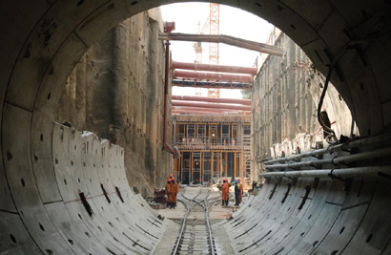
B
6m
15mm
C
O
D
Y
x
Conveyor Belt
Platform

(a) Show that the distance BD is 15sin x + 6 m (3)

(b) If x increases from 30º to 40º in value, by how much will the distance
BD increase? (Give your answer to the nearest m) (3)

(c) What will the value of x be if BD = 17m ? (Give your answer to the
nearest degree). (2)
[8]

(d) Crushing Plant

E
43
F

8km

Platform edge

D
6km

From the platform edge at D, trucks remove the rubble 6km along a road to point E.
From point E, the soil and rubble have to be moved a further 8km to the Crushing
Plant at point F. If $F\hat{D}E = {\text{43}}^{∘}$:

(i) Find $\hat{F}$ (correct to the nearest degree) (2)

- The project engineers need to speed up the removal of the
rubble and make a road from D to F to facilitate this.
Calculate the distance from D to F ( correct to nearest km) (3)

- Will this new road assist them in solving their problem?
Give a reason for your answer. (2)
[7]

SECTION C (45 MARKS)

QUESTION 9
This question must be answered on the answer sheet provided.

For this question, the domain is: $x ∈ [ 0^{∘} ; {\text{360}}^{∘} ]$
(a) On the set of axes provided in the answer sheet, sketch the graphs
of the following:

f(x) = 2cos x + 1
g(x) = tan (x – 45${}^{∘}$)

Label your curves clearly showing the scale on the $y$-axis. (6)

(b) Give the equation(s) of the asymptote(s) of g(x). (2)

(c) Read off the co-ordinates of the points of intersection of the two
graphs, where $x ∈ [ 0^{∘} ; {\text{270}}^{∘} ]$ (4)

(d) Use your graph to give the values of x where g(x) > f(x). (3)

(e) Find the values of a and b if a > 0 and a cos x + b has a maximum
value of 2 and a minimum value of – 6 (4)

[19]

QUESTION 10 START THIS QUESTION ON A NEW FOLIO SHEET FOR THIS SECTION

p q r p r q p
q
r
Diagram A Diagram B Diagram C

(a) Match one of the following descriptions with each of the above graphs:
1. negatively skewed.
2. positively skewed.
3. symmetrical distribution. (3)

(b) Which measure of central tendency does p, q and r represent? (3)
[6]

QUESTION 11

A photograph of the tunnel borer head used in the construction of the tunnel for the Gautrain is given below. Alongside the photograph is a sketch in the Cartesian plane illustrating parts of the borer head.

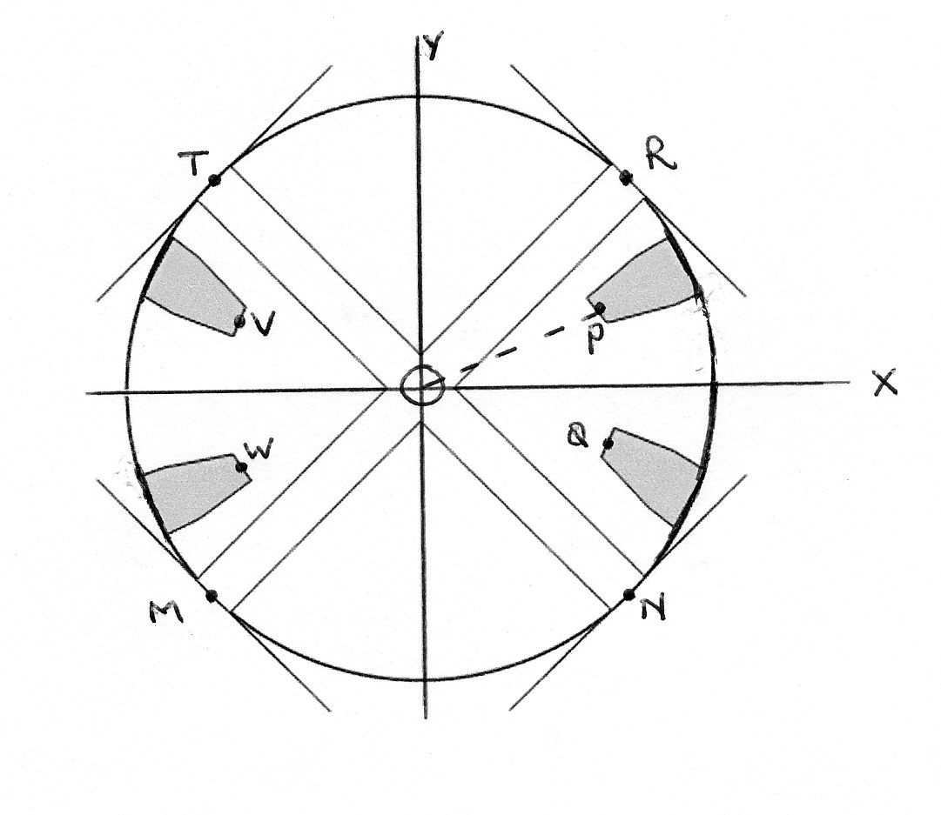
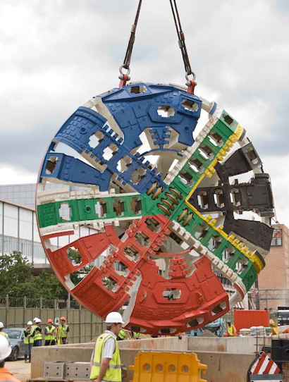

a) If the equation representing the circumference of the borer head is
x² + y² =11,6 m , what is the diameter of the borer head? (2)

b) (i) Give, by inspection, the size of $R\hat{O}T$ where O is the origin. (1)

(ii) If P ( 0,9 ; y) is on the line OP and $P\hat{O}X = {\text{30}}^{∘}$show that y = 0,5. (3)

- Describe each transformation of P, in the form : (a;b) (………. ; ………. )
to:
- Q
- W
- V (3)

- If $R\hat{O}X = {\text{45}}^{∘}$and point R(x; y) ,which lies on the edge of the given
circle, is transformed to R^{I} (2x ; 2y),

(i) What will $R^{I}\hat{O}X$measure? (1)

(ii) Give the equation of the circle, centre origin, passing
through R^{I}. (2)

(iii) Give the ratio of $\frac{\text{Area} \text{circle} \text{RTMN}}{\text{Area} \text{circle} R^{l}T^{l}M^{l}N}$ (2)

e) By using the rotation formula, show that the co-ordinates of the
image N^{I} of the point N (s; t) after rotation about the origin, through
an angle of 135${}^{∘}$ in a clockwise direction will be:

$\left(\frac{\sqrt{2}}{2}\left(t−s\right) \text{ ;} − \frac{\sqrt{2}}{2}\left(t+s\right)\right)$ (6)
[20]

SECTION D ( 25 MARKS) START THIS SECTION ON A NEW FOLIO SHEET

QUESTION 12
An ellipse with equation $\frac{x^{2}}{\text{49}}+\frac{y^{2}}{\text{25}}=1$ is drawn with centre the origin.

(a) If an ellipse has equation $\frac{x^{2}}{a^{2}}+\frac{y^{2}}{b^{2}}=1$ then its area is given by the formula
$A=π$$\text{ab}$ if $a,b>0$.
Use the formula to find the area of the ellipse drawn above in terms of $π$ (2)

(b) If an ellipse has equation $\frac{x^{2}}{a^{2}}+\frac{y^{2}}{b^{2}}=1$ then its perimeter can be approximated

by the formula: $p≈π\sqrt{2(a^{2}+b^{2})−\frac{(a−b)^{2}}{2}}$ when $a,b>0\text{.}$

Use this formula to approximate the perimeter of the ellipse drawn above in
terms of $π$. (3)

(c) If the $a$and $b$ values of the ellipse is reduced through the origin by a factor
of $\frac{1}{2}$ by what factor will the area of the ellipse be reduced. (2)

[7]

QUESTION 13

Let $a$, $b$ , $c$ and $d$ be integers such that $a$< $b$ < $c$ and $c$ = $d$.

- The mode of these four numbers is 11.
- The range of these four numbers is 8.
- The mean of these four numbers is 8.
Calculate the values of $a$, $b$ , $c$ and $d$. [5]

QUESTION 14
D

A
k
θ
B C

A cell phone tower DA is erected in the St Mary’s grounds in an effort to
improve signal coverage. Certain conditions have to be met in the construction
process, ie. DB = BC; AD = AC.
If the angle of elevation of D from B is θ and AB = k:

a) Express AC and BC in terms of k and θ. (4)

b) Express CD² in terms of k and θ. (3)

c) Prove that $\text{cos} C\hat{B}D = {\text{cos}}^{2}θ$ (6)
[13]

TOTAL 150

DIAGRAM SHEET 1 NAME: _______________________________________
Section B
QUESTION 4
The following data represents the percentage of family income allocated to
groceries for a sample of 50 shoppers.

Percentage | Frequency
16-25 | 5
26-35 | 15
36-45 | 17
46-55 | 10
56-65 | 3

This is the ogive graph of the data:
Percentage
Cumulative Frequency

- Indicate on the graph where you would read the values of Q_{1,} Q₂ and Q₃ .
Give an estimate of each of these values.____________________________ _______________________________________________________________(4)

(b) Draw a box and whisker plot beneath the x-axis. (3)

(c) Use the graph to determine how many families use less than 50% of
their income for groceries. ________________________________ (2)
[9]

DIAGRAM SHEET 2 NAME: _______________________________________

Section C
QUESTION 9 For this question, the domain is: $x ε [ 0^{0} ; {\text{360}}^{0} ]$

(a) On the set of axes, sketch the graphs
of the following: f(x) = 2cos x + 1
g(x) = tan (x – 45º)
Label your curves clearly and show the scale on the y-axis. (6)
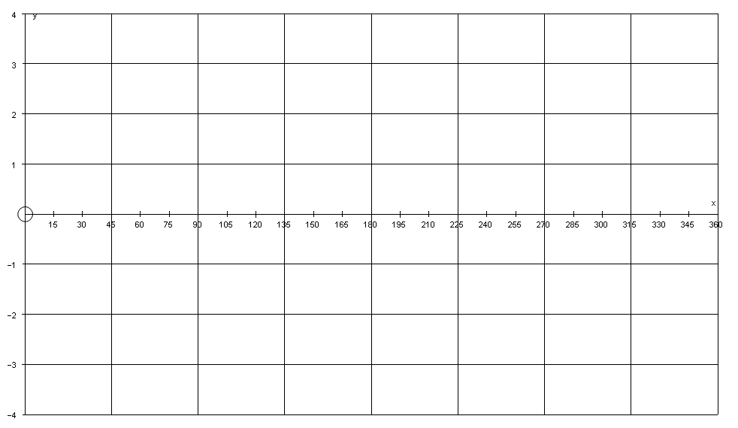
(b) Give the equation(s) of the asymptote(s) of g(x).
_______________________________________________________ (2)

(c) Read off the co-ordinates of the points of intersection of the two
graphs, where $x∈\left[0^{∘};{\text{270}}^{∘}\right]$ ______________________________
_______________________________________________________ (3)

(d) Use your graph to give the values of x where g(x) > f(x).
______________________________________________________
______________________________________________________ (4)

(e) Find the values of a and b if a > 0 and a cos x + b has a maximum
value of 2 and a minimum value of – 6
_______________________________________________________
_______________________________________________________ (4) [19]

