

ST MARY’S DSG, KLOOF

GR 12 EXAMINATION
JUNE 2009

MATHEMATICS

Total: 150 MARKS Time: 3 HOURS

READ THE FOLLOWING INSTRUCTIONS CAREFULLY:

- This question paper consists of 6 pages; and a formula sheet is supplied.

- There are 3 sections. Start each section on a new page and hand in separately.

- Answer all the questions.

- Number your answers as the questions are numbered.

- All the necessary working details must be clearly shown.

- Approved non-programmable calculators may be used except where otherwise stated.

- It is in your own interest to write legibly and to present your work neatly.

8. Where necessary, round off to two decimal places.

MATHEMATICS Grade 12 Page 2 of 6

SECTION A

- Solve for x for each of the following, round off to two decimal places where necessary:

(a) (x – b)(x – a) = 0 (2)

(b) $(x+3)^{2}−5=0$ (5)

(c) $\sqrt{3x+\text{13}}−x=1$ (5)

(d) $\frac{3^{3x}\text{.}9^{x−2}\text{.}{\text{27}}^{−2x}}{3^{1−3x}}=\frac{1}{\text{81}}$ (5)

(e) $\text{log}x+\text{log}(x−1)=\text{log}6$ (5)

(f) 4.6^{x} = 32 (4)

- Solve the following, without the use of a calculator: SHOW ALL WORKING

- $x = \sqrt{\text{45}} − \sqrt{\text{16} + 4}$ (3)

(b) $x=−{\text{log}}_{2}0,5$ (2)

3. Determine from first principles the derivative of f(x) where $f(x)=x^{2}−x$. (6)

4. Given the function $f(x)=−x^{3}+5x^{2}+8x−\text{12}$.
(a) Show that (x – 1) is a factor of f(x). (2)

(b) Factorise f(x) and then find the x-intercepts. Show all working. (3)

(c) Find the co-ordinates of the stationary points. (5)

(d) Draw a sketch of f, indicating the values of the intercepts and the stationary points .
(3)
[50 marks]

SECTION B: Please start on a new page.

- Evaluate:
(a) $D_{x}[\frac{2x^{\frac{3}{2}}−2\sqrt{x}}{\sqrt{x}}]$ (4)

(b) $f'(x)$ if $f(x)=(2x^{3}−3x)^{2}$ (4)

- The points A(-1; a), B(1; 1) and C(3; -2) are given.
(a) Find the midpoint of BC. (2)

(b) Find the value of a if points A, B and C are collinear. (5)
MATHEMATICS Grade 12 Page 3 of 6

7.
W(2; 5)
Y(6; 2)
X
Z
x
y
O

Garfield, a couch potato soccer fan, was
asked to design the perfect chair for
watching the 2010 Soccer World Cup on
his television.
Garfield got some graph paper and drew
a side view of his fantasy chair. He used
the scale of one unit in the x- and y- axis
to represent 20 cm.

To begin, Garfield drew a line from the origin to the point W, with co-ordinates (2; 5).

(a) Write down the equation of the line OW. (2)

Next Garfield drew a line WX with gradient of –2, as shown in the diagram, which is perpendicular to the line XY, with Y having co-ordinates (6; 2).

(b) Calculate the equation of WX. (3)

(c) Calculate the equation of XY. (3)

(d) Hence calculate the co-ordinates of X to be (4; 1), showing all working. (3)

Finally the line YZ was drawn which is parallel to the line OW.

(e) Calculate the actual length of the side which the chair occupies on the floor. (6)

(f) Calculate the angle between OW and XW. (5)

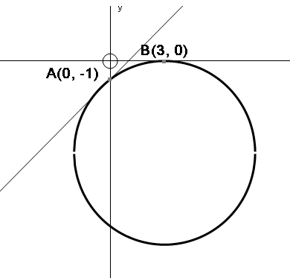

8. A circle, centre M, cuts the y-axis at
A(0; -1) and touches the x-axis at B(3; 0)
and has a radius of 5.
(a) Calculate the co-ordinates of M.
(2)
.M
(b) Determine the equation of the
tangent to the circle through
the point A. (3)

MATHEMATICS Grade 12 Page 4 of 6

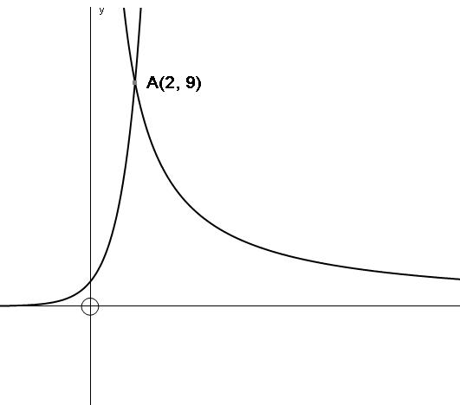
g
f
9. The figure represents the graphs of:
$f(x)=a^{x}$ and $g(x)=\frac{k}{x},\overset{}{}x>0$

(a) If A(2;9) lies on the graphs of f and g, determine the values of a and k. (4)

(b) If h and j are symmetrical about the y-axis to the graphs of f and g respectively, determine h and j in the form $h(x)=\text{.}\text{.}\text{.}\text{.}\text{.}\text{.}$ and $j(x)=\text{.}\text{.}\text{.}\text{.}\text{.}\text{.}$ (3)

(c) If the original f is shifted 2 units vertically up and 1 unit horizontally to the right, write its new equation in the form $k(x)=\text{.}\text{.}\text{.}\text{.}\text{.}\text{.}$ (3)

(d) Determine f⁻¹ and g⁻¹, the inverses of f and g respectively in the form y = …. (4)
[56 marks]

SECTION C: Please start on a new page.

10. If $\text{log}2=a$, write $\text{log}\text{25}$ in terms of $a$. (3)

11. Solve for x:

(a) $x^{2}>0$ (2)

(b) $(x+1)(x−2)<0$ (3)

(c) $\frac{(x+1)(x−2)}{x^{2}}<0$ (3)

12. Find the integer that is the closest approximation to:
2²⁰⁰⁸ + 2²⁰¹⁰
2²⁰⁰⁹ + 2²⁰⁰⁹ (3)

MATHEMATICS Grade 12 Page 5 of 6

Ground
6m
13.

A boy , Michail, stands on a 6m building and
throws a cricket ball into the air. The arc of the ball
is shown on the graph and is represented by
the equation $H=−\frac{1}{2}t^{2}+2t+6$ where H is its
height above the ground in metres, after t seconds.

Determine:

- Its height above the ground after 2 seconds (2)

- Its speed after 2 seconds. Explain your answer. (3)

- After how many seconds it will reach the ground? (2)

14.

A container firm is designing an open-top rectangular box,
with a square base that will hold 108 cm³.
Let the length of the sides of the square base be x cm.

(a) Show that the total surface area will be $A=x^{2}+\frac{\text{432}}{x}$ (3)

(b) What value of x will yield the minimum surface area? (3)

(c) What is the minimum surface area? (2)

MATHEMATICS Grade 12 Page 6 of 6

15. John claims that he can prove that $1>2$. Here is his proof:
Step 1: $\frac{1}{2}>\frac{1}{4}$

Step 2: $\frac{1}{2}>(\frac{1}{2})^{2}$ Step 4: $\text{log}\frac{1}{2}>2\text{log}\frac{1}{2}$

Step 3: $\text{log}\frac{1}{2}>\text{log}(\frac{1}{2})^{2}$ Step 5: $\frac{\text{log}\frac{1}{2}}{\text{log}\frac{1}{2}}>\frac{2\text{log}\frac{1}{2}}{\text{log}\frac{1}{2}}$

Step 6: $1>2$

Explain in which step(s) John went wrong and explain why. (3)

16. Jenna stands by a pool. She throws a pebble in the water and watches the ripples that form.
The ripples are represented by 6 circles, all with the same centre.
w₁
w₂
w₃
w₄
w₅
w₆
l₁
l₂

l₃
l₄
l₅
l₆
.
P

(a) The equation of the smallest circle, w₁, is $x^{2}+y^{2}+6x−4y+p=0$ and the equation of the circle, w₆, is $x^{2}+y^{2}+6x−4y=\text{87}$. If the circle w₆ has a radius which is 5 times that of w₁, calculate the value of $p$. (6)

(b) The parallel lines l₁, l₂, l₃,.... l₆ are tangents to the circles, w₁, w₂, w₃, ...... w₆. If the gradient of l₆ is $\frac{4}{3}$, find the possible co-ordinates of P, the point of contact. (6)
[44 marks]
TOTAL: 150 marks

EXTRA

8b. In the figure A(1; -1), B(0; k) and C(6; 4)
are the vertices of a triangle.
The equations of the sides AB and AC
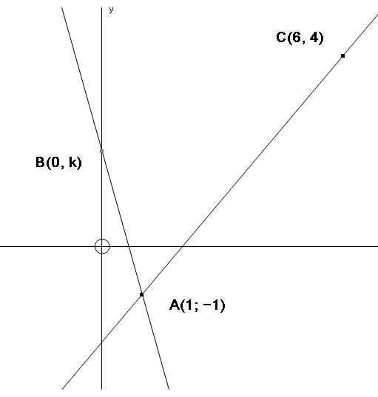
are y + 3x – 2 = 0 and x – y – 2 = 0
respectively.

(a) Show that the numerical value of k is 2. (2)R

(b) Show that ΔABC is right-angled at B. (4)R

(c) If BD is an altitude of ΔABC (i.e. a line from B to a point D which lies in AC, with $\text{BD}⊥\text{CA}$, find the equation of the line BD. (4)R

- If $B\hat{C}A$ = θ, calculate the size of θ correct to one decimal place. (4)C

13.2 The straight line with equation px + qy + 2 = 0 makes an angle of 135⁰ with the positive
x-axis and passes through the point (2; -1). Calculate the values of p and q. (6)C

QUESTION 6

The figure shows the cross-section
of a wheel bearing. The smaller
circles represent ball-bearings which
roll between the two larger concentric
circles, A and B which both have
centre M.

The equation of circle A is given by
x² + y² + 3x – 6y = 9.

P is the centre of one of the small
ball-bearings, each of which has a
radius of 2 units. Find the equation
which describes the path of P as it
rolls between the two larger circles.

Give your answer in the form:
(x – a)² + (y – b)² = r². (7) [7 marks]

