

ST MARY’S DSG
MATHEMATICAL LITERACY
PAPER 2
TRIAL EXAMINATION

GRADE 12

Date: September 2009

Examiner: Mrs J Kinsey Time: 3 hours
Moderator: Ms N Simpson Marks: 150
____________________________________________

Please read the following instructions carefully

- This question paper consists of 5 questions
- Your question paper consists of 14 pages including a 2 page answer sheet
- Answer all appropriate questions on the answer sheet and hand it in with your Examination script.
- Unless convention dictates otherwise, round all answers to TWO decimal places.
- An approved, non-programmable calculator may be used.
- It is in your own interest to write legibly and to show working at all times.

 | QUESTION 1 (33marks)
 | When you buy something it can cost you more than its purchase price. Robyn discovered this when she wanted to buy a car. She visited numerous second-hand car dealers and eventually settled on Zama’s Zazzy Cars where she saw two vehicles that she liked:
2008 Polo 1.6 C/line, Blue A/c,p/s,c/l,r/cd,fsh,mags,alarm/immob R119 990

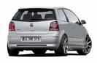
2008 Honda Jazz 1.4, CSi, A/c,,P/s,Low mileage R129 990

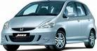

 | Before buying a vehicle Robyn researches their comparative petrol consumption on the internet at www.marvellousmotoring.com and finds the following table:
TABLE 1
Car | Cost of Car | Petrol consumption
Polo | R119 990 | 12km/l
Honda Jazz | R129 990 | 14km/l

1.1 | The polo has a petrol tank capacity of 50 litres and the Honda Jazz has a petrol tank capacity of 52 litres. Both cars are filled with petrol and driven until they are empty. Which car drives further and by how many kilometres? | (5)
1.2 | Petrol costs R7,47 a litre. How much will it cost to fill the Honda Jazz? | (2)
1.3 | How much petrol, in litres, does the Polo consume during a trip to Hilton, which is 78km away from Robyn’s home? | (2)
1.4 | Robyn wants to spend as little money as possible for each kilometre she drives. She therefore, prefers the petrol consumption of the Polo to that of the Honda Jazz. Is Robyn’s reasoning correct? Explain your answer | (3)
1.5 | Robyn plots the graph below showing the total costs (for purchase price and petrol) of the Polo versus the Honda Jazz as shown in Table 1. The graph shows the initial cost of purchase as well as the petrol costs per kilometre.
A | 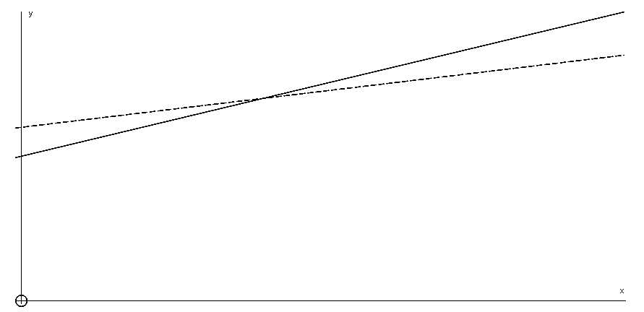
 | Use the Graph to help you answer the following questions
 | 1.5.1 There is a solid line and a dotted line. Which line represents the Polo’s cost  and which line represents the Honda Jazz’s cost? Give a reason for your answer | (4)
 | 1.5.2 Which is the independent variable and which is the dependent variable? | (2)
 | 1.5.3 What is the value at A? | (2)
 | 1.5.4 If Robyn drives 30 000km, find the Total cost (purchase price and petrol cost)  that she will incur if she was using the Polo. | (2)
 | 1.5.5 After how many kilometres will the Honda Jazz and the Polo have the same  total cost? (round off to the nearest km) | (4)
1.6 | Robyn decides she will buy the Honda Jazz – she has to use her own vehicle for business purposes. She needs to know what the Automobile Association of South Africa’s (AA) cost per km will be in order to claim her travel expenses from her company.
 | The AA provides the following tables for calculating the cost of operating a petrol driven car.
 | TABLE 2
RUNNING COSTS (cents per kilometre)
Engine size | Fuel | Maintenance
Engine size | Petrol Factor | Service and repair Costs | Tyre Costs
Engine size | A | B | C
1301-1500 | 8,64 | 15,87 | 8,29
1501-1800 | 9,22 | 16,71 | 11,26
1801-2000 | 9,83 | 23,48 | 17,65

 | TABLE 3
FIXED COSTS (cents per kilometre)
Purchase Price | Annual Distance travelled
Purchase Price | 15001-20000 | 20001-25000 | 25001-30000 | 30001-35000
75001-100000 | 177 | 143 | 120 | 105
100001-125000 | 195 | 157 | 132 | 115
125001-150000 | 235 | 189 | 159 | 139

 | 1.6.1 If the current petrol price is R7,47 per litre, use the formula to calculate the  annual running cost for the Honda Jazz as calculated by the AA. | (4)
 | Running cost (cents /km) = (A x petrol price in Rand /litre) + B + C

1.6.2 Use the formula below to determine the total annual operating cost in Rand for

the Honda Jazz if Robyn travels 30000 km in a year
 | Total operating cost (cents/km) = Running cost + fixed cost | (3)
 | QUESTION 2 (21 marks)
 | Jade and Tanita start their own business “Taja CC”. They decide they want to experiment with investing in foreign currency in order to try and make some money to pay back their bond on their new business premises.
 | The following exchange rate table is given:
Base Currency: Quote Currency | 15 September | 15 December
US$: Yen | 117.402 | 127.440
Euro:us$ | 0.91970 | 0.90440
US$:Swiss Franc | 1.62330 | 1.62930
Rand:Euro | 0.12730 | 0.08904
British Pound:US$ | 1.4710 | 1.4540
British Pound:Rand | 12.63020 | 18.05870
Rand:US$ | 0.11650 | 0.080710
Yen:Euro | 0.0092520 | 0.0086810
Yen:Swiss franc | 0.0138330 | 0.0127870
British pound:Yen | 1172.8630 | 185.440
Swiss franc:rand | 5.29390 | 7.62570
Euro:Swiss Franc | 1.49520 | 1.47330
Euro:British Pound | 0.62710 | 0.62220
Swiss Franc: British Pound | 0.41870 | 0.42220

What you have | The table gives currencies in the following order :  Base Currency: Quote Currency  What you want
 | You may need to convert to two or three different currencies before you are able to trade in the currency of your choice. Eg If you wish to trade in Swiss Franc you may need to first convert your Rand to US$ and then convert US$ to Swiss Franc as you are not given a direct Rand: Swiss Franc exchange
2.1 | The two business partners have R100 000 to invest in foreign currency. The first thing that they have to do is convert their R100 000 into US$. How many US$ will Jade and Tanita get to use for their investment on 15th September? | (2)
2.2 | Tanita and Jade have decided to invest in the Japanese Yen but unfortunately they must first buy US$ and then Japanese Yen to get started. How much Yen will they have on the 15th September? | (2)
2.3 | 2.3.1 On the 15th December, they decide to sell the Yen. Calculate whether they  have made a profit or a loss in Rand? | (6)
 | 2.3.2 What is the percentage change in the value of their money from  15th September to 15th December? | (3)
2.4 | The following information regarding a bond is available:
 | A bond is usually paid over a period of 20 years
 | The bond rate is 11,75% p.a.
 | The following formula is used $M=\frac{i×P}{[1−(1+i)^{−n}]}$ where
 | M is the monthly repayment
 | i is the monthly interest
 | P is the loan amount
 | n is the number of months
 | “Taja CC” wish to purchase a business premise for R1 387 000. They have a deposit of R150 000 and so will need to take out a loan for the balance of the purchase price.
 | 2.4.1 Calculate the monthly repayments on this bond | (4)
 | 2.4.2 How will an extra R50 000 on the deposit affect their monthly repayments? | (4)
 | QUESTION 3 (35 marks)
3.1 | The diagram below shows part of the plan for new coffee shop cum Art Gallery that Bianca and Camilla intend running called “Cambi”. The scale of the plan is 1:125
 | 3.1.1 The window in the bathroom is shown as W2. What is the actual length of this  Window in metres? | (2)
 | 3.1.2 Find the actual area of the bathroom in metres${}^{2}$ | (4)
 | 3.1.3 Find the actual area of the studio in metres${}^{2}$ | (6)
 | 3.1.4 Camilla and Bianca want to double the length and breadth of the serving area.  By what factor will the area of the serving area change? | (2)
3.2 | In front of the Cambi coffee shop and Art Gallery are models of a salt and pepper cellars made from a cylinder and a hemisphere as shown in the diagram.
 | 3.2.1 By using the following formulae calculate the volume of the salt cellar in cm${}^{3}$  if the diameter of the cylinder and the hemisphere is 30cm and the height of  the whole model is 78cm.  Volume of Sphere = $\frac{4}{3}{πr}^{3}$ and Volume of cylinder =${πr}^{2}h$ | (5)

3.2.2 The girls want to paint the models and because they are outside on the street

they would like to give them two coats of exterior wall paint. How many tins

of paint must they order if a 250ml tin of paint covers 1m${}^{2}$
 | Surface Area of a cylinder = $2{πr}^{2}+2π\text{rh}$ and Surface area of sphere = $4{πr}^{2}$ | (7)

3.2.3 If the cost of a 5 litre tin of paint is R389,99, what will it cost to paint the

models?
3.3 | A 3D view of the segment of the foundation trench is given  Scale 1:125  80cm  30cm  10cm  0.50m  Concrete section
 | Volume of triangular Prism = $\frac{1}{2}b×h×$ Height of Prism
 | Volume of rectangular Prism = l x b x height of prism
 | 3.3.1 Calculate the actual volume of concrete that the builder will need for the  concrete in the foundation in metres${}^{3}$ | (6)
 | QUESTION 4 (41 marks)
4.1 | The graph below shows the number of boys and girls interviewed at a local university who attended a private school in SA and the number of boys and girls who completed their high schooling at a private school in South Africa.
Boys who wrote matric at a Private school = 8325 | Girls who matriculated  from Private school = 94,2%  % of boys who  started Gr1  at a Private  school = 62%  % of girls who started Gr 1  at a private school = 38%  Boys who never completed their schooling at a Private school = 449  Girls who did not  complete their  schooling a Private  school = 5,87%
 | 4.1.1 How many boys started their schooling in Grade 1 at a private school in South  Africa? | (2)
 | 4.1.2 How many girls started their schooling at a private school in Grade 1? | (2)
 | 4.1.3 How many girls matriculated from a private school? | (3)
 | 4.1.4 Did a higher percentage of boys or girls leave private schooling before their  Grade 12 exams? Explain your answer and show all working | (4)
4.2 | The graph below shows the number of students who completed their schooling at a private school from the various different provinces.
 | 4.2.1 Which province had the greatest number of students who matriculated from  private schools in South Africa? | (2)
 | 4.2.2 A total of 23425 pupils matriculated from private schools in South Africa in  2008. What percentage of these students came from foreign countries? | (3)
4.3 | The table below gives the final English results for 50 boys and girls who wrote matric in 2008.
Girls | Boys |  | Girls | Boys
60 | 76 |  | 68 | 66
60 | 37 |  | 74 | 68
84 | 52 |  | 64 | 58
68 | 70 |  | 76 | 41
82 | 72 |  | 86 | 56
66 | 78 |  | 58 | 50
58 | 62 |  | 38 | 46
96 | 50 |  | 82 | 50
60 | 54 |  | 82 | 80
90 | 64 |  | 31 | 82
64 | 62 |  | 48 | 84
88 | 64 |  | 43 | 42
66 | 72 |  | 36 | 68
90 | 31 |  | 46 | 72
70 | 38 |  | 76 | 64
76 | 68 |  | 74 | 60
53 | 24 |  | 86 | 60
76 | 84 |  | 82 | 60
52 | 82 |  | 40 | 60
76 | 90 |  | 42 | 58
54 | 34 |  | 34 | 62
52 | 70 |  | 52 | 74
94 | 56 |  | 72 | 60
90 | 72 |  | 66 | 50
80 | 52 |  | 72 | 44

 | 4.3.1 Calculate the mean average final English mark of the 50 boys who wrote matric  in 2008? | (3)
 | 4.3.2 If you were to give a female student advice about what mark she needs to  obtain to get into the top ten, what would be the minimum mark would she  need to get? | (2)
 | 4.3.3 Construct a frequency table to summarise the information presented in the  table above. The table must summarise the information for boys and girls  separately and must use the following class intervals. 0 – 9, 10 - 19, 20 - 29 etc | (4)
 | 4.3.4 Use the grid on the answer sheet top draw a frequency polygon to represent  the information in the frequency table for girls only. | (4)
4.4 | 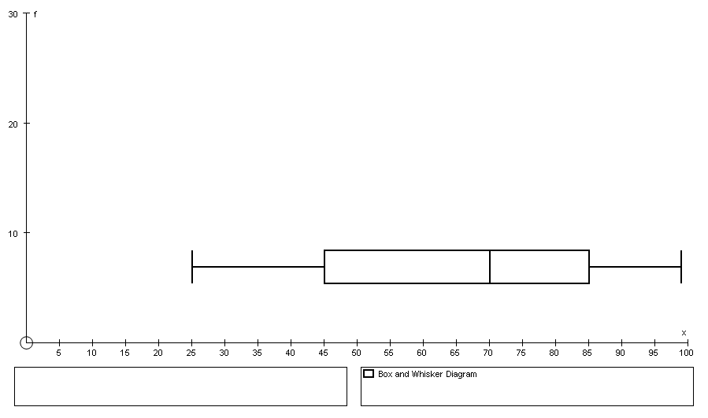  The following box and whisker diagram was drawn of the Grade 12 maths students results. Explain what this box and whisker indicates. Explain whether the results are skewed or not. | (4)
4.5 | The cumulative frequency or Ogive curve of the Grade 12 Science results

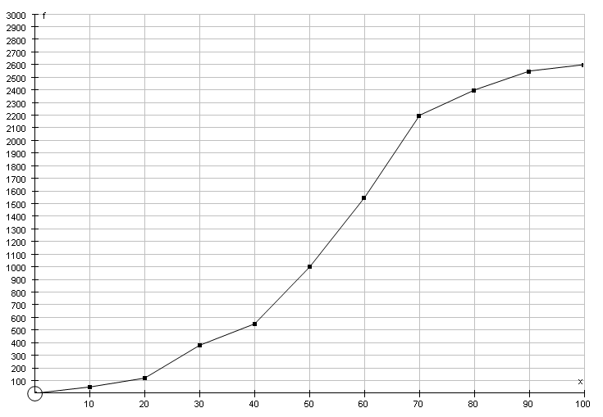
CLASS GROUPS
 | 4.5.1 Using the graph above give the median, lower quartile and the upper quartile of the Science results and indicate your answer on the graph. | (3)
 | 4.5.2 What percentage of students got over 50%? | (2)
 | 4.5.3 In order to determine a correct standard for the paper the norm is to have  10% of the students obtain an A. Does this occur in this paper? Explain  your answer. | (3)
 | QUESTION 5 (19 marks)
 | Lauren and Sam open up a new business called Samly’s which supplies frozen yoghurt to school tuckshops. They have bought a chest freezer for their business. The freezer is 120cm wide , 1,75m deep and 150cm high.
5.1 | Use the formula V = l x b x h to calculate the capacity of the fridge in litres if 1000cm${}^{3}$ = 1 litre | (3)
5.2 | Samly’s buys the frozen yoghurt in 25-litre containers. Calculate the number of  25-litre containers that the freezer is able to hold. | (1)
5.3 | Will they actually be able to fit this number of containers into the freezer? Explain your answer. | (2)
5.4 | The table belows lists the various tub sizes that Samly’s will be using for frozen yoghurt:
 | Sam and Lauren estimate the various tub sizes will sell in the following ratio
 | $\frac{1}{4}$ small, $\frac{5}{\text{12}}$medium, $\frac{1}{3}$ large
 | If they have 1500 litres of frozen yoghurt, use the information given above to calculate how many of each tub size they will sell. | (6)
5.5 | Sam and Lauren draw up a table which shows their costs:

Frozen Yoghurt: R200 for 25 litres
Container: R1,50 for each tub irrespective of size
Toppings: R0,50 per serving
 | 125ml - Small | 250ml - Medium | 500ml - Large
Cost | R1,00 +R1,50+R0,50 = R3,00

 | 5.5.1 Complete the table on your answer sheet | (4)
 | 5.5.2 Calculate what Sam and Lauren must sell a 150ml tub for, in order to make a profit of 30% | (3)

ANSWER SHEET GRADE 12 LIT PAPER 2

NAME: ____________________________________

Frequency Boys | Tally | Marks | Tally | Frequency girls
 |  | 0 – 9
 |  | 10 - 19
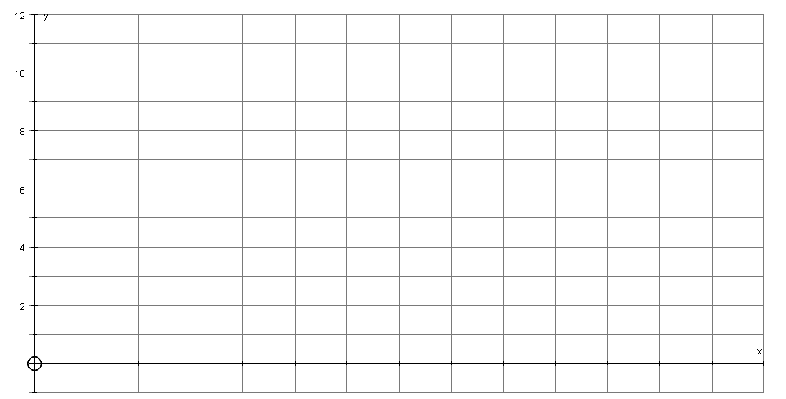

5.5
 | 125ml – Small | 250ml - Medium | 500ml - Large
Cost | R1,00 +R1,50+R0,50 = R3,00

GRIDS | LO1 | LO2 | LO3 | LO4 |  | TL1 | TL2 | TL3 | TL4
 | 37,5 | 37,5 | 37,5 | 37,5 |  | 0 | 15 | 75 | 60
1.1 | 5 |  |  |  |  |  |  | 5
1.2 | 2 |  |  |  |  |  | 2
1.3 | 2 |  |  |  |  |  | 2
1.4 | 3 |  |  |  |  |  |  |  | 3
1.5.1 |  | 4 |  |  |  |  |  | 4
1.5.2 |  | 2 |  |  |  |  |  | 2
1.5.3 |  | 2 |  |  |  |  |  | 2
1.5.4 |  | 3 |  |  |  |  |  | 3
1.5.5 |  | 4 |  |  |  |  |  |  | 4
1.6.1 |  | 4 |  |  |  |  |  | 4
1.6.2 |  | 3 |  |  |  |  |  |  | 3
QUES 1 | 12 | 22 |  |  |  |  | 4 | 20 | 10
2.1 | 2 |  |  |  |  |  | 2
2.2 | 2 |  |  |  |  |  |  |  | 2
2.3.1 | 6 |  |  |  |  |  |  |  | 6
2.3.2 | 3 |  |  |  |  |  |  | 3
2.4.1 | 4 |  |  |  |  |  |  |  | 4
2.4.2 | 4 |  |  |  |  |  |  |  | 4
QUES 2 | 21 |  |  |  |  |  | 3 | 3 | 16
3.1.1 |  |  | 2 |  |  |  | 2
3.1.2 |  |  | 4 |  |  |  |  |  | 4
3.1.3 |  |  | 6 |  |  |  |  | 6
3.1.4 |  |  | 2 |  |  |  |  | 4
3.2.1 |  |  | 5 |  |  |  |  | 5
3.2.2 |  |  | 7 |  |  |  |  |  | 5
3.2.3 |  | 3 |  |  |  |  |  | 3
3.3.1 |  |  | 6 |  |  |  |  |  | 6
QUES 3 |  | 8 | 32 |  |  |  | 2 | 18 | 15
4.1.1 |  |  |  | 2 |  |  | 2
4.1.2 |  |  |  | 2 |  |  | 2
4.1.3 |  |  |  | 3 |  |  |  | 3
4.1.4 |  |  |  | 4 |  |  |  |  | 4
4.2.1 |  |  |  | 2 |  |  | 2
4.2.2 |  |  |  | 3 |  |  |  | 3
4.3.1 |  |  |  | 3 |  |  | 3
4.3.2 |  |  |  | 2 |  |  |  |  | 2
4.3.3 |  |  |  | 4 |  |  | 4
4.3.4 |  |  |  | 4 |  |  |  | 4
4.4. |  |  |  | 4 |  |  |  |  | 4
4.5.1 |  |  |  | 3 |  |  | 3
4.5.2 |  |  |  | 2 |  |  |  | 2
4.5.3 |  |  |  | 3 |  |  |  |  | 3
QUEST 4 |  |  |  | 41 |  |  | 16 | 12 | 13
5.1 |  |  | 3 |  |  |  |  | 3
5.2 | 1 |  |  |  |  |  | 1
5.3 |  | 3 |  |  |  |  |  | 3
5.4.1 | 5 |  |  |  |  |  |  | 5
5.5.1 |  | 4 |  |  |  |  |  | 4
5.5.2 |  | 3 |  |  |  |  |  | 3
QUEST5 | 6 | 10 | 3 |  |  |  | 1 | 18 | 3
TOTALS | 39 | 35 | 35 | 41 |  | 0 | 25 | 65 | 60
% | 26% | 23% | 23% | 27% |  | 0% | 17% | 43% | 40%

