
NATIONAL
SENIOR CERTIFICATE

GRADE 12

MATHEMATICS P2

PREPARATORY EXAMINATION 2008

MARKS: 150

TIME: 3 hours

This question paper consists of 10 pages, a forumla sheet and 3 diagram sheets.

INSTRUCTIONS AND INFORMATION

Read the following instructions carefully before answering the questions.
1. This question paper consists of 11 questions. Answer ALL the questions.

2. Clearly show ALL calculations, diagrams, graphs, et cetera which you have used in determining the answers.

3. An approved scientific calculator (non-programmable and non-graphical) may be used, unless stated otherwise.

4. If necessary, answers should be rounded off to TWO decimal places, unless stated otherwise.

5. Number the answers correctly according to the numbering system used in this question paper.

6. Diagrams are NOT necessarily drawn to scale.

7. Write your name in the spaces provided on the DIAGRAM SHEETS and hand them in together with the ANSWER BOOK.

8. Write neatly and legibly.

QUESTION 1

In the figure A (x ; y), B (2 ; 4) and C (0; -6) are the vertices of a $Δ\text{ABC}$ in the Cartesian plane. The equation of the straight line AB is given by $y=−x+8$

B (2 ; 4)
C (0 ; -6)
y
A (x ; y)

x

1.1 | Determine:

 | 1.1.1  1.1.2  1.1.3  1.1.4 | The length of BC in the simplest surd form  Coordinates of M the mid-point of BC  The gradient of BC  $θ$, the inclination of the straight line BC |  | (3)  (2)  (2)  (2)

1.2 | Determine the equation of the straight line AM which is perpendicular to BC. |  | (5)

1.3 | Show that the coordinates of A are (11 ; -3). |  | (5)

1.4 | If $\text{BC}=2\sqrt{\text{26}}$ and A (11 ; -3), determine coordinates of the vertices of the $Δ$$A^{'}B^{'}C^{'}$– the enlargement of the $Δ$ABC through the origin by a scale factor of 2. |  | (3)

1.5 | Calculate the ratio of $\frac{\text{Area} ΔA^{'}B^{'}C^{'}}{\text{Area} Δ\text{ABC}}$ |  | (3)  [25]

QUESTION 2

2.1 | The straight line with the equation 3y – x – 11= 0 is parallel to the straight line passing through T (-4 ; 1) and U (k + 2 ; 4).  Calculate the value of k. |  | (5)

2.2 | In the figure below the tangent AB touches the circle $x^{2}+y^{2}−6x+2y+t=0$ at B. A is the point (-2 ; 0) and the length $\text{AB}=3\sqrt{2}$.
y
B
A (-2 ; 0)
x
.
M

 | 2.2.1 | Write down the coordinates of M, the centre of the circle. |  | (4)

 | 2.2.2 | Express the radius of the circle in terms of t. |  | (1)

 | 2.2.3 | If $\text{AM}=\sqrt{\text{35}}$calculate the numerical value of t. |  | (4)  [14]

B (4 ; 8)

C (2 ; -6)
A
(-6 ; 4)
y
x
QUESTION 3

3.1 | Given $Δ\text{ABC}$ with vertices A (– 6 ; 4), B (4 ; 8) and C (2 ; - 6).

 | 3.1.1 | $Δ\text{ABC}$ undergoes the following transformation: $(\text{x ;y})→(−\text{x ;} y+2)$  Write down the coordinates of $C^{'}$. |  | (2)

 | 3.1.2 | If AB = $2\sqrt{\text{29}}$;$\text{AC} = 2\sqrt{\text{41}}$, and $\text{BC}=10\sqrt{2}$, write down the length of $A^{'}B^{'}$. |  | (1)

 | 3.1.3 | Use the results obtained in QUESTIONS 3.1.1 and 3.1.2. Tshepiso, a learner in your class, states that:$\text{AB } = A'\text{B'}$, $\text{BC} = \text{B'C'}$ and $\text{AC} = \text{A'C'}$.  How did Tshepiso draw this conclusion? |  | (2)

 | 3.1.4 | A transformation W of $Δ \text{ABC}$ in the Cartesian plane is described as follows:  - Each point is rotated by 90° in a clockwise direction.  - Each point is then enlarged through the origin by a factor $\frac{1}{2}$.

 |  | (a)  (b) | Write down the general rule for the transformation W.  Use the grid on DIAGRAM SHEET 1 and make a fully labeled sketch of $Δ \text{KML}$, the image of $Δ \text{ABC}$ under the transformation W. |  | (4)  (3)

3.2 | Given the point A (1 : -2) in the Cartesian plane.  Determine the coordinates of $A^{'}$ – the image of A after the rotation through an angle of 60° in an anticlockwise direction about the origin. |  | (6)  [18]

QUESTION 4

Answer this question without using a calculator.
Show ALL calculations.

4.1 | If $\text{sin} β = a$ and ${\text{90}}^{o}< β <{\text{180}}^{o}$,determine, using a sketch, the value of $\text{tan} β$in terms of $a$. |  | (4)

4.2 | Simplify the following:  $\frac{\text{sin}{\text{15}}^{o}+2\text{cos}(−{\text{135}}^{o})}{\text{sin}{\text{300}}^{o}}$ |  | (7)

4.3 | Simplify the following expression to one trigonometric ratio of $θ$:  $\frac{\text{sin} (−θ)\text{.}\text{sin} ({\text{180}}^{o}− θ) + \text{cos} ({\text{90}}^{o} + θ)}{−\text{sin} ({\text{360}}^{o} − θ) − \text{tan} {\text{315}}^{0}}$ |  | (6)  [17]

QUESTION 5

Given the following identity:

$$\frac{1}{\text{cos}2A}+\frac{\text{sin}2A}{\text{cos}2A} = \frac{\text{sin}A+\text{cos}A}{\text{cos}A−\text{sin}A}$$

5.1 | State the values of A for which the above identity is undefined. |  | (2)

5.2 | Hence prove the given identity. |  | (6)  [8]

QUESTION 6

6.1 | Express $\text{cos}2x$ in terms of $\text{sin}x$. |  | (1)

6.2 | Without using a calculator, determine the general solution of the equation:  $\text{cos}2x+\text{sin}x=0$ |  | (6)  [7]

QUESTION 7

Given the following functions: $f(x)=\text{sin}(x+{\text{30}}^{o})$ and $g(x)=\text{cos}2x$

7.1 | Sketch the functions for $x∈[−{\text{90}}^{o};{\text{180}}^{o}]$ on DIAGRAM SHEET 1.  Clearly show the intercepts with axes as well as the turning points. |  | (8)

7.2 | Calculate values of x for f(x) = g(x) for $x∈$$[−{\text{90}}^{o};{\text{90}}^{o}]$. |  | (8)

7.3 | Use your graph to determine the value(s) of x for which $f(x)≥g(x)$ for  $x∈$ $[0^{o};{\text{180}}^{o}]$. |  | (2)

7.4 | State the value(s) of x for which g(x) is negative and x is increasing for $x∈$$[−{\text{90}}^{o};{\text{180}}^{o}]$. |  | (2)  [20]

QUESTION 8

In the picture of the elephants from the Pilansberg National Park, the angle of depression from the top of the elephant cow to the top of the calf is x and the angle $F\hat{E}L$ is 2x (as shown on the diagram below).

The angle of elevation from the tourist taking the photo to the top of the cow is y.

The distance EL is 2 metres.

8.1 | Express distance OL (from the tourist to the elephant) in terms of h and a trigonometric ratio of y. |  | (2)

8.2 | Hence show that the distance OL can be expressed by:  $$\text{OL} = \frac{4\text{sin}x}{\text{tan}y}$$ |  | (6)

8.3 | If x = 15° and $h=\text{3,2} \text{metres,}$calculate the area of $Δ\text{ELF}$.
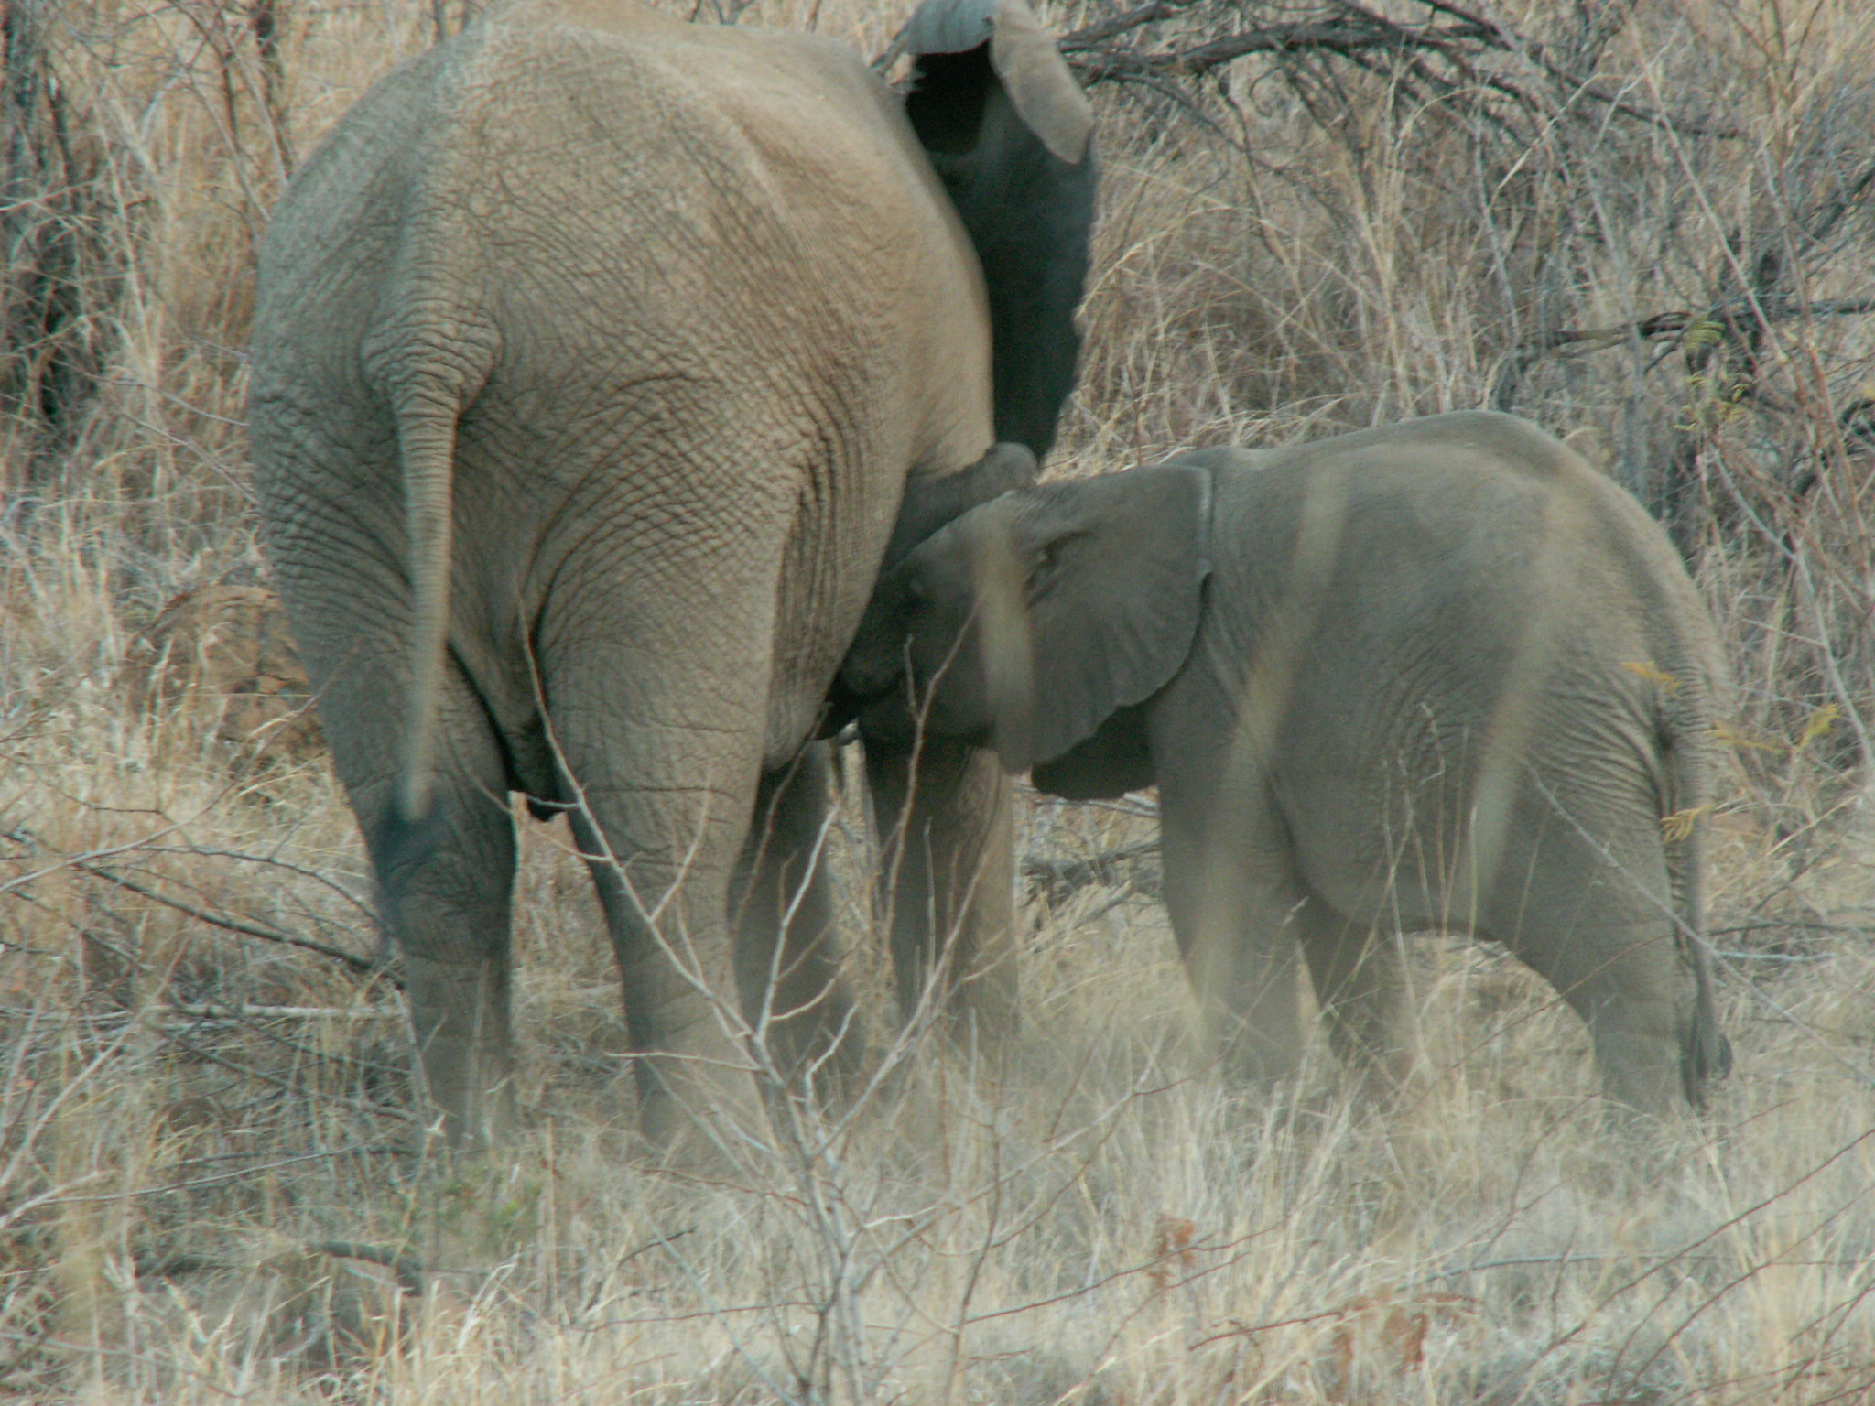
X
x
h
L
E
O
y
2m
Photo: J Bajorek
F
2x

(4)
[12]

QUESTIONS 9.1.1, 10.1 and 10.2 must be answered on DIAGRAM SHEETS 1 and 2 provided.

QUESTION 9

9.1 | An athlete's ability to take and use oxygen effectively is called his/her VO₂ max.  Twelve athletes each who had pre-recorded VO₂ max figures ran for one hour. The distances they covered in km and their VO₂ max figures are represented in the table below.

VO₂ max | 20 | 55 | 30 | 25 | 40 | 30 | 50 | 40 | 35 | 30 | 50
Kilometres | 8 | 18 | 13 | 10 | 11 | 12 | 16 | 14 | 13 | 9 | 15

 | 9.1.1 | Represent the data above on a scatter graph on DIAGRAM SHEET 2. |  | (3)

 | 9.1.2 | On your sketch, draw the line of best fit. |  | (2)

 | 9.1.3 | Use your graph to estimate the VO₂ max if an athlete runs 19 km. |  | (1)

 | 9.1.4 | Is there a relationship between the two sets of data given in the table above? Explain. |  | (2)

9.2 | The data below is organised on the stem and leaf plot and represents the number of cars passing through an intersection between 16:00 and 20:00 over a 17-day period.

1 | 2 5 5 7 8 8 9
2 | 0 1 2 3
3 | 3 4 4 8 8 8

Use the given stem and leaf plot to determine:

 | 9.2.1 | The median |  | (2)

 | 9.2.2 | The upper quartile |  | (1)

 | 9.2.3 | The lower quartile |  | (1)  [12]

QUESTION 10

A radar gun was used by police to measure the speed of cars on a certain stretch of the road in a city. The speeds (km/h) of 100 cars were measured and the data was compiled as follows:

SPEED INTERVALS  (IN km/h) | NUMBER OF CARS  (FREQUENCY) | CUMULATIVE FREQUENCY
40 – 49 | 18
50 – 59 | 22
60 – 69 | 30
70 – 79 | 20
80 – 89 | 8
90 – 99 | 2
 | TOTAL: 100

10.1 | On DIAGRAM SHEET 2 complete the cumulative frequency column. |  | (2)

10.2 | Use the table to draw a cumulative frequency curve (ogive) on DIAGRAM SHEET 3. |  | (3)

10.3 | Use your graph to determine the median. |  | (1)

10.4 | Briefly comment on the driving habits of this group of drivers whose speeds were measured. |  | (2)  [8]

QUESTION 11

The test results of 31 learners are given below. There was only one result of 26 marks and only one result of 64 marks.

64
26
36

11.1 | What information is omitted on the diagram above? |  | (1)

11.2 | The results were read to learners in ascending order. If the 8th learner's result was 26, which learner obtained a result of 64? |  | (2)

11.3 | One of the learners made the following remark:  'The data distribution is not symmetrical.'  Is the learner correct? Give a reason for the learner's remark. |  | (3)

11.4 | The class calculated the following using the test results:  mean ($\overset{−}{x})$ is 45,5 and the standard deviation $σ = \text{19},2$  Use the above information and find the number of results that fall outside ONE standard deviation of the mean. |  | (3)  [9]

TOTAL: |  | 150

FORMULA SHEET: MATHEMATICS

FORMULEBLAD: WISKUNDE

$x=\frac{−b±\sqrt{b^{2}−4\text{ac}}}{2a}$ $A=P(1+\text{ni})$ $A=P(1−\text{ni})$
$A=P(1−i)^{n}$ $A=P(1+i)^{n}$ $F=\frac{x\left[{\left(1+i\right)}^{n}−1\right]}{i}$
$\sum_{i=1}^{n}{1=n}$ $\sum_{i=1}^{n}{i}=\frac{n(n+1)}{2}$
$\sum_{i=1}^{n}{\left(a+(i−1)d\right)=\frac{n}{2}\left(2a+(n−1)d\right)}$ $\sum_{i=1}^{n}{{\text{ar}}^{i−1}}=\frac{a\left(r^{n}−1\right)}{r−1}$ ; $r≠1$
$\sum_{i=1}^{∞}{{\text{ar}}^{i−1}=\frac{a}{1−r}}$ ; $−1<r<1$ $f'(x)=\underset{h→0}{\text{lim}}\frac{f(x+h)−f(x)}{h}$
$d=\sqrt{(x_{2}−x_{1})^{2}+(y_{2}−y_{1})^{2}}$ M$\left(\frac{x_{1}+x_{2}}{2};\frac{y_{1}+y_{2}}{2}\right)$
$y=\text{mx}+c$ $y−y_{1}=m(x−x_{1})$ $m=\frac{y_{2}−y_{1}}{x_{2}−x_{1}}$
$m=\text{tan}θ$ ${\left(x−a\right)}^{2}+{\left(y−b\right)}^{2}=r^{2}$
In ∆ABC: $\frac{a}{\text{sin}A}=\frac{b}{\text{sin}B}=\frac{c}{\text{sin}C}$ $a^{2}=b^{2}+c^{2}−2\text{bc}\text{.}\text{cos}A$
$\text{area} Δ\text{ABC}=\frac{1}{2}\text{ab}\text{.}\text{sin}C$ $\text{sin}\left(α+β\right)=\text{sin}α\text{.}\text{cos}β+\text{cos}α\text{.}\text{sin}β$
$\text{cos}2α=\begin{aligned}\left\{{\text{cos}}^{2}α−{\text{sin}}^{2}α | \right.\left\{1−2{\text{sin}}^{2}α | \right.\end{aligned}$ $\text{sin}\left(α−β\right)=\text{sin}α\text{.}\text{cos}β−\text{cos}α\text{.}\text{sin}β$
$\text{cos}\left(α+β\right)=\text{cos}α\text{.}\text{cos}β−\text{sin}α\text{.}\text{sin}β$
$$\text{cos}\left(α−β\right)=\text{cos}α\text{.}\text{cos}β+\text{sin}α\text{.}\text{sin}β$$
$\text{sin}2α=2\text{sin}α\text{.}\text{cos}α$
$\bar{x}=\frac{\sum{\text{fx}}}{n}$ $σ^{2}=\frac{\sum_{i=1}^{n}{{(x_{1}−\bar{x})}^{2}}}{n}$
$P(A)=\frac{n(A)}{n\left(S\right)}$ P(A or/of B) = P(A) + P(B) – P(A and/en B)

Name/Naam: ___________________________________________________

DIAGRAM SHEET 1/DIAGRAMVEL 1

QUESTION/VRAAG 3.1.4 (b)

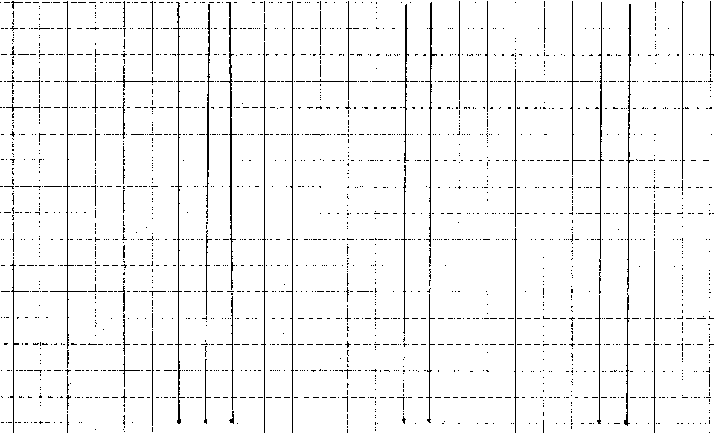

QUESTION/VRAAG 7.1



Name/Naam ___________________________________________________

DIAGRAM SHEET 2/DIAGRAMVEL 2

QUESTION/VRAAG 9.1.1

VO₂ max/maks

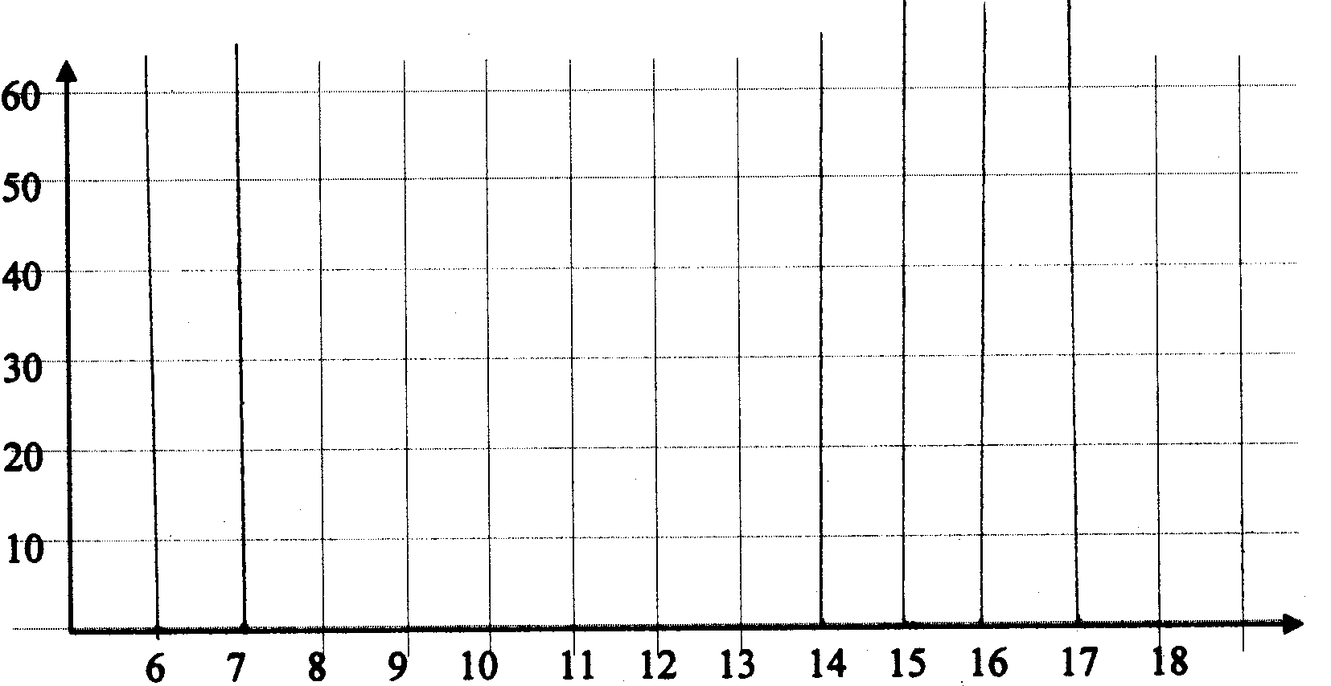
Kilometre(s)/Kilometer

QUESTION/VRAAG 10.1

SPEED INTERVALS/ | NUMBER OF CARS (FREQUENCY)/ | CUMULATIVE  FREQUENCY/
SPOEDINTERVALLE  IN km/h | AANTAL MOTORS  (FREKWENSIE) | KUMULATIEWE  FREKWENSIE
40 – 49 | 18
50 – 59 | 22
60 – 69 | 30
70 – 79 | 20
80 – 89 | 8
90 – 99 | 2
 | TOTAL/TOTAAL: 100
Name/Naam ___________________________________________________

DIAGRAM SHEET 3/DIAGRAMVEL 3

QUESTION/VRAAG 10.2

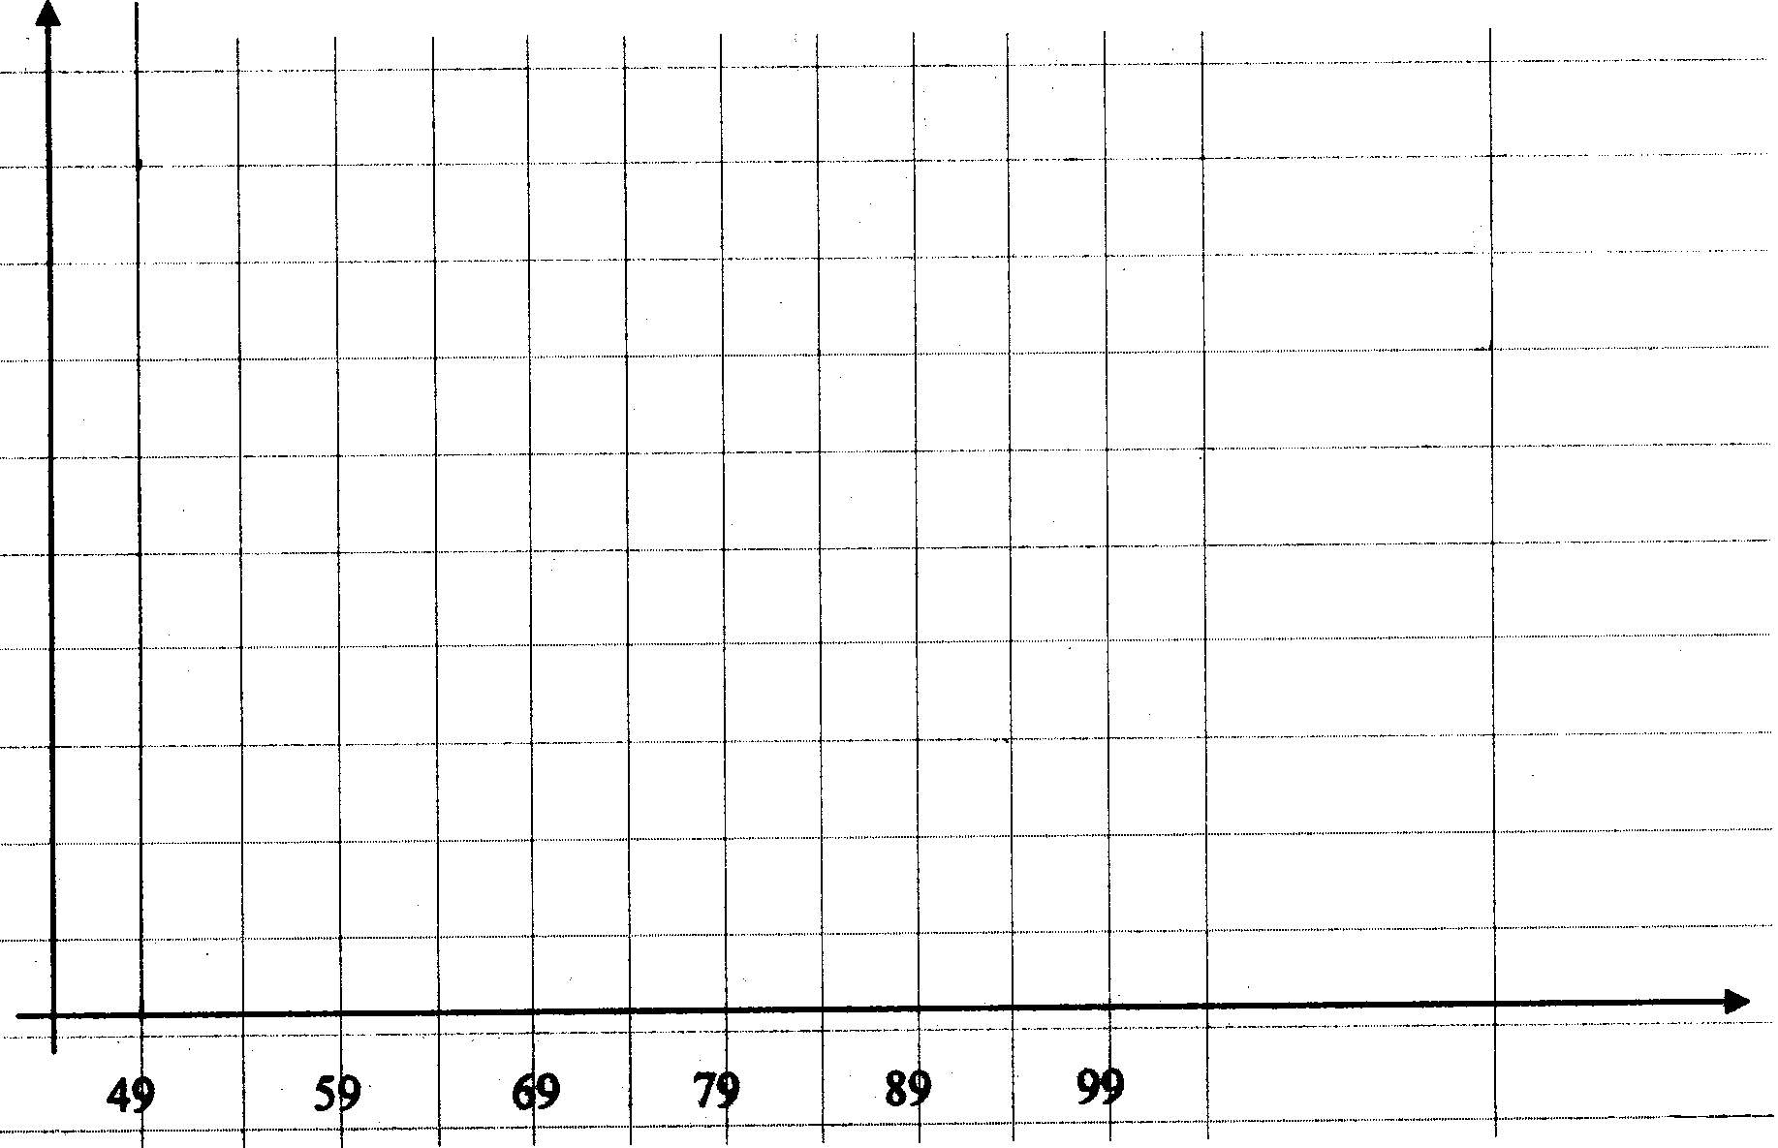

Frequency/Frekwensie

Speed/Spoed

